**Improving the Student Navigation Center One Minute at a Time – Using Queuing Theory to Predict Wait Times**

**Honors Thesis**

**Presented in Partial Fulfillment of the Requirements**

**For the Degree of Bachelor of Science in Business Administration**

In the Bertolon School of Business

At Salem State University

By

Alexis Stangas

Professor David Goodof

Faculty Advisor

Management Department

***

The Honors Program

Salem State University

2015

Abstract

The Student Navigation Center at Salem State University is a one stop shop where students can receive help for anything they need. It includes Financial Aid, the Bursar’s office, the Registrar and the Clipper Card Office and provides several services to students. A one stop shop is a great way to better services to students, but along with the implementation many problems can arise such as congestion and long wait times. The Student Navigation Center has made several improvements since they first transitioned into a one stop shop in order to better their services to students and make things as easy and quick as possible. However, there have been several complaints in regards to lines being very long and students wanting to know how long they are going to be waiting before they can go inside. Queuing theory is an analysis tool that can predict wait times and improve those times by adjusting the arrival rate, the service rate or the number of servers. This paper analyzes the improvements made along with further improvements that need to be made at the Student Navigation Center and provides a queuing analysis for the Financial Aid and Student Accounts services. These services were chosen due to their high importance to students and the high volume of students that come in for problems or questions relating to them. The paper gives an idea of how the Student Navigation Center functions and what they have done to help their students and the queuing analysis shows what can be done to further serve the needs of students by predicting and improving wait times for Financial Aid and Student Accounts.

Acknowledgements

I first want to express my gratitude to my advisor, David Goodof. He goes above and beyond for his students and has helped me immensely throughout my time here at Salem State University. I also want to thank Saverio Manago who consistently helped with any question that I had. It was he who gave me the idea to write about the Student Navigation Center. He as well as Elizabeth Haran have been amazing supports in the ODS department and have taught me so much. I am thankful to Laura Dichiara and Bryan Boppert who helped me throughout my internship and allowed me the pleasure of interning at the Student Navigation Center as well as Professor Haran who advised me throughout the internship. Finally, Joanna Gonsalves and Kim Poitevin. They are amazing educators and supporters of mine who have helped me immensely throughout my thesis writing process.

Table of Contents

**Abstract**..............................................................................................................................ii

**Acknowledgements**……………………………………………………………………...iii

**List of Tables and Figures**……………………………………………………………….v

**Introduction**………………………………………………………………………………1

Statement of the Problem………………………………………………………….1

Scope of the Project……………………………………………………………….2

Significance of the Study………………………………………………………….3

**Literature Review**………………………………………………………………………..4

**Background**……………………………………………………………………………..10

Service Methods Used by the Student Navigation Center…………....………….10

Setup…………………………………………………………………….10

System……………………………………………………………………………13

QNOMY…………………………………………………………………13

Polaris……………………………………………………………………14

Improvements Made by the Student Navigation Center………..………………..15

Hierarchical Set Up…………………………………….………………...16

Goodbye Money Matters…………………………………………….…..17

Station 7 and Self-Service…………………………….………………….18

Communication through Texting………………………….……………..20

Morning Training……………………………………….……………….22

Goal of the Improvements……………………….………………………23

Further Improvement…………………………………………………………….24

Communication Inside and Out………………………………………….24

Students Wanting to Go Inside…………………………………………..25

Student Opinions and Complaints……………………………………….25

Wait Times……………………………………………………………….26

Business Specialists………………………………………….…………..27

**Methodology**……………………………………………………………….……………28

Generating the Queuing Model…………………………………………………..30

Arrival Rate and Service Rate……………………………………………………33

Pivot Tables……………………………………………………………………...35

Graphs……………………………………………………………………………37

**Application and Results**……………………………………………………….……….40

Financial Aid Average Queuing Models………………………………………...41

Financial Aid Peak Hours Queuing Models…………………………………….43

Student Accounts Average Queuing Models……………………………………47

**Discussion**………………………………………………………………………………48

**Conclusion and Reflections**……………………………………………………………54

**Bibliography**…….……………………………………………………………….……..56

**Appendix.**……………………………………………………………………………….57

Tables and Figures

**Table 1** Service Time, Wait Time, Students for Financial Aid………………...30

**Table 2** Service Time, Wait Time, Students for Student Accounts……………32

**Table 3** Arrival Rate and Service Rate for Financial Aid……………………...34

**Table 4** Arrival Rate and Service Rate for Student Accounts…….……….…...35

**Table 5** Financial Aid Pivot Table…………………………….………………..36

**Table 6** Student Accounts Pivot Table…………………………………………37

**Figure 1** SNC Process Map……………………………………….……………..12

**Figure 2** QNOMY Service Console…………………………………………......14

**Figure 3** Trexting Screenshot…………………………………………..………..21

**Figure 4** Line Graph Total Students and Hours for Financial Aid……………....31

**Figure 5** Line Graph Total Students and Hours for Student Accounts…………..32

**Figure 6** Line Graph Arrival Rate per Hour for Financial Aid…………….….....38

**Figure 7** Line Graph Service Rate per Hour for Financial Aid……………….….38

**Figure 8** Line Graph Arrival Rate per Hour for Student Accounts………………39

**Figure 9** Line Graph Service Rate per Hour for Student Accounts………………39

**Figure 10** Queuing Model Average 1 for Financial Aid…………………………..41

**Figure 11** Queuing Model Average 2 for Financial Aid…………………………..42

**Figure 12** Queuing Model Average 3 for Financial Aid…………………………..43

**Figure 13** Queuing Model Financial Aid Peak Hour 12:00-1:00 p.m.….………….44

**Figure 14** Queuing Model Financial Aid Peak Hour 12:00-1:00 p.m. (2)..…….….45

**Figure 15** Queuing Model Financial Aid Peak Hour 1:00-2:00 p.m. (1)…..….…...45

**Figure 16** Queuing Model Financial Aid Peak Hour 1:00-2:00 p.m. (2)…………...46

**Figure 17** Queuing Model Financial Aid Peak Hour 1:00-2:00 p.m. (3)..…………46

**Figure 18** Queuing Model Average 1 for Student Accounts………………………47

**Figure 19** Queuing Model Average 2 for Student Accounts………………………48

**Introduction**

The Salem State University Student Navigation Center is a student’s one stop shop to receive any help they need or any question they have answered. The Student Navigation Center contains four main service areas: the Registrar, Bursar, Clipper Card, and Financial Aid. Within these four areas, any question or need a student has can be serviced. However, the Student Navigation Center is something students often think about with frustration and irritation. Why is that? Often they find that going to the Student Navigation Center is something they dread doing due to its inefficiency in services. At a fully functional University, such as Salem State University, student services have to be optimized to full efficiency for student experiences to run smoothly. I can say that the Student Navigation Center was definitely not something that was optimized to full efficiency when it opened. However, since last year there have been several large improvements that the Student Navigation Center has made that have greatly decreased complaints and overall wait times. Although they have made impressive improvement to the efficiency and effectiveness of the Student Navigation Center, there are still more negative opinions about it than positive ones, and there are improvements still to be made.

**Statement of the Problem**

I began an internship at the Student Navigation Center at the beginning of September this semester to gain more understanding of why students had such constant negative opinions. I have been spending a lot of time observing employees and students being served. One main complaint from students I have routinely noticed is when they take a ticket to be placed into the queue to go inside, they have no way of knowing how long they are going to be waiting. The only thing that the student employees at the front desk can tell them is how many people are in front of them. The problem with this is one student can take five minutes, and other times they can take twenty. This is very frustrating to students who have very busy schedules and want to know how long this is going to take. One method I will use to potentially solve this problem is a quantitative analysis tool known as queuing theory. Queuing theory is the study of lines, or queues. The purpose of using a queuing theory model is to try to pin down the relationship between the number of servers, service rate and arrival rate. These variables are then adjusted to try to improve performance and wait times. By pinning down this relationship I can come up with a model that can predict a rough wait time for how long a student will be in the queue and from there I can find ways to improve those times.

**Scope of the Project**

I am going to focus on predicting wait times for Financial Aid and Student Accounts which are the two services that receive the most foot traffic and also have the longest wait times. I am using data from August 7, 2015 to October 16, 2015 in the queuing models.

I am going to be researching other schools out of the country that have also created student services centers, catered towards giving students one location to go to for all their needs. This literature review will allow for comparisons between Salem State University and other Universities that implement the same service methods. Out of this literary research the purpose is to see if the other schools are succeeding using this method or not. Also through literature review I will be looking at the beginnings of one stop shops, how they were created in the earlier years, the student-university customer relationship, queuing models used in other places such as airports, and the overall importance of student centered services. Original research through my internship at the Student Navigation Center as well as responses from current students regarding the quality of their service also plays a very large role in this thesis. Original research will also include the set up and processes of the Student Navigation Center, current improvements and future improvements and the queuing analysis that I did on Financial Aid and Student Accounts.

As I mentioned before, the Student Navigation Center has already made many improvements to their services but throughout this paper my goal is to improve efficiency in order to better serve students through literature review, original research and using queuing theory to predict wait times and improve Financial Aid and Student Accounts. The purpose of this project is to solve the major problem at the Student Navigation Center of long wait times and students not knowing how long they will be waiting. The goal of my project is to pin down the relationship between arrival rate, service rate and the number of servers and to adjust them in order to clearly see an improvement in the wait times. These processes will overall inform readers and improve the Salem State University Student Navigation Center.

**Significance of the Study**

Students nowadays are extremely busy and, in order for them to be best served, it would be helpful for them to have an estimated wait time. If they do not know how long they are waiting, they could end up sitting there for longer than expected. Students often have an expectation of how much time they will have to spend waiting at the Student Navigation Center, and when the wait time surpasses their expectations it is upsetting and frustrating. Using queuing models to predict wait times can give the student an idea of how long they are going to wait and also it can give the employees and directors at the Student Navigation Center an idea of what they can do to lower the wait times. It allows for satisfaction on the student’s end and optimization on the Student Navigation Center’s end.

**Literature Review**

Throughout my research, I have not found one source regarding queuing theory and student services. What I have found is queuing theory being used in airports, in DMVs and transportation services, but not used in higher educative services. In the example of an airport, the queuing model was based on the congestion at an airport and included control of arrival and departure services rates which allowed them to predict the congestion of the airport at certain times and based off of certain flight times (Jacquillat, Odoni, 2015). Adjusting the arrival rates and services rates can be changed or controlled in order to maximize their operating efficiency because they can see what changes in these rates affect the congestion and flight schedules (for example, if a flight is delayed or canceled). The analysis allows for an allocation of resources based on the adjustment of the variables in order to optimize their business. For example, because they can predict the congestion based off of the rates at a certain time of the day during the year, they then can allocate their resources and schedules based on this information which can lower their congestion during that time. This relates to my project in that I am using arrival and service rates in order to predict overall wait times, which then allows me to see what I can do to adjust these variables and improve overall services. From this adjustment, I can see where resources and employees need to be allocated in order to support this improvement.

Queuing theory can be used to improve student services and optimize business processes but the relationship of students to their university as a whole is something that is often overlooked. A dissertation completed at the University of Montana in 2012, notes how student services are delivered is a vitally important issue in a time when students view themselves as customers of colleges and universities (Johannes, 2012). Also during a time when colleges and universities are conscious of being student-centric and providing integrated services (Johannes, 2012). It is clear that students are viewing themselves more and more as customers of business as well as students of schools. An article written in the Educational Research Review states, “it is the students who directly experience education, they are the ones who are in the classroom and also utilize the resources within the educational establishment, the conceptualization of student-as-customer would fit well with much advocated beliefs that the students are the immediate beneficiaries of the educational process” (Tasie, 2010). In any business, the business to customer relationship is of utmost importance because they are the ones who are making money for the business and are directly receiving their services. Relating this back to education, students are making a lot of money for the university, or the business, that they attend. When considering their overall experience, everything should be at its best, especially the services the school provides for them. At the end of it all, these services were created for students and there should be no question as to if they are the best for the students or not (Schulz, Szekeres, 2008). Most students, including myself when I applied, only think about things like how nice their dorms are, the food, and the amenities they can provide because those are the things that are shown to them when they come visit. No one is told when given a tour that the student services may not be at their very best, and when they are choosing a school to go to they do not add that in as a deciding factor. Mary Jo Bitner (2012) notes that there are many benefits that could ensue from a consumer perspective being more widely adopted within higher education and that “viewing higher education through a service lens represents a significant shift” (Bitner, Burkhard, Ostrom, 2012). From the beginning of the application process, if the university focuses on the direct services to their student and the promise that they will be served as best as possible, then eventually this mindset will be permanently embraced by everyone. Embracing the idea of the university-to-student relationship will lead to improved services and increased happiness of the overall university because it shows that they care for the students who are paying to attend their university.

Student services have been a part of universities for as long as anyone can remember, but their level of importance was definitely not at the top. *Innovation in student services: Planning for models blending high touch/high tech* written by Darlene Burnett and Diane Oblinger in 2003 begins to explain this importance and what makes a student service the “best” practice. They reiterate how important it is to “invert the view of service” or put the student at the center of every future interaction. This ensures the quality, accuracy and responsiveness of the services that are expected by students (Burnett, Oblinger, 2003). Several main factors they present show what should be used in the best practice model of student-centered services. Some of these include customer/student satisfaction, a skilled staff, self-service specialists, and a shift from transactions to relationships with the students (Burnett, Oblinger, 2003). From this list, shifting transactions to relationships is one that should be noted because when a student comes into the service area, they should feel as though they are warmly welcomed and helped. More often than not students do not feel welcomed because the employees want to make sure they can serve every student as quick as possible, and students can feel like they are brushed to the side. Even if their problem was solved, they still do not leave feeling satisfied. Students usually expect a positive experience and they expect the employee to be knowledgeable and caring and to have their problem completely solved by the time they leave (Burnett, Oblinger, 2003). When this does not happen, students become angry and frustrated, often forming an opinion that is negative about the service they were provided. This is something that I have noticed at the Student Navigation Center; students expect certain things when they walk in there, and when they find out that they may not be able to solve their problem right away then they immediately leave having negative feelings about the Student Navigation Center. This leads to improving communication with students and doing whatever it takes to show them that the employees are doing whatever they can to fix the problem. So by the end, if the problem still is not solved the student will still leave feeling as though they were helped as much as possible.

One stop shops are a growing trend in many universities today due to the improved experiences they provide, but “it is not enough to re-arrange student services into one building, what is important is that the re-organization of services actually helps students” (Draeger, 2008). One stop shops should focus on resolving student’s issues no matter what they may be and providing the best service possible while aiding the student. The one stop shop student services model is something that was created in order to better the experience for students when trying to receive help for something at their university. Oftentimes, students arrive for services with several questions and tasks that need to be taken care of. Beckie Supiano explains in her interview with Christopher Redd, who worked at a student service center at Virginia Commonwealth University, that Christopher saw a lot of frustrated students who had to go to several places all over campus in order to get one thing done. After seeing the annoyances and frustrations from students, VCU created a one stop shop containing registration, student accounts and financial aid so students could receive assistance in one place (Supiano, 2011). Similar to Salem State University, VCU students would have to go to several different places to complete one task, and most college students today just do not have that time to run all over the place and they most likely have more than one thing that they need to do. What is so great about one stop shops is that students can get all they need figured out in one place and not have to go anywhere else. However, when everything is in one place that leads to a lot of students and a long line. The congestion that can build up at a one stop shop can lead to the same frustrations that the one stop shop was created to prevent. The larger the university and the more departments it contains leads to more of this congestion. More work needs to be done on one stop shop system and optimizing it to its full potential. Once a one stop shop is running at full efficiency, then it can greatly impact the university in a very positive way.

Universities in Australia have been focusing on what the students have to say about student services and what they think about creating a one stop shop. Involving students in this process can help increase their satisfaction and understanding of why it is being implemented and how it can help them. Melissa Buultjens and Priscilla Robinson at La Trobe University in Melbourne, Australia constructed a study to examine responses from some of the 30,000 students that attend the university. The questions and responses concern their opinions about the student services they currently use and ways in which their services could be centralized into a one stop shop (Buultjens, Robinson, 2011). They received an overwhelming amount of responses from students saying that if there was a one stop shop then they would like it better than having to search for services all over their large campus. They explain the importance of a university’s expectations to response when a student faces challenges (Buultjens, Robinson, 2011), and that is exactly what this university did. The university did not know that these students were struggling with navigating the huge university so much until this study was conducted. They were thinking of this idea and decided to involve the students to gain more insight, and once they did they immediately knew that it had to be done (Buultjens, Robinson, 2011). Students are the primary importance of a university and once La Trobe University realized this, it made their decision a lot more clear that implementing a one stop shop would be best for the students.

Similar to La Trobe University, the University of Western Sydney in Sydney, Australia found an effective and systematic way to analyze data using a qualitative software tool. This software tool allowed the university to look at actual feedback all of the students were giving them and analyze it in a way that can effectively improve the student experience based on what the students were saying (Grebennikov, Shah, 2013). Although I mainly am going to use quantitative data in my research, the use of qualitative research reiterates the important fact that efficient use of student feedback helps increase student satisfaction. More often than not when students are involved in something and understand the process of something happening, there will be a much more positive response when it begins to happen or opens. In the case of one stop shops, a lot of students are weary due to the possibility of congestion and long wait times, but if it is explained beforehand and students have the chance to understand the processes, they will be a lot more understanding if these problems occur.

**Background**

**Service Methods Used by the Student Navigation Center**

**Setup**

The way a one stop shop is set up is extremely important to maintaining its efficiency. Before explaining exactly how everything is set up, I want to explain the main flow of the Student Navigation Center. First students come to the desk and check in, if the problem is simple enough they can be answered by the student employees, if the problem is a little more complicated they are brought to the self-service station with a student helper. If the problem is more complex they are put in the queue, given a ticket and directed to Station 7 (which is also run by student employees). Station 7 is able to answer more complex questions and is also the document drop off station. Above this, they are given a ticket to be put in the queue for a higher service based on the subject of their question. Sometimes students need to make an appointment with the specialists if the problem cannot be solved immediately. An appointment must be made to see a specialist and this can take days.

The ticket placed in the queue is a number and it is brought up on a TV screen outside when they are ready inside, the number is then called along with what station the student is being sent to. This hierarchy of service allows for minor problems to get filtered out of the queue instead of sending everyone inside. If a student has a simple question about their bill, then one of the student employees can help them right away. This is better than having to take a ticket and be put in the queue to wait for someone from Financial Aid to talk to them. This filtering allows for fewer wait times, less traffic and happier customers. At first I did not have a clue how it all worked but having an internship there has helped with understanding why they implemented the things they did and how they have had an impact on their services. Before the reception desk there was a kiosk that students would slide their clipper card into and go inside based on their question. Before the one stop shop even existed they just had several different offices for all of the services all over campus. Moving them all into one space is much more convenient for students and the way they have set things up helps keep the flow constant.

Below is a process map of the desired flow of the Student Navigation Center that was created and given to me by the Student Navigation Center. This represents the ideal hierarchical flow that they would like to achieve for every student that comes in. It visualizes the set up described earlier which focuses on filtering students with less complex questions out of the queue to make enough time for those with questions that could take more time to figure out.

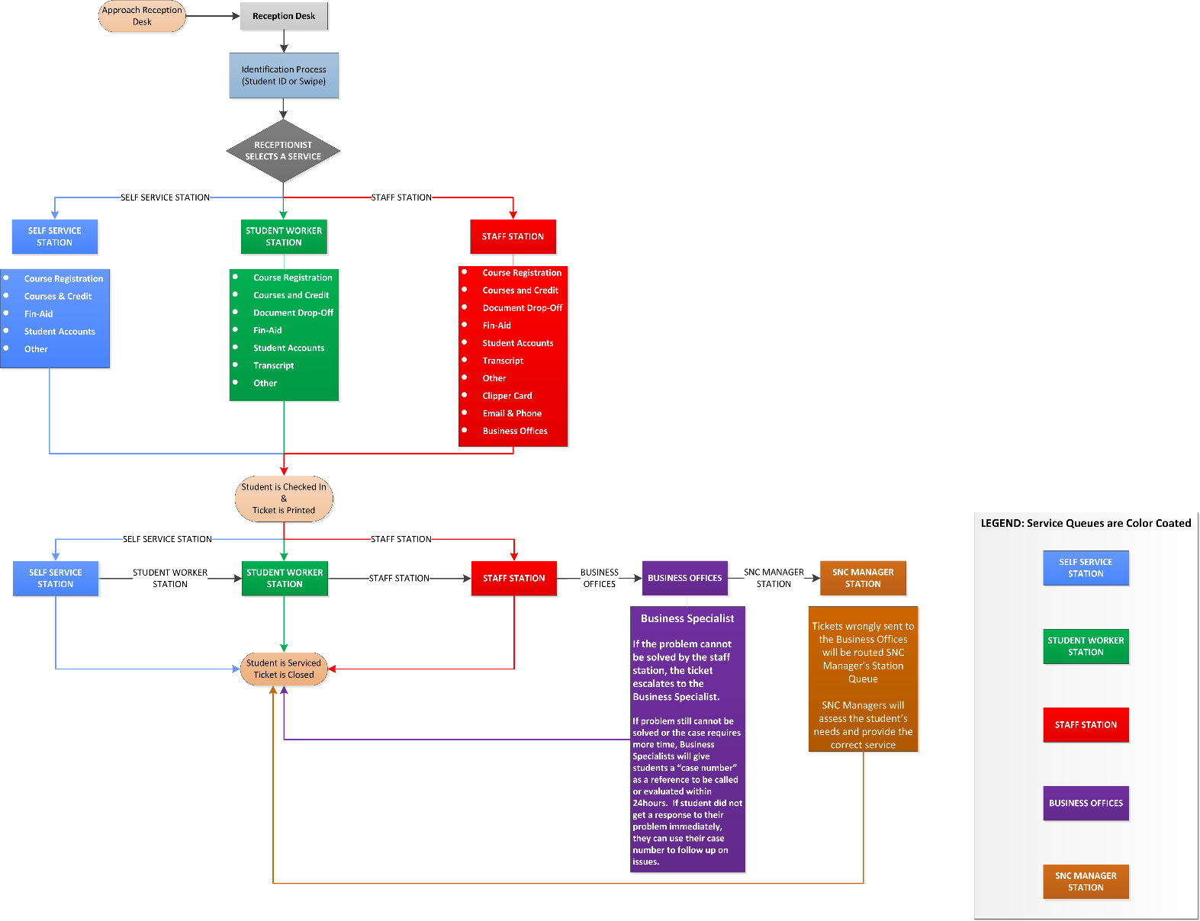**Figure 1. SNC Process Map**

Source: Student Navigation Center

The process map regarding the hierarchy is a great way to show the flow of the Student Navigation Center. The stations are inside are numbered from one to seven and a student will be called to one of those stations based on the nature of their question. The setup is very clear and easy to understand for a student who has never been there before.

**System**

**QNOMY**

QNOMY is the queuing system that the Student Navigation Center uses in order to create tickets as well as keep track of all of the data and cases they have. When the student approaches the reception desk, they are first asked for their student ID number or their clipper card. The student ID number is the universal key for the employee to access any information they could possibly need about the student. They input the student’s ID number into QNOMY and then ask them what they are there for/what they need help with. Based on the question/problem, the student employee then determines how to serve them. If they need a service inside, they select the service in QNOMY and write a brief description of the problem at hand so the station that they are going to knows what the student is coming in for. All of the stations can see the person in the queue along with the problem described and the station that can best help them will click on the ticket and call them in. This screen pasted below is the service console that everyone can see which allow them to see what tickets are in the queue and what they are for. The ticket numbers start with a specific letter and are followed by a random three digit number. The student’s names and ID numbers are crossed out, but note that that is where they would be when looking at the service screen:

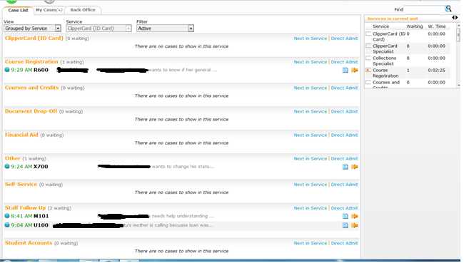**Figure 2. QNOMY Service Console**

The letters represent the station that they are going to. They are chosen as follows:

F – Financial Aid R – Course Registration U – Staff Follow Up

M – Student self-service T – Transcripts D-Document DropOff

X – Other C – Courses and Credits

S – Student Accounts I – Clipper Card (ID card)

QNOMY allows all employees to see what tickets are being created and what they are being created for. If an employee takes a ticket and later needs help answering the question or solving the problem, most people will already know the problem because they were able to see the tickets that were being created.

**Polaris**

Polaris is the way that employees can look up a student’s information regarding things like their bill, their Financial Aid, forms they have filed, etc. by signing into the student’s navigator account. Polaris is extremely helpful in servicing students because it allows employees to see everything they need to know about a student and they can easily answer their questions with this information present.

**Improvements Made by the Student Navigation Center**

Although the system they were using and the set up they had implemented was set, when the Student Navigation Center first opened there was still a lot of room for improvement. The wait times were very long they and were unable to give each student the best service they could due to so many students trying to get things ready for the fall semester. The new setup was not only new to the employees, but also new to the students. Most were not sure why they were moving all of the offices up into one room (where the library used to be) and a lot of them were skeptical. While observing in the Student Navigation Center for my internship, something I have particularly noticed is a lot of students saying “where is the old kiosk?” or “why is everything in one room all of a sudden?” I think they were a little taken aback by having to explain themselves to someone first instead of just creating their own ticket. They definitely did not understand the premise of being a one stop shop and how it can be a lot more convenient for student services. That being said, the Student Navigation Center began with a lot of complaints and frustrations coming from students, and although many things have changed since then a lot of students do not know that these changes have been made. It is very possible that some have avoided the Student Navigation Center all together since they came when it first opened.

**Hierarchal Setup**

The biggest, most noticeable improvement that they have made was right from the start, and that is their hierarchical set up. Just to reiterate this setup briefly, students come to the reception desk and based on the nature of their problem, they are either helped by the front desk, helped by self-service, or helped by Station 7. If the problem is more complex than what these three services can handle, the student is placed in the queue and given a ticket number to go inside and talk to an employee at the desk based on the service that they need. The hierarchal setup is the basis of all other improvements that have been made and that are going to be made in the future. When they first opened they had a kiosk that students would choose what they were there for from a list of services on the screen, swipe their clipper card and the machine would print them a ticket. The problem with this was that the employees inside would only see the service they were going to, not what they were actually there for, and often students just chose other so it was very difficult for them to keep track of everything. They quickly got rid of this kiosk and only had the employees at the reception desk copy down the student’s ID number into QNOMY instead to get their ticket. As you saw in the photo posted above, QNOMY allows the Student Navigation Center employees to efficiently see what students are actually here for and keep track of each student on a case by case basis. It also allows them to also keep track of wait times, service times, the number of students they are serving and more. They can later go back into QNOMY and compare each month or even day to the numbers that they had last year to see if they are truly improving.

Because the Student Navigation Center is a one stop shop, things need to be organized a certain way in order for it to be efficient. In this case, it is often difficult because one stop shops can easily get clogged due to the fact that everything is in one room rather than having separate offices. The hierarchal setup that they implemented starts taking this clogging factor out. Instead it brings in the filtering factor I mentioned before. Because so many questions can be answered before the students even have to take a ticket and be put into QNOMY, it allows for less students to be put into the queue, which leads to shorter wait times for students that have complex questions. Also if these students with complex questions are in there for a longer amount of time due to the nature of their problem, the longevity of service time becomes less of an issue due to the fact that there are less people in the queue. When I am in the Student Navigation Center there are some hours that are quiet. There are not a lot of students coming to the reception desk and oftentimes their wait times are very short. Compared to last year, the wait times and line lengths have definitely progressed due to their new setup.

**Goodbye Money Matters**

The kiosk in the old set up mentioned above caused a large problem for the “Money Matters” service at the Student Navigation Center. When students would go to the kiosk and choose a service, often they did not know what Money Matters entailed, so they would just choose “Other”. Because of this employees inside had no idea what the student was coming in for or what question they had and it caused a lot of confusion. After they transitioned into having a reception desk Money Matters stayed for a little while but it was still causing a problem. Money is such a key problem that students most often come to the Student Navigation Center for and there was still a lack of communication from the outside to the inside. They solved this problem by splitting the Money Matters services into both Financial Aid and Student Accounts. There are now two services for finance related questions and this allows for more specific questions and more specific services. This specificity clears up a lot of the confusion when the employee creates a ticket at the reception desk because the employee inside can see which service the student is specifically there for and they also know the premise of their problem. In QNOMY, it is clear where students are going when they want to look at the data. Splitting Money Matters into two separate services led to less confusion and more overall efficiency, and it clearly shows today.

**Station 7 and Self-Service**

Mentioned several times in the hierarchal setup is Station 7 and Self-Service. Both of these services are always run by a student employee and they are key components in the flow of the hierarchical set up. Station 7 is imperative because it is the middleman between the inside desk and the reception desk outside. Many questions can be answered by the student employee working at Station 7 to keep the flow out of the main offices. Students often do not realize how many questions can actually be answered by the Station 7 employee, they are highly trained and can not only help the students, but also inform them and teach them how to do things on their own. A student employee at the Student Navigation Center that works at Station 7 stated that “Station 7 is wonderful in that it is a student to student connection, and it can create a more personal experience. Not only that, but it is a representation of the student worker and how much they can teach other students.” They can teach students how to solve problems on their own at the self-service desk so they do not need to keep coming back and waiting. He also notes that “it is the ‘middle ground’ of the Student Navigation Center, and it is imperative to the flow of things.”

Station 7 is also known as the Document Drop-Off station, this is another key improvement because before students would have to take a ticket in the queue and wait a very long time just to drop off a form. Now they are still placed in the queue but it is more for purposes of data collection. Often a student will either give it to the front desk, who can pass it on to Station 7, or they will wait a very short time to bring it directly to Station 7 themselves and have it processed right away.

The documents dropped off are placed in color coded folders labeled by service, (red for Registration, green for Financial Aid, blue for Bursar, and orange for Clipper Card) and from here they are processed at the appropriate location several times a day. This was an essential part of improvements because all forms that students fill out are important in some way. They have to physically come to the Student Navigation Center for and cannot send them via email. It was a very large headache for a lot of students who did not have the time to sit and wait twenty minutes just to hand them a piece of paper. Speaking from personal experience, last semester I came up to the Navigation Center to drop off a Financial Aid form thinking that I was just going to be able to go in and out. I ended up having to leave because I had to go class and it was very frustrating. The Student Navigation Center took the necessary steps to improve this problem and make things a lot easier for students in a very short amount of time. Another great thing about Station 7 is that in between taking tickets, they take the time to answer emails. They answer them in a timely and also detailed manner so that you will not have to make another trip for your question unless it is something you need to talk to an employee in person about. Another major improvement made is the implementation of the student self-service.

When a student walks up to the reception desk often they will see two people sitting down and one person standing up and walking around. The person standing up and walking around is the student employee assigned to work in self-service. If a student comes to the desk with a certain problem, more often than not the student can take them inside to the self-service station and show them how to find the answer to their question or fix the problem on their own. This shows the student coming in that student employees are really here to help them and they are doing what they can so students do not have to wait long to be helped. A few things that self-service can help with are register for add/drop period, view e-bill and account activity, view Financial Aid, set up a TMS payment plan and much more. Self-service also just began going mobile. Instead of having to take them inside to the computers, the student employees began using iPads outside in the waiting area. They can sit with the student right away and show them what they need to do if it is something they can solve. Also they can help several students in the waiting area with the iPad and filter people out of the queue if it is getting congested by helping them right outside instead of the person waiting to go in. Although there is a button now in QNOMY for self-service, it is recorded more so to represent this flow within QNOMY when they look back at the data. This transitional element from computer to mobile is a great way to make the flow even stronger.

**Communication through Texting**

Not only do the employees at the Student Navigation Center communicate with each other in a mobile way, but they also communicate with students. The Student Navigation Center recently began using Trext which is a texting app used to mass text students different questions. They can formulate the answers based on the student answering “yes”, “no” or “I don’t know”. Based on these responses they can see which students have yet to do something and they can process this answer or they can remind them again. The goal is for that student to complete whatever they have not done yet so they do not come to the Student Navigation Center past the deadline or at all. Below is an example of a question they sent to my phone via Trext:

**Figure 3. Trexting Screen Shot**

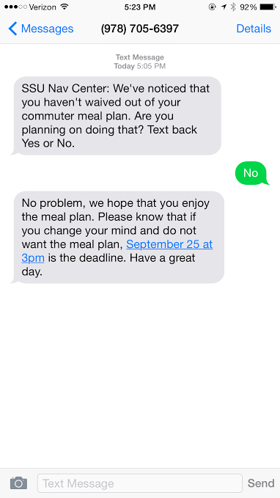

They had already contacted via email asking whether or not I was going to waive out of the meal plan on Navigator, but I completely forgot to. Now they easily know that I still want my meal plan. It allows them to keep track of the students that still have to do something important before a specific deadline and it also helps the student because they can answer the question and sometimes not even have to do anything else. They send out several texts every month or so that pertain to important bills, graduation, withdrawal dates, etc. Obviously, some students do not respond or do not look at their Salem State email in which case they will end up coming to the Student Navigation Center in person. But while there they can learn about trexting and how it works so they know that they just need to answer a simple text next time instead of spending time coming in person.

The Student Navigation Center also has feedback texting in which students can rate their experiences after leaving. The number shown in the picture above can be used by students to provide feedback. They need only to text that number the world “Feedback” and then they can rate their experience from one (poor) to ten (great). If the experience is rated low, they will text back asking how they can improve. If the experience is rated high, they will still ask the student for any other things they think they should be doing. This is a great tool that students can use voice their concerns about what they want to see change at the Student Navigation Center. The only problem is that they rarely receive responses from students. They have informed students of this feature in several different ways but it is either ignored or students just forget. If actually utilized by the students this would be an incredible help for the Student Navigation Center to see the problems students have firsthand and use these responses to improve even further.

**Morning Training**

In order to improve even further improve communication, the employees recently started having training meetings Monday-Thursday from 8:30-9:30 a.m. to discuss things that they need to learn more about, or problems employees may be having. These help grow their skills even further by learning from one another as well. While they are in training, there is one employee at the desk and one on phones, but the rest of the employees working are all student employees. If a question arises that a student employee cannot answer at the reception desk, self-service or Station 7, the student is placed in a staff follow up queue. In the follow up queue their name, ID number, the question or problem and best way to contact them is written down and when the employees are done with training they will contact them to help them with their problem as soon as possible. Although that can seem inconveniencing to some students, the Student Navigation Center is growing their skill set by not only further training their already knowledgeable staff, but the student employees are also growing and learning because their goal is to keep students out of the follow up if possible at all. By keeping students out of the follow up, they are working together and learning to solve more complex problems in order to better service their student body.

Of course there are going to be times where it is actually impossible for the student employees to answer a student’s question in which case they have to be put in the follow up queue, but they have been doing a great job of filtering out the queue as much as possible.

**Goal of the Improvements**

The goal of all of these improvements that the Student Navigation Center has made and continue to make are ultimately to better serve Salem State University students. What most of these improvements do is prevent students from coming in in person by teaching them or reminding them that they can do these things on their own without even coming to the Student Navigation Center. Every interaction with a student is a learning experience, not only for the employee but the student as well. These improvements also filter the students out that have questions that can easily be answered by student employees before even going inside or by showing them how to do it online. All of this lowers the congestion that can occur for the students that have problems that need extensive assistance and also just lower the congestion in general.

The improvements at the Student Navigation Center have undoubtedly enhanced their services to students, but there is always room for more. As time goes on they are only going to continue improving successfully.

**Future Improvement**

As explained above, the Student Navigation Center has made several changes in order to improve their services to students, however, there are still a few minor problems that they have to figure out in order to further that improvement.

**Communication Inside and Out**

There have been a lot of improvements when it comes to communication in the Student Navigation Center. Employees inside communicate using Microsoft Lync, and they text and email students to communicate with them about things they have to get done and feedback regarding their experiences. There is a problem with communication between the employees at the desk inside and the student employees at the reception desk outside. When a student walks up to the reception desk and explains their question, the student employee writes a ticket if needed and will write the main subject of the problem for those inside to see. Sometimes the reception desk employee writes a ticket that is unclear to those inside which makes it difficult to know what the student is coming in for. Sometimes the student just does not want to be specific when telling the desk employee what they are there for, in which case the employee has to try and ask several open response questions in order to get more detail. It is their job to get at least a little detail out of the student and they cannot write a vague ticket. It causes a lack of communication between the outside and the inside and it makes it more difficult for things to run smoothly. Eventually the students outside will have access to Microsoft Lync so if there is confusion regarding a ticket employees inside can send a quick message asking for more detail. That can also work when the employees outside need help answering a question for a student outside, and it can prevent students from being added into the queue to go inside. The chat between employees can lead to a lot more efficiency and optimized communication.

**Students Wanting to Go Inside**

The student employees that sit outside at the reception desk are highly trained and students that come for help sometimes do not realize that they are not just there to give them a ticket. When a student goes to the Student Navigation Center for help they have to the question will usually be simple but the student still feels the need to go inside and talk to an employee in there even though their question can be answered. The student employees cannot tell them that they are not allowed to go inside to talk to someone else, and that can be very frustrating for the reception desk employees. They have gone through a lot of training for a reason, and when a student does not take their advice and still feels the need to go inside it defeats the purpose of the hierarchy. Unfortunately this is something that the employees outside cannot control. All they can do is answer their questions to the best of their knowledge, and if a student still wants a ticket then they give the student a ticket. The expectation from this is that the student will learn from the problem they have and not have to come back for similar problems in the future.

**Student Opinions and Complaints**

Even though the Student Navigation Center has made an immense amount of improvements in a very short amount of time, students still have their complaints.

It is clear that even when the Student Navigation Center is brought up to a student that their opinions are not always the most positive. While observing at the Student Navigation Center, students sitting outside in the chairs are often noticeably frustrated and some even take it out on the reception desk workers when they do not receive the answers that they want. Often, the biggest problem students will voice is when they have to wait a long time to go inside. The Student Navigation Center wants to ensure to their student’s that they will do whatever they can do provide the best service to students that they can.

The overall response that the Student Navigation Center wants to receive is positive and the goal of these improvements is to turn the negative experiences into positive experiences. Eventually students will know that when they go to the Student Navigation Center they are going to be helped with anything they need in a timely manner.

**Wait Times**

Most of the negative responses that were given in the survey were regarding the long wait times when they are waiting to go inside. When I sat and observed the student employees at the reception desk, a lot of students would ask how long they were going to be waiting, and unfortunately there is no way for the employee to tell them that. All they can tell them is how many students are in front of them in the queue. It seems that waiting is what has students so upset, which makes sense considering how busy students are nowadays. Another question I asked in the survey asked on average how long students had to wait for Financial Aid, Bursar, Clipper Card and Registration. Financial Aid was the biggest complaint, with 29.47% of the students in the survey having to wait over 20 minutes to go inside. This is a real problem considering Financial Aid is one of the more imperative services that the Student Navigation Center provides, yet it takes the longest. This is the reasoning for my project and what I am going to try and improve using queuing theory. Using queuing theory I can create a model using different variables to roughly predict wait times in the queue for students coming to the Student Navigation Center for either Financial Aid or Student Accounts. This queuing model will give an idea to the student of how long they may have to wait before their ticket is called and based on this they will stay and wait or they will come back another time. This can reduce complaints in that a student will know how long they will be waiting instead of expecting to be able to go right in and then having to wait. Also the variables used in queuing theory can be adjusted for improvement, which can further lower the wait times and increase positive opinions from students.

**Business Specialists**

The business specialists are the hidden faces of the Student Navigation Center. They have offices in the back and receive the problems that cannot be solved by the staff in the front. However, the specialists are a very big problem due to their lack of processes. When a student comes in and has a problem that needs to be brought to the specialists, it can take weeks for them to get a response. The student will then keep coming back and asking about something that should have been resolved weeks before, and they become very frustrated. What students do not understand is that the staff in the front has no control over the specialists because they are a separate office. When evaluating their services and seeing what is wrong, they have done so much at the front end, their processes are efficient and they have made a lot of improvements to make it that way. When a student goes through the processes, they are basically brought to a complete halt when they reach the specialists and that is where the complaints circulate. It is a problem that needs to be looked at, and it is something new that I have learned while doing this project. It is up to the administrators in the back to figure out their processes, but they haven’t. If this is fixed in the future, which I think it will be, then I believe that the Student Navigation Center will be 100% efficient, the processes just need to match up. It has to be efficient on both ends or nothing will ever work. This becomes very frustrating to the front end because they are the ones that work directly with the students and their families and receive all of their complaints. People in the back do not work directly with students so no one ever thinks it’s their problem, when they are the problem. In the future this is something that needs to be analyzed and potentially solved, without doing so then processes will continue to be inefficient.

**Methodology**

The main objective of my project is to potentially find a way to improve the Student Navigation Center by using queuing theory and adjusting the variables to predict and improve wait times for Financial Aid and Student Accounts. In order to achieve my goals for this project I had to collect a lot of data to analyze and create the queuing models as well as create visual tools such as graphs and pivot tables to help understand the problem even further.

At the very beginning of this semester I began this project by looking at the data. The data that I received was in QNOMY, which is the system that the Student Navigation Center uses as their queuing system and data tracker. QNOMY can generate multiple different types of information based on what you want to look at and analyze. I received a lot data from the Student Navigation Center and had a QNOMY account created for me to gather all of the data that I needed for this project.

I started looking at the Unit Service Level Analysis which can be generated either daily, weekly, monthly or yearly and I looked at daily. It shows every service in the Student Navigation Center and gives the average service time, average waiting time, waiting time distribution and total number of students served. I used this data to look at the overall services because that was my original intention when I began this project. I created a large excel file showing daily data from the day the Student Navigation Center opened up until present day including average service times, wait times and students served for all services. But after I created this file I realized that this was too much data and did not serve my project purpose of using queuing theory because it was too broad. I decided to refine it by looking at the data and seeing what service was having the most problems. From here I saw that the money related services, Financial Aid and Student Accounts, were the services that had the longest wait times and the highest number of students in the queue (aside from the Business Specialists).

After refining what I wanted to look at I also realized I needed to find a sample set of data that was concise yet long enough to analyze the numbers. The Student Navigation Center turned “Money Matters” into Financial Aid and Student Accounts on August 7, 2015, so I started there and looked at the data up until October 16, 2015, which was the day that I began looking at the data. This allowed for enough data to analyze and to perform a queuing analysis. NOTE: The Financial Aid and Student Accounts are separate services in the queue, so when I generated the charts in QNOMY and did analyses it was all separate data. Both services were analyzed but I am only explaining data collection for Financial Aid because the collection was the same for both services. I will show the data for both services in order for it to be better understood.

**Generating the Queuing Model**

To gather data to generate a queuing model, I collected data from QNOMY using the Service Time Interval Service Level Analysis which allows me to look at specific services by one hour intervals during a specific period of time. I generated the chart based on one hour intervals for the Financial Aid service and the Student Accounts service from August 7, 2015 to October 16, 2015. The information that I extracted to excel included the hours they were open along with the average service time, average wait time and the students served/abandoned for each hour. The reason I used the total served and abandoned data is because this includes all arrivals to the Student Navigation Center, whereas the total served column just includes those that were completely served through the queue.

**Table 1. Service Time, Wait Time, Students for Financial Aid**



Service Time Interval Service Data for Financial Aid.

This table shows the Service Time Interval Service data for Financial Aid that I extracted into excel to begin the queuing analysis. In order to better visualize this data I created a line graph below that shows the number of students arriving per hour during that time period. This chart allows me to see what hours were the busiest during that time frame and what hours I am going to look at in my queuing models.

**Figure 4. Line Graph Total Students and Hours for Financial Aid**

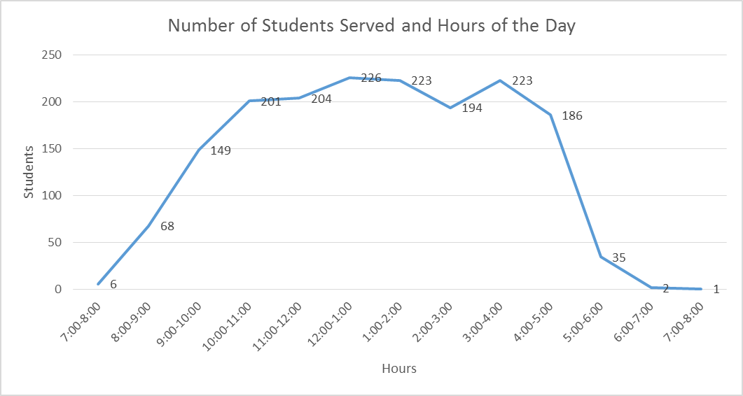

Number of students arriving per hour for Financial Aid from August 7, 2015-October 16, 2015.

The data collection for Student Accounts was the exact same as it was for Financial Aid, I used the Service Time Interval Service Level Analysis tool to generate the chart in QNOMY and then extracted that data into excel. The Student Accounts data and line graph are below.

**Table 2. Service Time, Wait Time, Students for Student Accounts**



Service Time Interval Service Data for Student Accounts.

**Figure 5. Line Graph Total Students and Hours for Student Accounts**

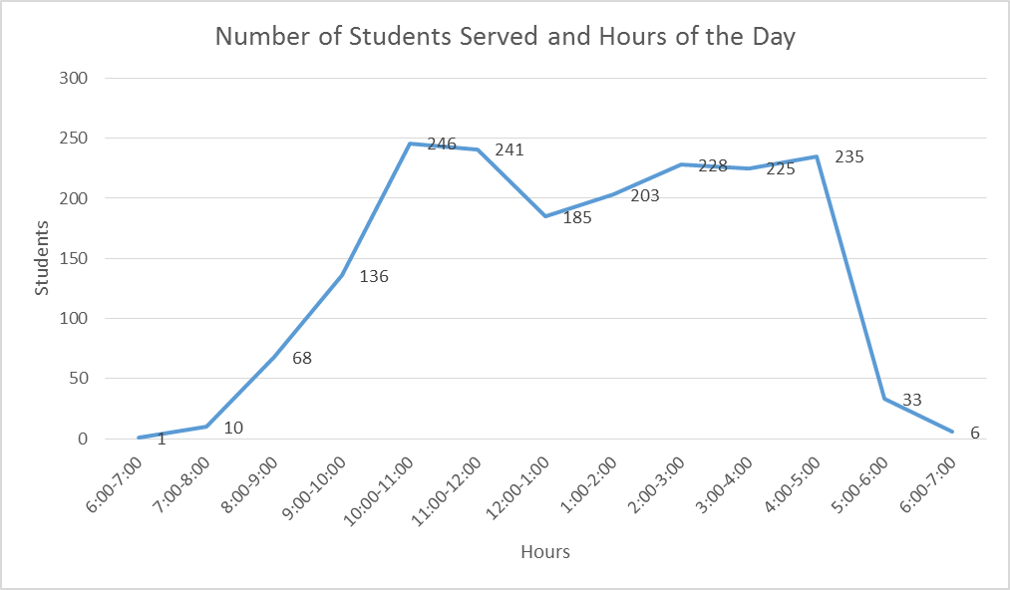

Number of students arriving per hour for Student Accounts from August 7, 2015-October 16, 2015.

Both line graphs clearly show a spike in the number of students during the peak hours.

**Arrival Rate and Service Rate**

After I extracted all of the data into excel, I then calculated the arrival rate per hour and the service rate per hour for both Financial Aid and Student Accounts. The arrival rate per hour is the number of students that arrived during open hours during the time period of August 7th to October 16th. The service rate is the number of students that the employees served per hour during that time period. These are the crucial variables along with the number of servers used in queuing theory to create the model.

In order to calculate the arrival rate per hour I divided the total number of students for that hour by the total amount of days that I used in my sample, which was 45 days. So for example, the total amount of students for hours 8:00-9:00 a.m. was 68 students, I then divided that by 45 in order to get the arrival rate for that hour.

In order to calculate the service rate per hour I took the number of minutes in an hour (60) and divided that by the service time minute and made that into a decimal based on the percentage of seconds within the hour. To further explain this, the service time from hours 7:00-8:00 a.m. was 8:11 (8 minutes and 11 seconds). I divided 11 by 60 in order to get 11% of 60. The percentage is .1833333, so the number that I divided by was 8.18 (60/8.18). The reason that I did this is because if I used 8.11, the calculation would be off due to the fact that .11 is a different percentage of 60. The number needs to be a decimal percentage of 60 because I divided into 60 to get the service rate per hour. Another example is for the hours 11:00-12:00 p.m. the service time was 9:27 (9 minutes and 27 seconds). So I divided 27 by 60 in order to get 27% of 60 which is 0.45, so the number that I divided by for that hour was 9.45 (60/9.45) in order to get the service rate for that hour. Below are the arrival rates and service rates per hour for both Financial Aid and Student Accounts that I calculated.

I also calculated the average arrival rate and the average service rate by using the average function in excel which sums up all of the rates and divides them by the number of hours in the day. For Financial Aid, the average arrival rate is 6.659477922 students per hour and the average service rate is 4.625 per hour. For Student Accounts, the average arrival rate is 7.7296166 students per hour and the average service rate is 4.962 students per hour.

**Table 3. Arrival Rate and Service Rate for Financial Aid**



Ex.) 4.311 students arrived at the SNC and 6.607 were served from the hours 2:00-3:00 p.m.

**Table 4. Arrival Rate and Service Rate for Student Accounts**



Ex.) 4.111 students arrived at the SNC and 7.782 were served from the hours 12:00-1:00 p.m.

**Pivot Tables**

After I found all of this data to put into the queuing models, I decided that I wanted to look at it in a different way. I wanted to see what days and hours were the busiest based on daily data, not just the monthly data that I gathered and the charts that I created. So in order to do this I created two pivot tables (one for Financial Aid and one for Student Accounts) in excel for the hours and the days of the week to see where the highest volume of students arriving was. The benefit of the pivot tables is that by seeing what days/hours are the busiest, a manager can see where they need to schedule more/less employees in order to reduce wait times and make processes more efficient for these two services.

I constructed these pivot tables based off of daily and hourly data that I got from QNOMY from August 7th-October 16th. In QNOMY, I found the hourly data for each day and copied it into excel. Excel has a pivot table function in which they create the table for you based off of the data that is there. The pivot tables show how many students arrived each hour of each day of the week and total them. From the charts we will again be able to see on what days and hours the most students were arriving during that time period. From here we can assume that the days and months following will be similar and this allows for more efficient scheduling and understanding of working hours. Below are the pivot tables created for Financial Aid and Student Accounts.

**Table 5. Financial Aid Pivot Table**



From this pivot table I can see that for the Financial Aid Service, Wednesdays were the busiest days with a total of 394 students arriving and the lunch hour of 12:00-1:00 p.m. was the busiest hour with 226 students arriving.

**Table 6. Student Accounts Pivot Table**



From this pivot table I can see that for the Student Accounts service, Wednesdays were again the busiest days with a total of 448 students arriving and the morning hour of 10:00-11:00 a.m. was the busiest hour with 246 students arriving.

**Graphs**

To further visualize the data for analysis I created two graphs for Financial Aid and two graphs for Student Accounts. The two graphs I created for each were the arrival rate in relation to the hour of the day and the service rate in relation to the day. I created these graphs in order to see how the rates were fluctuating throughout the day to further understand where the volume is by hour at the Student Navigation Center.

**Figure 6. Line Graph Arrival Rate per Hour for Financial Aid**

The arrival rate graph shows me at what hours the arrival rate of students is the highest or the “peak hours” similar to the number of students graph.

**Figure 7. Line Graph Service Rate per Hour for Financial Aid**

The service rate graph shows me the consistency of the service rate and that it does not fluctuate much at all throughout the day.

**Figure 8. Line Graph Arrival rate per Hour for Student Accounts**

The arrival rate graph shows me at what hours the arrival rate of students is the highest or the “peak hours”.

**Figure 9. Line Graph Service Rate per Hour for Student Accounts**

The service rate graph shows me the consistency of the service rate and that it does not fluctuate much at all throughout the day.

The arrival rate graphs are similar to the number of students served graphs I created earlier which show a pike of students during the peak hours of the day. The service rate graphs are much more constant.

Gathering all of the data, organizing it and visualizing it is a key component in successfully creating queuing models. The reason for all of this is being able to understand the data and analyze it based on what your goals are. Queuing theory is ultimately about decision making and adjusting the variables in order to see what will help and what will not. All of the tables and graphs that I created allowed me to understand my data and see what I wanted to pinpoint down to the very hour when conducting my analysis. If I did not organize and visualize my data, then I would not have known which hours to try and improve and focus on

**Application and Results**

In order to predict wait times using queuing theory, the data calculated for the arrival rate and the service rate need to be implemented in a queuing model. After gathering the data in order to create the queuing models, I then created the queuing models using a queuing template. Because I was looking at both Financial Aid and Student Accounts, I used queuing models for both services and I looked at the average rates for both services. I used the same methods for both Financial Aid and Student Accounts so I will mainly go into detail about my analysis for Financial Aid due to the fact that it is the same for both services.

The queuing template that I used is known as an M/M/s queuing model, simply put this is an infinite queuing system with multiple servers. This is exactly what the Student Navigation Center is; they have a queue that is infinite because there are always students arriving and needing help and they have multiple servers working there.

**Financial Aid Average Queuing Models**

Once the two variables (arrival rate and service rate) were calculated, I entered them into the template along with 1 server to get the results of the queuing model for Financial Aid. The first number I entered into the model is the average service rate and the average arrival rate for Financial Aid along with 1 server. The arrival rate is lambda ( the service rate is mu (, and the number of servers is s (s).

**Figure 10. Queuing Model Average 1 for Financial Aid**



This average queuing model for Financial Aid shows several variables as well as the variables that I already calculated. The queuing template generates all of the variables on the right for me based on equations that were already embedded. The numbers that I am going to look at are the utilization percentage which basically tells me how much they are actually serving the students based on the students coming in, the expected total time in the system (W) which is how long the student is in the system from when they receive a ticket to when the ticket is closed, and the expected time in the queue (Wq) which is how long the student waits from when they get a ticket to when they go inside to be served. I multiplied the numbers highlighted in orange by 60 minute to see the predicted numbers in minutes. If a student were to ask how long they are going to have to wait, then the average would be about 20 minutes, however that is extremely long and often times the wait times will be much shorter than that. This is a rough prediction but it gives them at least a ballpark time of how long they could possibly be waiting. Because the average is so long, I decided to see what I could do to lower the wait times.

In the average queuing model, there is a 69.45% utilization percentage, meaning that about 70% of the server’s time is going towards serving students, which is a decent amount. When looking at utilization I want a high percentage, but not anything that goes over 100% because if servers are working 100% of the time, then that is inefficient. This is inefficient because for someone to be 100% utilized means that they are overworking themselves. The ideal situation would be for one to be close to full utilization within human capabilities. The average time in the system is about 30 minutes, and the average time waiting to go inside is about 20 minutes. This is a very long time, so I thought to myself what can be done in order to better these wait times and make them shorter? This is where the adjusting of the variables comes in in order to improve this. If the Student Navigation Center is looking at this model, they can see what they need to do in order to lower these wait times and make their processes more efficient. The first thing I decided to do was increase the amount of servers from 1 server to 2 servers.

**Figure 11. Queuing Model Average 2 for Financial Aid**



This made the wait times go down significantly and that is really good to see, however, the utilization percentage also went all the way down to 34.73% which is not good. In this analysis there is assumed to be 1 server for Financial Aid and 1 server for Student Accounts, adding another server for both services is something that does not make sense due to the fact there are not enough employees. I decided to increase the service rate for 1 server because this allows for improving what the Student Navigation Center already has instead of hiring more people. I increased the service rate from the average of 6.5 students per hour to 9 students per hour.

**Figure 12. Queuing Model Average 3 for Financial Aid**



This also decreased the wait times significantly from 30 minutes in the system to about 14 minutes in the system and about a 7 minute wait time. This is a reasonable amount of time for a student to wait, and it makes sense that they could take about 7 more minutes once they get inside. The times are not as low as they were when adding another server, but the utilization percentage is still 51% which is much better than 34% and is still an acceptable percentage based on the other variables.

**Financial Aid Peak Hours Queuing Models**

From all of the data I collected and graphs I created I concluded that there are specific times of the day that the highest volume of students arrive at the Student Navigation Center. The peak hours of the day that I chose based on both Financial Aid and Student Accounts are 10:00 a.m.-5:00 p.m. I created queuing models for each separate hour of the peak hours based on the arrival rate per hour and the service rate per hour, as well as one server for each service. If a student asks during a specific hour how long they are going to be waiting, these models can be used to give them a time but they were also very long wait times. Using these models, the Student Navigation Center can look at the wait times of the specific hours and see what they need to do to make the hour more efficient and the wait times shorter.

For each hour from 10:00 a.m.-5:00 p.m. I used the arrival rate per hour and the service rate per hour that I calculated prior along with one server to see what the predicted wait times and utilization percentage would be. After calculating for each hour, I then looked at the longest wait times and tried to improve them. When I created the pivot table described in the Methodology section of this paper, I found that the lunch hour of 12:00-1:00 p.m. had the largest number of students that arrived at the Student Navigation Center for Financial Aid. After creating queuing models for all of the peak hours, I found that the hour of 12:00-1:00 p.m. did not have the longest wait times, but they were still very long. The two hours that were the longest (the arrival rates were the same and the service rates were very close) were hours 1:00-2:00 p.m. and 3:00-4:00 p.m.

**Figure 13. Queuing Model Financial Aid Peak Hour 12:00-1:00 p.m. (1)**



The wait times for this hour are very high at 37 minutes in the system and an almost half an hour wait time in the queue. I increased the service rate from 6.644 students to 11 students per hour to see how much that would affect the predicted wait times.

**Figure 14. Queuing Model Financial Aid Peak Hour 12:00-1:00 p.m. (2)**



It is clear that the wait times decreased significantly with about a 5 minute wait time in the queue and only 10 minutes total in the system. I then looked at the highest peak hour based off of the queuing analysis, which was 1:00-2:00 p.m.

**Figure 15. Queuing Model Financial Aid Peak Hour 1:00-2:00 p.m. (1)**



From hours 1:00-2:00 p.m. I immediately noticed that the wait times were extremely long. 41 minutes in the system is just unacceptable, but the utilization percentage was high at about 77%. From here, I again increased the service rate from 6.41 but this time I increased the service rate to 10 students per hour.

**Figure 16. Queuing Model Financial Aid Peak Hour 1:00-2:00 p.m. (2)**



The wait times decreased significantly, going from 40 and 30 minute wait times to only having to wait about 6 minutes before going inside and only being in the system for a total of 12 minutes.

I decided to look at what decreasing the arrival rate for the hour of 1:00-2:00 p.m. would do. I lowered the arrival rate from 4.956 students to 4 students per hour.

**Figure 17. Queuing Model Financial Aid Peak Hour 1:00-2:00 p.m. (3)**



It lowered the wait times a good amount, but not as much as increasing the service rate. Also, decreasing the arrival rate is something that is mostly out of the Student Navigation Center’s control. As much as they show student’s how to do things online or on their own, it does not mean they will not show up in the future. Focusing more on increasing the service rate, which is in the employee’s control would be more feasible in the long run. The hour of 3:00-4:00 p.m. had the same wait times due to the rates being so similar, from here I concluded that increasing the service rate would improve that hour as well.

**Student Accounts Average Queuing Models**

After I created all of the queueing models for Financial Aid, I did the same thing for the Student Accounts service in order to see what those hours were like in terms of waiting times. Below is the queuing model based on the average arrival rate and the average service rate for Student Accounts.

**Figure 18. Queuing Model Average 1 for Student Accounts**



I immediately noticed that the average predicted wait times were significantly lower than the wait times for Financial Aid. The total time in the system (21 minutes) was the about the same as the wait time in the queue for Financial Aid. This is because the arrival rate was about the same at 5 students per hour, but the service rate was almost at 8 students per hour, whereas the service rate for Financial Aid was closer to 6 students per hour. I increased the service rate for Student Accounts from 7.729 to 9 students per hour.

**Figure 19. Queuing Model Average 2 for Student Accounts**



The wait times decreased significantly while keeping a stable utilization percentage of 55.13% similar to the analysis for Financial Aid. From the queuing analyses for both services I concluded that in order to lower wait times, one of the best things that the Student Navigation Center can do is find ways to increase service rates for both services.

**Discussion**

Working in the Student Navigation Center has helped me learn and understand all that they have done to improve their efficiency, they have change their whole set up and process, created new stations to better help students, found several ways to communicate with students and have furthered their training. Of course there are still things that they need to improve including communication inside and outside at the reception desk, and lessening student complaints and wait times. One of the problems at the Student Navigation Center at Salem State University is the inability to tell students coming in how long they will have to wait in order to go inside and receive help. Using queuing theory, I am able to predict wait times using three variables; the arrival rate, the service rate and the number of servers. I can adjust then the variables in order to improve these wait times and overall processes.

Organizing and visualizing data is one of the most important components when using queuing theory. If you cannot see what your data is doing then you will not understand what the data is doing in a queuing model. The line graphs visualize the data to see trends over time. The line graphs that represent the number of students served and the arrival rate for both service are all based off of the hours in the day that the Student Navigation Center was open. They all show a similar trend throughout the day, and that is that it slowly builds in the morning and spikes up and the trend stays constant throughout the day then spikes back down in the evening hours. This was to be expected considering college students often do not wake up early and they come during late morning and lunch hours when they have time and do not usually go during the evening because those are the social hours of the day. The pivot tables that were created presented the data in a way that was different than all of the others because it showed not only hours, but days of the week as well. The pivot tables for each service showed which days and times had the largest amount of students arriving. In Tables 5 and 6, they show Financial Aid had the highest volume on Wednesdays from 12:00-1:00 p.m. and Student Accounts had the highest volume of students on Wednesdays as well, but from 10:00-11:00 a.m.

From the queuing models that I created for Financial Aid, I found that the wait times that were predicted based on the average arrival and services rates were very long. In Figure 10, the average wait time for Financial Aid was at about 20 minutes and the total time in the system was almost 30 minutes. I thought to myself that there is no way that if I came up to the reception desk and was told that I would have to wait 20 minutes to see someone from Financial Aid that this would be acceptable to me. I predicted the wait times but I did not find them to be good enough to use. Adjusting the variables is how queuing theory is used to optimize business decisions. Adjusting the amount of servers present for Financial Aid is one way in which the wait times could go down. In Figure 11 I added 1 server to have 2 servers for the Financial Aid service and the wait time in the queue went down to 1 minute and only 10 minutes total in the system. This was great to see and seemed obvious that this would be the solution but there were some problems with this.

First, the Student Navigation Center does not have the means to be hiring more desk employees than they already have and the utilization percentage was only at 34% which is not good. Because they cannot add more people, what they will have to do is improve what they already have. This means that the employee working is going to have to do whatever they can to improve their service rate. In Figure 12, I looked at the results of increasing the service rate to 9 students per hour instead of 6.659 students per hour for Financial Aid. This lowered the wait times significantly as well to only 7 minutes in the queue and 13 in the system along with a stable utilization percentage of 51%. I also looked at the average wait times for Student Accounts which were significantly lower than Financial Aid with only 13 minute wait times and 21 minute total in the system (Figure 17). This was surprising to me at first because they had a lot more students per hour than Financial Aid did, but I then realized that they have a higher service rate with about 1 more student per hour being served and the average arrival rates were about the same at 5 students per hour. Student Accounts served a lot more students than Financial Aid, yet had lower wait times. This tells me that it is completely possible for more students to be served per hour for Financial Aid and that is what needs to be done in order to lower the average wait times.

Based on my data visualizations I found that the peak hours of the day for Financial Aid and Student Accounts is 10:00 a.m-5:00 p.m. The separate queuing models created showed the wait times for each specific hour. The pivot tables that were mentioned before showed specific days and hours that had the most foot traffic. 12:00-1:00 p.m. for Financial Aid had 226 students arrive, with a 27 minute wait in the queue and 36 minutes total. Yet the wait times were not as long as they were for 1:00-2:00 p.m. and 3:00-4:00 p.m. which both had 223 students arrive and 31 minutes in the queue and 41 minutes total in the system. The problems that were occurring during the 1:00 p.m. hour must have consistently been longer than they were from the 12:00 p.m. hour each day during the time period. For Student Accounts, 10:00-11:00 a.m. had the most foot traffic with 246 students arriving. The volume coincided with the wait times in the queuing models with that hour being the highest with 24 minutes in the queue and 32 minutes total in the system. Student Accounts had a lot more students arrive, yet the wait times were significantly lower than Financial Aid. I concluded from this that when students go in for Financial Aid help, the questions are lot more complex, for example questions regarding a payment plan or learning about scholarships. Whereas Student Accounts questions are a lot simpler, such as a student asking about a hold on their account or learning how to pay their bill.

After conducting all of the queuing analysis in my results section mentioned above, I concluded that the Student Navigation Center can significantly reduce their wait times if the employees increase their service rate. The increase of the service rate by only 2 or 3 students per hour reduces both wait time in the queue and total time in the system without bringing down the utilization percentage too much. This can either be done by average, or based on the hours that have the longest wait times. To increase the service rates, small improvements mentioned earlier can be made such as more training for the employees or increasing the means for communication between the inside desks and the outside desks. These small improvements provide more knowledge and understanding for the employees and can increase the service rate quickly. I also thought about lowering the arrival rate, however this is something that is less in their control. They have done a lot to lower the arrival rate, but that does not mean students will not still show up whenever they feel like it. I felt that focusing on the service rate is something that is feasible and more in their control. The power of the queueing models allows for the Student Navigation Center to see where improvement is needed and focusing on it. For example, if Financial Aid wants to lower their wait times from 1:00-2:00 p.m., they can increase their service rate from 6.41 students per hour to 10 students per hour and this brings the wait time in the queue down from 31 minutes to only 5 minutes and the total time in the system from 41 minutes to only 12 minutes. Sometimes it is out of the employee’s control if the student they are serving has a complex question. Keep in mind that there are always variables to factor in that can make it very difficult to increase the service time. In the instances where there are not any, they should focus on being efficient, yet satisfying to the student in order to increase their service rate per hour. This follows the views of Darlene Burnett and Diane Oblinger (2003), who believe that interactions between the student and the employee should be warm and welcoming yet quick because the student expects their problems to be resolved in one meeting.

The size of the data sample that I used consisted of about 45 days, from August 7, 2015 to October 16, 2015. It was difficult to use a larger sample because Financial Aid and Student Accounts were combined into Money Matters on August 7th. I would have liked to use at least a three month period, but I wanted to stick to two services and I began collecting the data on October 17th due to limited time. 45 days is a decent amount of time but I believe that collecting data all the way until the end of the semester would have created slightly better results in the queuing analysis because there would have been more students to base the analysis off of and there would not have been as much need for improvement to lower the wait times. But adjusting the variables in my project shows how queuing theory works and I believe that it provided great explanation to the differences in wait times when the variables are adjusted. For further research, a larger data sample should be collected over the entirety of the fall 2015 semester, then next year during the fall 2016 semester, the same data sample should be collected and compared to this year. That way the comparison can be true to both Student Accounts and Financial Aid. Doing this comparison can aid in seeing the differences between the two years and if the wait times improved or did not. I would have like to do a last year comparison, but it would not have been true because Financial Aid and Student Accounts did not exist on their own last year. I believe that doing this comparison will truly prove how much the Student Navigation Center has improved over the course of the years that they have been open and the queuing analysis will be even better.

The results of the queuing analysis show that adjusting variables and seeing what the predictions are based on the adjustments can really help in making decisions and seeing where improvement is needed in student services. Adjusting the variables in order to improve the wait times and the utilization rate is what can be used to improve the Student Navigation Center. They can look at this queuing model and do their own calculations to account for a longer period of time and a different time of the year. Considering one of the best things they can do is increase their service rate, they can use the queuing models and pivot tables to see how many students they need to focus on seeing during specific hours of specific days. For example, registration just occurred and the time periods of registration can be generated in QNOMY and the variables can be calculated in order to see how many students they will need to see per hour to keep wait times low. It can be used for so much when it comes to process improvement. Visualization and tables further this decision making in seeing where resources can be properly allocated. The overall analysis of this project emphasizes how small changes, like serving 2 more students per hour, or increasing communication between employees or between employees and students can greatly improve overall processes of a one stop shop.

**Conclusion and Reflections**

The Student Navigation Center at Salem State University is a student centered one stop shop in which all services for students are in one place. One stop shops are often easy to implement but difficult to uphold due to problems like congestion and long lines. However, they are very important and must be fully functional and efficient to be able to give the best services to students possible. The Student Navigation had a rocky beginning, but made large improvements in order to better serve students and now are operating excellently. A problem that they have is students not knowing how long they are going to have to wait to go inside and receive help. Queuing theory solves this problem by predicting wait times and seeing where improvement is needed, and allowing for that improvement by the adjustments of three variables. There is always room for improvement, and the Student Navigation Center knows this and continues to strive for complete efficiency. Students are the main focus of the Salem State University, and all services should revolve around this focus. By using queuing theory to allocate resources and lower wait times, it will make the students a lot happier knowing that they are being heard.

Financial Aid and Student Accounts are the two most important services provided by the Student Navigation Center. They have the highest volume of students that come in and they also have the longest wait times. In order to lower these wait times, I concluded that employees can use the queuing models and the pivot tables to figure out how many students they need to see per hour to increase their overall service rate. Increasing their service rate, while still being warm and proficient towards students will keep wait times very low and improve the overall processes of the Student Navigation Center.

**Bibliography**

Bitner, M. J., Ostrom, A. L., & Burkhard, K. A. (2012). Service blueprinting: Transforming the student experience. *EDUCAUSE Review, 47*(6), 38-40, Retrieved on April 12, 2015 from ERIC.

Burnett, D. & Oblinger, D. (2003) *Innovation in student services: Planning for models blending high touch/high tech.* Ann Arbor, MI: Society for College and University Planning. Retrieved on April 17, 2015 from ERIC.

Buultjens, M., & Robinson, P. (2011). Enhancing aspects of the higher education student experience. *Journal of Higher Education Policy & Management, 33*(4), 337-346. Retrieved on April 4, 2015 from Business Source Premiere.

Draeger, J. (2008). Brad Honious gets it right with a one-stop shop. *Greentree Gazette*. 70-71. Retrieved on November 16, 2015 from Academic Search Premier.

Grebennikov, L., & Shah, M. (2013). Student voice: Using qualitative feedback from students to enhance their university experience. *Teaching in Higher Education, 18*(6), 606-618. Retrieved on April 12, 2015 from ERIC.

Jacquillat, A., & Odoni, A. R. (2015). Endogenous control of service rates in stochastic and dynamic queuing models of airport congestion. *Transportation Research Part E: Logistics and Transportation Review, 73*(0), 133-151. . Retrieved on April 4, 2015 from Business Source Premiere.

Johannes, C. L. (2012). One stop shop student services: A student perspective. (Doctoral Dissertation). Retrieved on April 17, 2015 from ERIC (ED543036).

Schulz, L., & Szekeres, J. (2008). Service provision to students: Where the gown best fits. *Journal of Higher Education Policy & Management, 30*(3), 261-271. Retrieved on April 4, 2015 from Business Source Premiere.

Supiano, B. (2011). One-Stop Shops for Student Services Aim to Eliminate Hassle. *Chronicle of Higher Education*, *58*(17), A18. Retrieved on October 12, 2015 from Academic Search Premier.

Tasie, G. O. (2010). Analytical observations of the applicability of the concept of student-as-customer in a University setting. *Educational Research and Review*, 5(6), 309-313. Retrieved on April 16, 2015 from ERIC.

Pictures/Data

SNC Process Map was provided by the Student Navigation Center.

The QNOMY Service console was screenshotted through my QNOMY account.

The data was from QNOMY and the screenshots of QT were created and analyzed by me.

**Appendix**

**Supplementary Data File A:**

The accompanying Excel spreadsheet shows the queuing theory analysis for the Financial Aid Service. The first sheet (Financial Aid) shows the data calculations and analysis in order to form the queuing models. The average queuing model peak hours sheet is active sheet which can be used to adjust the variables. The following sheets show the queuing models for each peak hour of the day using the arrival rate and service found for those specific hours.

**Filename:**

Queuing Theory Financial Aid.xls

**Supplementary Data File B:**

The accompanying Excel spreadsheet shows the queuing theory analysis for the Student Accounts Service. The first sheet (Student Accounts) shows the data calculations and analysis in order to form the queuing models. The average queuing model peak hours sheet is active sheet which can be used to adjust the variables. The following sheets show the queuing models for each peak hour of the day using the arrival rate and service found for those specific hours.

**Filename:**

Queuing Theory Student Accounts.xls