THE EFFECT OF INSTAGRAM ON SELF-ESTEEM AND LIFE SATISFACTION

Honors Thesis

Presented in Partial Fulfillment of the Requirements
For the Degree of Bachelor of Science in Psychology

In the College of Arts and Sciences
At Salem State University

By
Nicole Dion

Dr. Joanna Gonsalves
Faculty Advisor
Department of Psychology

***
The Honors Program
Salem State University
2015

Abstract
This quasi experiment examined the effects of Instagram, a social media site that consists of posting pictures, on self-esteem and life satisfaction. Specifically, I looked at the effects of following celebrities on Instagram in relation to the ideas of social comparison theory. Traditionally-aged college females (N = 51) were assigned to either the control group where they were asked to use Instagram as they normally would, or the experimental group where they were asked to follow 15 specific celebrities for 4-6 weeks. Participants were given a pretest and posttest which included a self-esteem and a life satisfaction survey. There were no statistically significant differences found between the experimental group and the control group, nor between the pretest and posttest scores, and there was no interaction effect between time of measure and experimental group. However, a subgroup of participants that initially followed a minimal amount of celebrities before the experiment showed a decline in their life satisfaction at posttest which approached statistical significance. Further experimental research is needed to confirm that altering one’s social comparison group on Instagram can lower life satisfaction among traditionally-aged college females.
Keywords: Instagram, life satisfaction, self-esteem, Social Comparison Theory, social media

The Effect of Instagram on Self-Esteem and Life Satisfaction
With the expansion of technology and the internet, social media websites have become more and more popular. Among the most popular, Facebook, Twitter and Instagram seem to be social media platforms that many people use frequently in their everyday lives. It is questioned whether social media has any negative effects on the individuals who use them often. For those who are constant tweeters, Facebookers and/or Instagrammers, another question for research is whether this has any effect on their self-concept or self-report. Does it make them feel better or worse about themselves, or does it have a neutral effect on users? Many studies and experiments have been done on the various factors that affect self-report, but there has not been a wide array of studies on social media’s effect on self-report in particular.
Now that social media has developed into a more accessible online platform and has become more prominent in many people’s everyday lives, studying the effect it has on individuals is an important aspect to explore. Recent studies have shown that social media use is a good predictor of body dissatisfaction, eating disorder symptoms, and life satisfaction in adolescent girls (Ferguson, Muñoz, Garza, & Galindo, 2014). Other studies have shown that increased feelings of envy are significantly related to decreased feelings of life satisfaction and self-esteem for women who use online blogs and social media (Cretti, 2015). Many studies have also shown that social media use causes individuals to create negative social comparisons with the people that they follow or are friends with on social media websites, which leads to negative effects on self-report (Vogel, Rose, Okdie, Eckles, & Franz, 2015); (de Vries & Kühne, 2015); (Vogel, Rose, Roberts, & Eckles, 2014).
Social comparison theory is a psychological theory originally coined by Leon Festinger in 1954. This theory focusses on the belief that individuals have a drive to gain accurate self-evaluations. The social comparison theory explains how individuals compare themselves to others to evaluate their own opinions and abilities in order to reduce any uncertainty in these areas and to learn how to define the self. Social comparison can be a way of self-enhancement by downward social comparisons, by means of looking to another individual or group that they consider to be worse off than them in order to feel better about themselves. It can also have a negative impact on an individual’s self-report by means of upward comparisons, when comparing themselves with others who are better off or superior. Such negative social comparisons are detrimental to the perceptions about the self.
There have been a small handful of studies testing social media’s effect on self-report through social comparison. A recent study examined the indirect relationship between Facebook use and self-perceptions through negative social comparison and whether that relationship differs depending on whether the individual was initially a happy or unhappy person (de Vries & Kühne, 2015). The survey given to 231 participants, ages 18-25 years of age, showed that Facebook use related to a greater degree of negative social comparison, which related to negative self-perceived social competence and physical attractiveness. The researchers found that social networking site use was negatively related to self-perception through negative social comparison, especially among unhappy people.
Experimental studies have also suggested a cause and effect relationship between social media use and social comparisons. In one experiment, researchers verified 120 female undergraduate students’ social comparison orientation (SCO) to determine whether they pay a lot of attention to themselves compared with others or not (Vogel et al, 2015). Participants were then either asked to browse a Facebook profile of either an acquaintance in same age and gender, their own profile, or an activity not engaging in social comparison. Results showed that participants high in SCO had poorer self-perceptions, lower self-esteem, and more negative effect balance than their low SCO counterparts after engaging in the brief social comparison on Facebook.
Another experimental study examined social comparison and self-esteem with social media. Participants were 128 undergraduates, 94 females and 34 males, who were asked to view a social media profile created by the researchers that allegedly belonged to another student of the same sex at their university (Vogel et al, 2014). This was a 2x2 study: user content (upward comparison-healthy or downward comparison-unhealthy) by social network content (upward-active or downward-inactive). User content included posts related to fitness, well-being, attractiveness, and vitality. These factors were chosen because health, appearance, and fitness were deemed to be important for college students. The use related to the high or low number of “likes” and comments attached to the photograph that the user posted. Results showed that people had lower self-esteem after exposure to those with a higher user activity but user content was not significant.
As noted, more studies have been conducted with specific social platforms, predominantly Facebook, and have shown significant effects on self-report and social comparisons. However, other social media apps such as Instagram have been scarcely studied. Instagram differs as a social media tool unlike other platforms. Dissimilar to other social networking sites like Facebook or Twitter, Instagram is solely for posting pictures (and short video clips). People post pictures for their followers to view, “like” and comment on. Instagram helped begin the selfie-revolution, where users take pictures of themselves using the front-facing camera. Instagram has filters and photo editing tools to edit your pictures before you post them. Some people post fancy photographic pictures of scenery, pictures of food, etc., but many people use this social platform to upload pictures of themselves.
Unlike Facebook where most people mostly follow friends and family, Instagram allows you to follow celebrities and other famous people to see what they post about their day-to-day lives, whether it is selfies at their modeling photo-shoot, or pictures of their luxurious vacations in foreign beautiful countries. With Facebook, your social comparison group is mainly your friends and family. You compare yourself to others who are most likely similar to you in many ways. With Instagram, your social comparison group can become celebrities that have a lot more money and many more significant attributes valued by society than most who follow them. For those individuals who use Instagram often, they see what these celebrities post every day. If celebrities become their social comparison group, it is possible that this could have an even more negative effect on an individual’s self-report.
Instagram is a newer social media platform that blossomed more recently, having been created in 2010, which is why very few studies exist with Instagram. One of the very few studies done on this social network site, titled Instagram #Instasad?: Exploring Associations Among Instagram Use, Depressive Symptoms, Negative Social Comparison, and Strangers Followed, explored the associations among Instagram use and depressive symptoms through the mechanisms of negative social comparison, and moderation by amount of strangers one followed (Lup, 2015). This study consisted of 117 participants between the ages of 18-29 years old. They completed online questionnaires containing demographics, frequency of Instagram use, amount of strangers followed on Instagram, the Center for Epidemiological Resources Scale for Depression, and the Social Comparison Rating Scale. Results showed that Instagram use was marginally positively associated with depressive symptoms, and positive social comparison was significantly associated with depressive symptoms. The amount of strangers followed moderated the association of Instagram use with social comparison. These results determined that more frequent Instagram use has negative associations for people who follow more strangers, but a positive association with people who follow fewer strangers, in relation with social comparison and depressive symptoms.
As the above study demonstrates, the amount of strangers an individual follows correlates with negative social comparisons. What we don’t know is who the strangers are that these individuals are following. It could be other people in their age group that they do not necessarily know personally, or it could be celebrities or other famous people. Following strangers changes their social comparison group, whether they are users who are similar to them in demographics, social class, etc., or are famous people that have a lot more money and much more social status than them. This could have an effect on other factors such as their self-esteem or life satisfaction. Following strangers such as celebrities and models may cause the individuals to have a lower self-esteem and feel dissatisfied with their life by seeing the pictures celebrities post day-to-day about their lavish lifestyles, “perfect” bodies, and pretty faces. Studies done to test the exposure of images of models to girls have found that participants who viewed pictures of models reported a significantly lower body satisfaction and self-esteem report than those in the control group who were not exposed to any models (Clay, 2005).
When females are exposed to models for a short duration, it has an effect on their body satisfaction and self-esteem. What if females are exposed to other female celebrities and models on an every-day basis by following them on a social media platform such as Instagram, for an even longer period of time? These models and celebrities become their social comparison group by seeing their pictures of their beauty and their lavish lifestyles every single day. Could this repeated exposure effect their self-esteem or life satisfaction?
The purpose of this proposed study is to test the effects of Instagram on self-esteem and life satisfaction by means of exposure to celebrities and famous people on the social media app. The current study is an experiment to test the hypothesis that Instagram use has a negative effect on self-esteem and life satisfaction.
Method
Design
This quasi experiment utilized a (2 x 2 x 2) mixed factorial design. The between groups variables were experimental group (following celebrities) vs. control group (not following celebrities). There were two within group variables. The first within group variable was self-esteem which was measured at two different points by means of a pretest and a posttest. The second within group variable was life satisfaction which was also measured at two different times by means of a pretest and a posttest.
Participants
A total of 51 female participants, ages 18-25, participated in this study. Participants were chosen from the undergraduate psychology research pool from a university on the North Shore of Massachusetts, some of whom received extra credit for participating. Another method of recruiting was by means of convenience sampling by posting promotions on Facebook and Instagram to friends and family. The selection criteria were age (must be a traditional-aged college student between the age of 18-25), sex (must be female), Instagram use (must use Instagram at least once a day), and must not follow more than 15 celebrities on Instagram. Other demographics such as participants’ race or ethnicity were not collected.
Materials
Participants were first given a disclosure statement (see Appendix A). Participants were then given an online survey to take which included basic questions about their Instagram usage. It also included measures of self-esteem (see Appendix B) and life satisfaction (see Appendix C).
Self Esteem. The self-esteem survey was adapted from the Rosenberg Self Esteem Scale- Revised Positive Version which has strong internal consistency reliability (Greenberger, 2003). The response scale was altered to have a range of 1-7 with ‘1’ = Strongly Disagree to ‘7’ = Strongly Agree. Such statements that respondents were asked to rate included “On the whole, I am satisfied with myself,” “I feel that I have a number of good qualities,” “I take a positive attitude towards myself,” etc. The sum of respondents’ scores were computed. The highest possible score was a 70 and the lowest possible score was a 10. Higher scores indicated higher self-esteem and lower scores indicated lower self-esteem.
Life Satisfaction. The life satisfaction survey was adapted from the Revised Work and Nonwork Life Satisfaction Scales which had strong internal consistency reliability (Grawitch, 2013). The response scale was 7-point scale ranging from ‘1’ = Strongly Disagree to ‘7’ = Strongly Agree. The “work life satisfaction” statements were not used in the present study. The “non-work life satisfaction” statements were used, but altered to make sense in the context of the experiment. It was a minor change, and the phrase “non-work” was taken out from each statement, as it would be redundant if kept. Such statements included “The conditions of my life are excellent,” “I am satisfied with my life,” “If I could live my life over, I would change almost nothing,” etc. The sum of the respondents’ scores were computed. The highest possible score was a 50 and the lowest possible score was a 5. Higher scores indicated higher life satisfaction and lower scores indicated lower life satisfaction.
Exploratory Qualitative Sub-study. In the posttest, participants were given the opportunity to provide participation in optional comments about the study based on their experiences with the study and with following these celebrities.
Procedure
This experiment received IRB approval. Participants were provided a disclosure statement before they began the experiment.
Potential participants were asked to take part in a study about the social media platform, Instagram. When promotions and notifications were given out about taking part in the experiment, individuals had two weeks from that date to complete the pretest survey. Individuals first took an online survey administered by Survey Monkey which asked questions about their general Instagram use such as how many celebrities they followed and how often they use the app. Participants then filled out both the self-esteem survey and the life satisfaction survey. There was a six-week interval between pretest and the administration of the posttest, in which participants were given one week to complete the posttest.
Once the initial two-week deadline was up and participants’ data was collected for the pretest, participants were assigned to one of two conditions: the control group or the experimental group. Participants were assigned to groups based on whether or not they allowed the experimenter to follow them on Instagram, a question that was asked in the pretest. Participants who said yes were assigned to the experimental group. Participants who said no were assigned to the control group. Since there were more participants who said yes than no, some of them were assigned to the control group to make the groups equal in number.
In the control group, participants were asked to continue their Instagram usage as normal. In the experimental group, participants were asked to follow a list of 15 celebrities. To avoid any overlap of having participants follow celebrities that they may already be following, famous common celebrities could not be chosen. Celebrity Instagram users that were chosen by the experimenter were females considered to be “Instagram famous” and had thousands of followers, many of them being models, some actresses, and other famous women in the media. Female users were also chosen based on the amount of followers they had, how often they posted pictures on the site (the more they posted, the stronger the manipulation effect), and the type of photos they posted. The targeted types of photos they posted were mostly flashy pictures, showing beauty, wealth, and luxury. The 15 specific celebrity Instagram users that they were asked to follow can be found in Appendix D.
Participants in the experimental group were asked to follow these celebrities for six weeks. Once the six-week period was up, the posttest was administered to participants in both the experimental group and the control group which consisted of the same self-esteem and life satisfaction surveys, as well as an opportunity to provide participation in optional comments about the study including how these celebrities’ pictures made them feel. A manipulation check was also provided on the posttest by asking participants how long they followed the celebrities on Instagram, to make sure they were followed for the duration of the study.

Results
Self-Esteem
A 2 x 2 mixed ANOVA for self-esteem with group (experimental or control) as a between groups factor and time of measurement as a within groups factor was performed. Upon examination, it was found that the hypothesis that Instagram has an effect on self-esteem was not supported. No statistically significant differences were found between the experimental group and the control group, nor between the pretest and posttest scores. Furthermore, there was no interaction effect between time of measure and groups. The means and standard deviations for the pretest and posttest scores for self-esteem in the control group and the experimental group are presented in Table 1.
As can be seen in Figure 1, the groups were initially not equal during the pretest for self-esteem scores. There were initially outliers in the data set, therefore two participants’ data were removed from the set. Any outliers that were removed were those that were two standard deviations above or below the mean. There was still no main effect or interaction effect after the outliers were removed. In Figure 1 it is demonstrated that the control group (M = 59.20, SD = 5.46) and the experimental group (M = 56.20, SD = 8.44) initially had different means, and they both decreased around the same amount during the manipulation period.
Life Satisfaction
A 2 x 2 mixed ANOVA for life satisfaction with group (experimental or control) as a between groups factor and time of measurement as a within groups factor was performed. Upon examination, it was found that the hypothesis that Instagram has an effect on life satisfaction was not supported. No statistically significant differences were found between the experimental group and the control group, nor between the pretest and posttest scores. Furthermore, there was no interaction effect between time of measure and groups. The means and standard deviations for the pretest and posttest scores for life satisfaction in the control group and the experimental group are presented in Table 2.
As can be seen in Figure 2, the groups were initially somewhat equal during the pretest for life satisfaction scores. The control group (M = 24.69, SD = 4.86) and the experimental group (M =23.68, SD = 5.77) initially had similar means. It also demonstrates that life satisfaction increased in the control group and decreased in the experimental group but there was no statistically significant difference.
Follow-up Analysis
Since there was an interesting decrease in life satisfaction in the experimental group and an increase in the control group (see figures), the data was examined closer. The same analysis as above was performed for participants that followed the minimal amount of celebrities (those who follow only 0-4 celebrities as established in the pretest). Interaction between group and time of measurement approached significance F(1,21) = 3.67, p = .069. The means and standard deviations are presented in Table 3. Figure 3 also depicts these results that life satisfaction increased in those from the control group from the pretest (M = 24.62, SD = 4.56) to the posttest (M = 26.85, SD = 4.32) but life satisfaction decreased in those from the experimental group from the pretest (M = 22.30, SD = 6.38) to the posttest (M = 20.00, SD = 6.91).
Qualitative Responses
In the posttest participants were given the option to make any comments on the study. Twenty-four participants from the experimental group commented on their experiences with the study and with following these celebrities. There were three categories of responses, either positive feelings about the study, negative feelings towards themselves, or negative attitudes about the celebrities or study in general.
The majority of the responses were negative feelings about themselves which included statements such as:
“They just showed off their money and what they had and how they looked. Made me feel bad about myself and how I didn't have that kind of money or look like that.”
“Being a female and being asked to follow multiple, beautiful female starlets did not make me feel very good about myself. Constantly seeing their, probably photo shopped but nonetheless beautiful photos, didn't really inspire me to want to be like them but rather just made me feel bad about the way that I look. Their photos seemed effortlessly gorgeous.”
“The pictures that the celebrities posted made me wish I had their bodies, and lives...”
“Some made me feel bad about myself because they were skinny people in little clothes.”
Many comments were also negative feelings about the celebrities’ posts and the study in general such as:
“I got really annoyed with this study. I went on Instagram to see what my friends had posted and all I kept getting were these celebrities. Their posts were very repetitive and kind of pointless. I'm annoyed that these people have so many followers and such a presence when all they do is edit and take way too much time to create a photo.”
“I was annoyed with the amount of photos they posted. It looks like they live such unrealistic lives.”
Surprisingly, there were participants who enjoyed following the celebrities and made comments such as:
“They motivated me to get active and dress nicely.”
“I felt empowered by some of the Instagram posts from the celebrities because of their confident posts.”
Discussion
Previous research on social media has shown that exposure to other people’s lives through the internet appears to have an effect on various factors. Many of these studies have suggested that social media use can cause individuals to create negative social comparisons, as suggested by Festinger’s social comparison theory, depending on who they follow or are friends with on such social media websites. This in turn causes negative effects on their self-report such as self-esteem and life satisfaction. The present study, however, did not support the hypothesis that Instagram has an effect on self-esteem and did not support the social comparison theory in relation to effects on self-esteem because both group’s scores went down by roughly the same amount.
Although there was no significance overall in self-esteem and life satisfaction, it approached significance with life satisfaction regarding only those participants who initially followed a minimal amount of celebrities before the study. For those whose social comparison group on Instagram were primarily just friends and family, it was clear that having celebrities become their social comparison group did have somewhat of an effect on their life satisfaction, as it decreased from the pretest to the posttest. This information is consistent with tenets of the social comparison theory, further implying that comparing yourself to a wealthier social group such as celebrities may be related a lower life satisfaction. By initially having their social comparison group just being their friends and family, those who are similar to them, having them change their social comparison group to those who are better off can affect their life satisfaction.
Not only were the quantitative results interesting, but the qualitative results were even more interesting. Although significant interaction results were not reflected in the quantitative conclusions, the qualitative findings, which were comments given by twenty-four participants from the experimental group, suggested that this study had an impact on many of the participants in the experimental group, whether positively or negatively. Implications from these results suggest that changing one’s social comparison group from friends and family to celebrities may not exactly alter their self-esteem or life satisfaction, but it does cause various feelings to arise.
Limitations
There may have been limitations in this study that could have affected the outcome. In this study, internal validity may have been jeopardized. There were a total of 10 participants who did not get factored into the initial assignment to groups at the beginning, so they were automatically put into the control group which didn’t allow everyone an equal chance of being in either group. Many participants were also chosen to be in the experimental group if they agreed to allow the experimenter to follow them on Instagram (as a manipulation check that was based on self-report only), which also did not give everyone an equal chance to be put in either group. Because of this, the internal validity was jeopardized by the type of assignment.
The study’s construct validity in regards to the dependent variables, self-esteem and life satisfaction may have also been jeopardized. Although the surveys used to measure the variables had strong internal consistency reliability, the life satisfaction survey was minimally adapted so this minor change may have changed its reliability. External validity may have also been weak since the participants weren’t pooled from random samples; they were selected through convenience sampling, which may have limited the types of people that ended up in the study.
Other factors that may have affected the results of the study are the specific celebrities that the experimental group were asked to follow. There may have been too many celebrities or the celebrities may have posted too often that the participants got annoyed and refrained from viewing their posts. A confounding variable is whether the participants actually looked at the celebrities posts on Instagram or if they just scrolled past them in their newsfeed and were unaffected by their pictures, which would also affect the construct validity
Future Research
Future studies should continue to be conducted on this topic, especially focusing more on Instagram than Facebook as it has become a widely used social media app among the various younger generations. More research should be conducted on the effect of following celebrities on Instagram, using participants who follow little to no celebrities to show a better causal relationship, as this present study included participants who followed up to 15 celebrities which may mean that they were already previously affected. It would be predicted that those individuals who only had friends and family as their initial social comparison group on Instagram would be more affected because their whole social comparison group would change drastically to those who are rich, famous, and better off than them.
If this study is duplicated, it would be beneficial to have a panel to choose the people/celebrities to be followed by the participants, as this would increase the validity of the choices. Other factors to explore might be body dissatisfaction instead of self-esteem, when focusing on having participants follow celebrities that not only post pictures of their luxurious lifestyle, but also pictures that depict beauty in females. It would also be interesting and worthwhile to see if the participants’ positive or negative comments from the exploratory qualitative sub-study have any relationship with the quantitative results on self-esteem or life satisfaction.

References
Clay, D. H. (2005). Body Image and Self-Esteem Among Adolescent Girls: Testing the Influence of Sociocultural Factors. Journal Of Research On Adolescence (Wiley- Blackwell), 15(4), 451-477.
Cretti, C. (2015). The relationship between envy, life-satisfaction, and self-esteem for female readers of women's online personal lifestyle blogs. Dissertation Abstracts International, 76.
de Vries, D. A., & Kühne, R. (2015). Facebook and self-perception: Individual susceptibility to negative social comparison on facebook. Personality And Individual Differences, 86217- 221. doi:10.1016/j.paid.2015.05.029
Ferguson, C. J., Muñoz, M. E., Garza, A., & Galindo, M. (2014). Concurrent and prospective analyses of peer, television and social media influences on body dissatisfaction, eating disorder symptoms and life satisfaction in adolescent girls. Journal Of Youth And Adolescence, 43(1), 1-14. doi:10.1007/s10964-012-9898-9
Festinger, L. (1954). A theory of social comparison processes. Human Relations, 7117-140. doi:10.1177/001872675400700202
Grawitch, M. J., Maloney, P. W., Barber, L. K., & Mooshegian, S. E. (2013). Revised Work and Nonwork Life Satisfaction Scales. Psyctests, doi:10.1037/t23875-000
Greenberger, E., Chen, C., Dmitrieva, J., & Farruggia, S. P. (2003). Rosenberg Self-Esteem Scale--Revised-Positive Version. Psyctests, doi:10.1037/t12471-000
Lup, K. L. (2015). Instagram #Instasad?: Exploring Associations Among Instagram Use, Depressive Symptoms, Negative Social Comparison, and Strangers Followed. Cyberpsychology, Behavior & Social Networking,18(5), 247-252.
Valenzuela, S., Park, N., & Kee, K. F. (2009). Is there social capital in a social network site?: Facebook use and college students' life satisfaction, trust, and participation. Journal Of Computer-Mediated Communication,14(4), 875-901. doi:10.1111/j.1083- 6101.2009.01474.x
Vogel, E. A., Rose, J. P., Okdie, B. M., Eckles, K., & Franz, B. (2015). Who compares and despairs? The effect of social comparison orientation on social media use and its outcomes. Personality And Individual Differences,86249-256. doi:10.1016/j.paid.2015.06.026
Vogel, E. A., Rose, J. P., Roberts, L. R., & Eckles, K. (2014). Social comparison, social media, and self-esteem. Psychology Of Popular Media Culture, 3(4), 206-222. doi:10.1037/ppm0000047

Table 1
Pretest and Posttest Scores for Self-Esteem
Group | Pretest  M(SD) | Posttest  M(SD) | N
Experimental | 56.20(8.44) | 55.60(11.06) | 25
Control | 59.20(5.46) | 59.00(6.22) | 26

Note: Self-esteem scores could range from 7 (very low self-esteem)
to 70 (very high self-esteem).

Table 2
Pretest and Posttest Scores for Life Satisfaction
Group | Pretest  M(SD) | Posttest  M(SD) | N
Experimental | 23.68(5.77) | 23.12(7.51) | 25
Control | 24.69(4.86) | 26.31(5.45) | 26

Note: Life satisfaction scores could range from 5 (very low life satisfaction)
to 35 (very high life satisfaction).

Table 3
Follow-up Analysis: Pretest and Posttest Scores for Life Satisfaction
Group | Pretest  M(SD) | Posttest  M(SD) | N
Experimental | 22.30(6.38) | 20.00(6.91) | 10
Control | 24.62(4.56) | 26.85(4.32) | 13

Note: Life satisfaction scores could range from 5 (very low life satisfaction)
to 35 (very high life satisfaction).

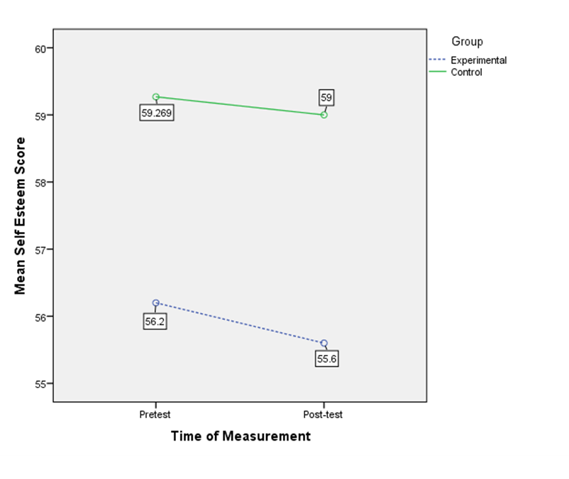
Figure 1. Pretest and Posttest Mean Scores for Self-Esteem

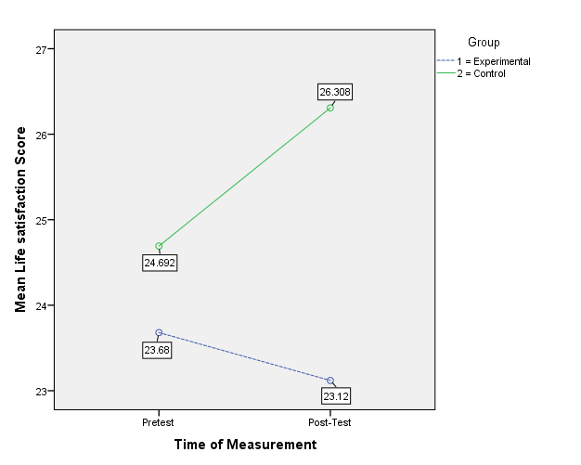
Figure 2. Pretest and Posttest Mean Scores for Life Satisfaction

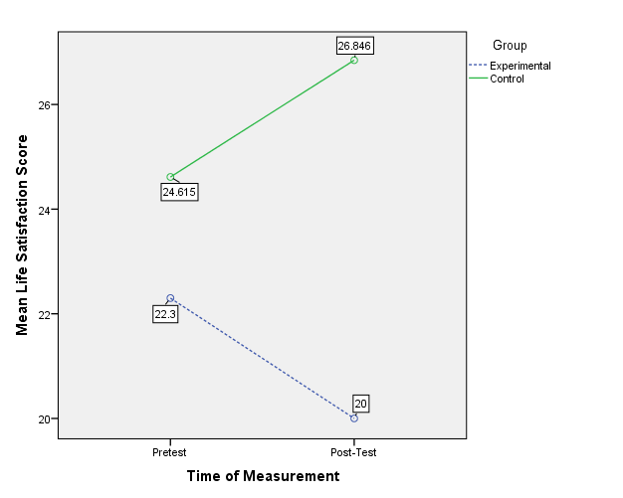
Figure 3. Follow-up Analysis: Pretest and Posttest Mean Scores for Life Satisfaction

APPENDIX A

Salem State University
Disclosure Statement
This self-esteem survey and life satisfaction survey are for my honors thesis project that I am doing for a course at school. To participate in this study, you must be a female and over 18 years of age.
Participation is completely voluntary. You may discontinue participating at any point without penalty. However, I must be notified in the case that you decide to discontinue participating so I may discard your results from the study. You will be asked to complete these surveys at the beginning and end of the study which will last 4-6 weeks. There are no right or wrong answers to the surveys. They are all your own personal answers. Your name is required on the surveys so that I can record your pretest and posttest information. If you do not wish to share your identity, you may use your initials or a username of your choice, as long as you write the same information on the beginning and ending surveys. Your name and information will be kept confidential and will be kept safe in the privacy of the experimenter’s residence. Your personal information will be destroyed once the project is over. You may also be asked to allow the experimenter to follow you on Instagram to ensure that directions are being followed for the study.
The risks of this study are minimal. Responses to the surveys will be kept confidential, and you may stop responding at any time. You may also discontinue participating in the experiment if for any reason you feel uncomfortable, but I must be notified. Please understand that this study is confidential, that your name or identity will not be used in reports or presentations using the study’s findings. All of the information collected will be confidential with the exception that must be reported under Massachusetts law, including cases of child or elder abuse.
If you have any questions or concerns regarding this study, please contact my sponsor Joanna Gonsalves at jgonsalves@salemstate.edu or (978)-542-6247.
This research study has been approved by the Institutional Review Board at Salem State University. Thank you for your participation.

For concerns about your treatment as a research participant, please contact:
Institutional Review Board (IRB) Sponsored Programs and Research Administration Salem State University
352 Lafayette Street, Salem, MA 01970
(978) 542-7556 or (978) 542-7177 or irb@salemstate.edu
A copy of this signed form is as good as the original.
This research project has been reviewed by the Institutional Review Board at Salem State University in accordance with US Department of Health and Human Services Office of Human Research Protections 45 CFR part 46 and does not constitute approval by the host institution.

APPPENDIX B

Self-Esteem Survey
Directions: Answer each item on a scale of 1-7 using this scale
1 = Strongly Disagree
2 = Disagree
3 = Slightly disagree
4 = Neither agree nor disagree
5 = Slightly agree
6 = Agree
7 = Strongly agree

- On the whole, I am satisfied with myself. ______
- At times I think I am pretty darn good. ______
- I feel that I have a number of good qualities. ______
- I am able to do things as well as most other people. ______
- I feel I do have much to be proud of. ______
- I really feel useful at times. _______
- I feel that I’m a person if worth, or at least on an equal plane with others. ______
- I think I have enough respect for myself. ______
- All in all, I am inclined to feel that I am not a failure. ______
- I take a positive attitude toward myself. ______
Taken and revised from:
Greenberger, E., Chen, C., Dmitrieva, J., & Farruggia, S. P. (2003). Rosenberg Self-Esteem Scale-- Revised-Positive Version. Psyctests, doi:10.1037/t12471-000
APPENDIX C

Life Satisfaction Survey
Directions: Answer each item on a scale of 1-7 using this scale
1 = Strongly Disagree
2 = Disagree
3 = Slightly disagree
4 = Neither agree nor disagree
5 = Slightly agree
6 = Agree
7 = Strongly agree

- In most ways my life is close to my ideal. ______
- The conditions of my life are excellent. ______
- I am satisfied with my life. ______
- So far I have gotten the important things I want in life. ______
- If I could live my life over, I would change almost nothing. ______

Taken and revised from:
Grawitch, M. J., Maloney, P. W., Barber, L. K., & Mooshegian, S. E. (2013). Revised Work and Nonwork Life Satisfaction Scales. Psyctests, doi:10.1037/t23875-000

APPENDIX D

- @bellahadid (Bella Hadid)
- @chiaraferragni (Chiara Ferragni)
- @Garypeppergirl (Nicole Warne)
- @rumineely (Rumi Neely)
- @juliahengel (Julia Engel)
- @tuulavintage (Jessica Stein)
- @peaceloveshea (Shea Marie)
- @songdani (Dani Song)
- @shaym (Shay Mitchell)
- @thassianaves (Thassia Naves)
- @iamerica_mena (Erica Mena)
- @alexisren (Alexis Ren)
- @yoventura (Yovanna Ventura)
- @sophiamiacova
- @Katyaelisehenry

