THE EFFECT OF FOAM ROLLING ON
PULSE WAVE VELOCITY

Honors Thesis

Presented in Partial Fulfillment of the Requirements

For the Degree of Bachelor of Science in Sport and Movement Science
In the College of Arts and Sciences
at Salem State University

By

Melissa Molloy

Anthony D’Amico
Faculty Advisor
Department of Sport and Movement Science

***

Commonwealth Honors Program
Salem State University
2018

ABSTRACT

INTRODUCTION: This thesis is part of a larger study on the effect of foam rolling on several variables. This thesis specifically discusses the effect of foam rolling on pulse wave velocity. Foam rolling is becoming an increasingly popular form of self-myofascial release, which may have an effect on autonomic function. Pulse wave velocity is a measure of arterial stiffness, which can indicate the possibility of a cardiovascular event to occur. Arterial stiffness is affected by autonomic function. Foam rolling may be able to affect arterial stiffness via the autonomic nervous system. The purpose of this study is to determine if foam rolling has an effect on pulse wave velocity, a measure of arterial stiffness. METHODS: There were 40 participants, both male and female, randomly placed in either the foam rolling condition (FR) or control condition (CON). Pulse wave velocity was measured in both conditions once each day for eight days. Those in the foam rolling condition foam rolled the quadriceps, hamstrings, gastrocnemius, medial thigh, iliotibial band, and gluteus each for 60 seconds per leg every day after pulse wave velocity measures were taken. A two-tailed Mann Whitney U test was used to compare the change from the baseline area under the curve between FR and CON. RESULTS: The results concluded that there was no significant difference in pulse wave velocity measures between the foam rolling and control conditions (p > 0.05). DISCUSSION: This research suggests that foam rolling does not influence pulse wave velocity 24 hours after a bout of foam rolling. Further research is necessary to determine the amount of time necessary to see an effect on pulse wave velocity.

TABLE OF CONTENTS

Abstract i
Introduction 1
Methods 8
Results 10
Discussion 11
References 15

PULSE-WAVE VELOCITY AND FOAM ROLLING
INTRODUCTION
This thesis is part of a larger experiment that tested foam rolling’s effect on exercise-induced muscle damage. Many measurements were taken in this study, but this focus is primarily on the pulse-wave velocity measurement and how it is or is not affected by foam rolling after exercise.
Pulse wave velocity is a measure of the speed at which the arterial pulse wave travels. It is a non-invasive measure of arterial stiffness, which is important in identifying cardiovascular health. The stiffer the arteries are, the more likely that a cardiovascular event could occur due to the lack of the arteries’ ability to expand when necessary.¹ When the heart contracts during systole, blood is forced out of the left ventricle into the body, which creates pressure waves throughout the arteries in the body. When the pressure of this arterial pulse wave is low, the arteries are more elastic. Elastic arteries are able to have large oscillations, which means the artery and able to greatly expand and contract to push blood through the body. Consequently, this lessens the pressure of the heart to push blood through the body, as the elasticity of the arteries help in doing so. This creates low pressure throughout the circulatory system in the body, and the heart does not have to work as hard to eject blood to the body. However, when there is high pressure in the circulatory system, this puts increased pressure on the arteries, causing them to stiffen up. When this is a chronic situation, the arteries are going to always be stiff. When the arteries become stiff to endure increased pressure, the afterload increases and oscillation decreases. This means that the heart has to work harder during systole to contract to force the blood to the body, as the arteries can no longer expand enough to provide large contractions to push the blood through. Therefore, increased arterial stiffness is indicated by a high pulse wave velocity, which signifies that the heart must work much harder to compensate. More elastic arteries, which are signified by a low pulse wave velocity, are much more beneficial, as the heart does not have to work nearly as hard.²
There are several factors that affect pulse wave velocity. One important factor is blood pressure (BP). Increased BP increases pulse wave velocity because the faster the blood is running through the arteries, the less elastic the arteries become. A study by Lurbe et al (2012) indicates that abnormalities in BP can be seen through pulse wave velocity measures at an early age. The study found that there are incremental increases from normotensive to high-normal to hypertensive children and adolescents.³
Another important factor that affects pulse wave velocity is age. Diaz et al (2017) investigated the effects of age on individuals with normal BP and those with untreated hypertension. It was found that both normotensive as well as hypertensive individuals pulse wave velocity measures increased significantly with age. The pivotal age for increase was 50 years old. After this age, whether one has high BP or normal BP, pulse wave velocity is going to incrementally increase as the years go on. This shows that arteries stiffen with age.⁴ Cardiovascular changes come with aging, including increased collagen fibers and decreased elastin. Elastin is what allows arteries to be flexible. Increased systolic BP comes with aging, which fractures the elastin in the arteries. When the elastic is fractured, it is replaced with collagen. This causes the arteries to stiffen, as collagen is a connective tissue fiber.⁵
Koivistoinen et al (2007) researched the approximate norm pulse wave velocity values. Young, healthy females averaged a pulse wave velocity of 8.1 m/s, and young healthy males averaged a slightly higher pulse wave velocity of 8.9 m/s. Older females and older males both averaged higher pulse wave velocities than younger females and males, which can be attributed to age.⁶ Boutouyrie et al (2010) also agreed with increasing arterial stiffness as age increases. This study suggested that the normal values for pulse wave velocity gradually increased with age. For example, Boutouyrie et al suggests that the estimated normal value of pulse wave velocity for individuals less than 30 years old is 6.6 m/s while the normal value for individuals 70 years old and older is 11.7 m/s. Both studies suggest that with increased age comes increased arterial stiffness.⁷
The nervous system is a potential contributor to pulse wave velocity. The nervous system is divided into the central nervous system (CNS) and peripheral nervous system (PNS). The CNS consists of the brain and spinal cord. The PNS contains 12 pairs of cranial nerves and 31 pairs of spinal nerves. The PNS is further divided into the sensory division and the motor division. The sensory division carries information towards the CNS, and the motor division carries information from the CNS to the rest of the body. The autonomic nervous system is considered to be a part of the motor division of the PNS. The autonomic nervous system controls involuntary body functions, including HR and BP. The autonomic nervous system is divided into the sympathetic nervous system (SNS) and parasympathetic nervous system. The SNS is the “fight or flight” system in which the body prepares for a crisis. The parasympathetic nervous system is the “rest and digest” system in which it carries out the bodily processes at rest. The parasympathetic nervous system influences the body in that it decreases the rate of contraction of the heart, vasoconstricts coronary blood vessels, and has a relaxing effect on blood vessels. The parasympathetic nervous system therefore lowers blood pressure and increases arterial compliance when stimulated because it is relaxing the heart and arteries.⁸
The autonomic nervous system indirectly affects pulse wave velocity in addition to those previously mentioned. One study suggests that the autonomic nervous system affects mean arterial pressure (MAP) in addition to heart rate (HR). Then, changes in HR and MAP influence aortic stiffness. Therefore, the autonomic nervous system plays a role in pulse wave velocity. When the sympathetic nervous system is stimulated, HR and BP increase. This has been suggested to cause an increase in aortic stiffness, hence, increasing pulse wave velocity.⁹
In addition to HR and MAP, the autonomic nervous system affects pulse wave velocity through the angiotensin aldosterone system. The sympathetic nervous system is stimulated, and HR increases. As HR increases, the angiotensin aldosterone system is stimulated, causing angiotensin converting enzyme (ACE) to be released. ACE is released to convert angiotensin I to angiotensin II, and may degrade bradykinin. Bradykinin releases nitrate oxide (NO). Decreased NO is related to increased arterial stiffness. Therefore, if ACE is released, angiotensin II increases, causing a reduction in bradykinin. Then, this reduction causes a decrease in NO, which causes an increase in arterial stiffness.¹⁰
In terms of MAP, arterial stiffness is affected. Arterial stiffness is affected by the distending pressure in the arteries. The MAP is a measure of the distending pressure in the arteries. The autonomic nervous system influences MAP. When the autonomic nervous system stimulates MAP to increase, increased pressure arises within the circumference of the arteries. When this pressure becomes chronic, this causes an increase in collagen fibers in the arteries. Again, collagen fibers create arterial stiffness, as they are a tough connective tissue fiber. With chronic increase in MAP, collagen fibers increase to compensate for the increase distending pressure and provide stability for the arteries. The increase in collagen fibers replaces the elastin in the arteries. This creates stiffer arteries, which would be denoted by a high pulse wave velocity.¹¹
Collagen fibers increase when there is a chronic, not acute, increase in BP. It is important to discuss the difference between acute increases in BP and chronic increases in BP. An acute increase in BP occurs during exercise, where the body demands increased blood flow. During exercise, the systolic blood pressure increases due to more intense workload. However, chronic increases in BP can be attributed to high blood pressure, also known as hypertension. A hypertensive individual continuously has high blood pressure. Hypertensive individuals have a systolic BP between 140-159 mmHg and/or a diastolic BP of 90-99 mmHg.⁸ Therefore, it is the chronic increase in BP that causes the increase in collagen fibers. The arterial walls have to constantly be pressurized, which occurs with hypertension, in order for the collagen fibers to compensate. The collagen fibers do not increase due to acute increases in BP because it is short-lived.¹¹
Methods to creating a lower pulse wave velocity in individuals is important to the health and fitness fields, since this measure of arterial stiffness can be important in identifying possible cardiovascular events.¹ If certain methods are successful in lowering pulse wave velocity, which is essentially reducing arterial stiffness, there is a decreased potential for a cardiovascular event to occur in that specific individual. Massage has been suggested to decrease arterial stiffness. Kang et al (2018) discusses two forms of massage, Tui-Na and Thai massage, and their effects on arterial stiffness. Measures of arterial stiffness were taken before and after the massage protocol for each form of massage. The results suggested that both forms of massage decreased arterial stiffness, as measured by pulse wave velocity.¹² From this, it is possible that other forms of massage could decrease arterial stiffness. One of these forms of massage potentially could be foam rolling. Foam rolling is a form self massage in which the user places a cylindrical piece of foam under a desired body part and uses one’s own body weight to roll out that area.
Numerous studies have shown various effects of foam rolling, as it has been gaining more popularity. Cheatham et al (2015) performed a systematic review of foam rolling and its effects. From the studies of this systematic review, hip range of motion (ROM), sit and reach, knee flexion ROM, ankle ROM, post-exercise muscle recovery, and muscle performance were reviewed. This review suggested that foam rolling had an effect on many of these measures. The following observations were made: hip ROM increases temporarily, sit and reach values improve, significant increases in knee flexion ROM, less pain post-exercise muscle soreness, and an increase in muscle performance.¹³
Okamoto et al (2014) suggests that using foam rolling as a form of self-massage can release tension in targeted muscles. This improves range of motion, which essentially improves flexibility. According to Okamoto et al, flexibility and arterial distensibility are related. Using this relationship, there may be a way to relate foam rolling to arterial distensibility, since studies have shown that foam rolling improves flexibility.¹
Foam rolling may have an effect on the nervous system. When one foam rolls muscles, one is essentially foam rolling the fascia. Fascia is connective tissue that covers muscles and other tissues. This is what gives muscles their structure. Fascia have nerves, which are part of the autonomic nervous system. The main type of cell in the fascia is the fibrocyte. The fibrocyte is responsible for responding to mechanical stretch.¹⁴ Manual therapies are aimed at manipulating the fascia to change through pressure. Foam rolling can be considered part of this, as it uses one’s own bodyweight to exert pressure on the foam roller to the targeted area. There are mechanoreceptors in fascia that are stimulated by myofascial release. These receptors include interstitial and Ruffini mechanoreceptors. Once these mechanoreceptors are stimulated in the fascia, it has a relaxing effect on the entire muscle. These receptors send a message to the central nervous system saying that they have been stimulated, and the central nervous system responds by altering the tissue’s tonus regulation. This may become a long-term effect if the myofascial therapy is consistent.¹⁵ Aboodarda et al (2015) suggests that massage and self-myofascial release from foam rolling stimulates the parasympathetic nervous system because it is initiating relaxation to the specified body part. During massage and foam rolling, stress is released from a targeted area, which is suggested to stimulate the parasympathetic nervous system to influence biochemical substances, such as cortisol, in the body.¹⁶
There has been much research about foam rolling and its effects after exercise, on flexibility, and other factors. However, there is limited research about foam rolling and its relationship with pulse wave velocity. From the physiology of arterial stiffness and foam rolling’s effects on the body, there could be a possible relationship. If arterial distensibility and flexibility have a relationship, then foam rolling may be related as well, as several studies suggest that it influences flexibility. If this can be determined, then foam rolling would not only be popular among athletes and individuals who exercise. Instead, it could be used with those who have cardiovascular problems that are indicated by a high pulse wave velocity. If the foam roller can manipulate the fascia in the targeted muscle, the autonomic nervous system may be stimulated. The autonomic nervous system has an effect on MAP and BP, both of which have an influence on pulse wave velocity.
In this study, it is hypothesized that foam rolling will reduce pulse wave velocity after a bout of exercise-induced muscle damage.

METHODS
The study took place in the Human Performance Lab at Salem State University. There were eleven participants, both males and females ranging from 18 years old to 35 years old. The participants were randomly assigned to the control group or the foam rolling group. The participants in the control group did not foam roll, but they participated in the same familiarizations and testing battery as the foam rolling group.
Each round of data collection ran for eight days. The first three days were familiarization days, during which baseline pulse wave velocity measures were collected. The following Monday the participants partook in the sprinting protocol and underwent the testing battery immediately after. From Tuesday to Friday, the participants underwent just the testing battery.
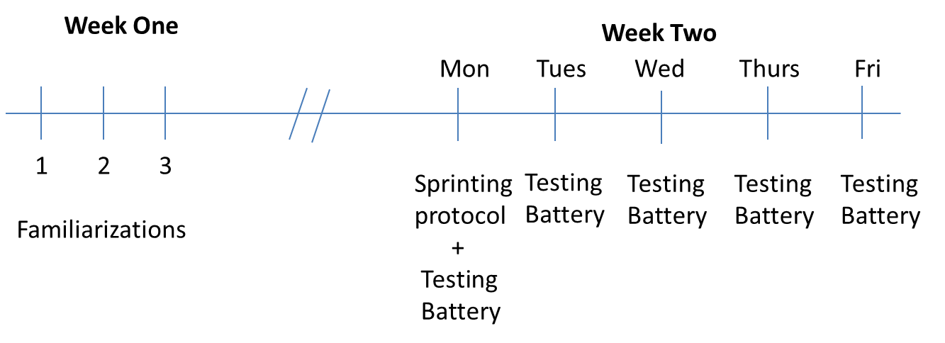

The sprinting protocol consisted of 40 15-meter sprints with a 5-meter deceleration zone. The deceleration zone is responsible for the exercise-induced muscle damage, according to Woolley et al (2014). When decelerating from a sprint, the muscles in the legs, particularly the hamstrings and quadriceps, lengthen to decelerate. The lengthening of a muscle happens during an eccentric contraction. When this occurs, there is added stress on those muscles, causing muscle damage.¹⁷
The foam rolling protocol consisted of participants in the foam rolling group to foam roll with a high-density foam roller (Theraband, Hygienic Corporation, Akron, Ohio, USA). The following body parts were foam rolled: quadriceps, hamstrings, gastrocnemius, gluteus maximus, iliotibial band, and medial thigh.¹⁸ This was performed on each leg at 5 second cadence for each back and forth motion. Each part was foam rolled for a total of 60 seconds per leg.
An iWorx software LabScribe (LabScribe 3, iWorx, Dover, New Hampshire, USA) measured pulse wave velocity. Each participant laid down after 15 minutes of rest and electrodes were applied to both wrists and the right lower abdomen, which attached to the iWorx device. The brachial pulse was found on each participant and a plethysmograph was taped onto the site of the brachial pulse. LabScribe was started and ran for two minutes to get an accurate reading. The last five peaks were recorded for accuracy. This was repeated with the plethysmograph on the tip of the middle finger. The distance from each participant’s brachial pulse site to the tip of his or her middle finger was also recorded. The following equation was used to decipher each pulse wave velocity:
Pulse wave velocity = distance between brachial pulse and tip of middle finger /
(average of the brachial pulse times – average of the finger pulse times)
Each participant’s pulse wave velocity was recorded all eight days of testing. Data analysis was conducted using GraphPad Prism 5.0 (GraphPad Prism 5.0, GraphPad Software, San Diego, California, USA). The Kolmogorov Smirnov test was used to assess data for normality. Normally distributed data used a two-tailed independent t-test.
Otherwise, a two-tailed Mann Whitney U test was used to compare the change from the baseline area under the curve between FR and CON.

RESULTS
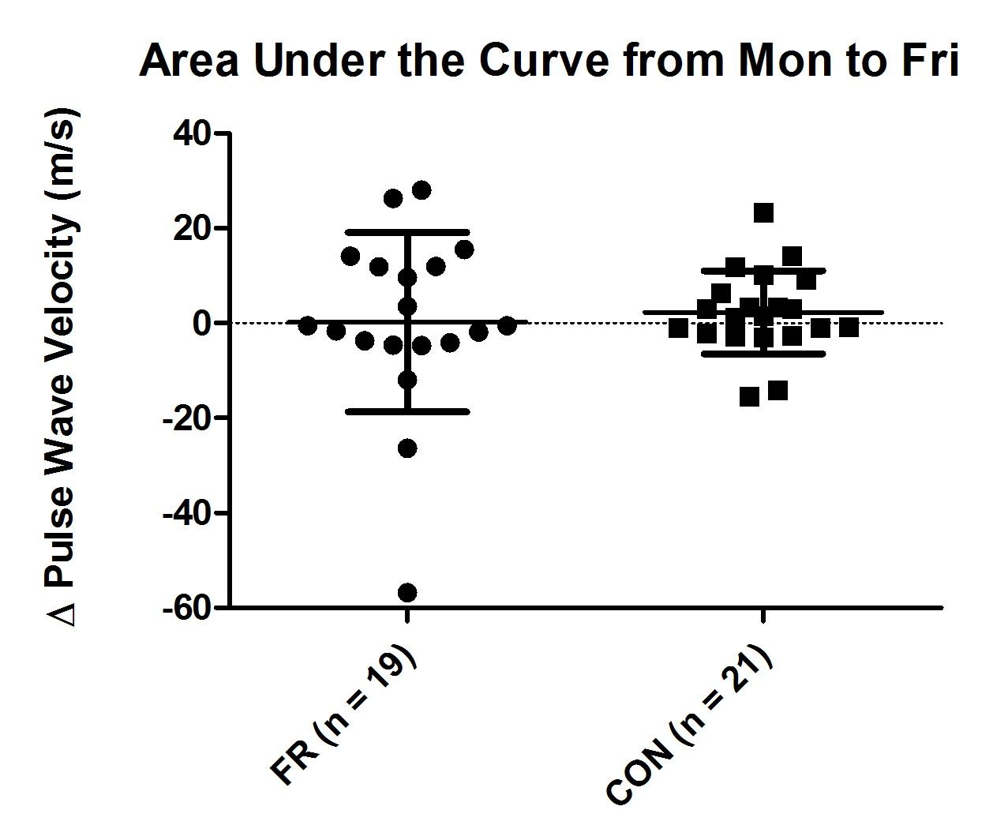

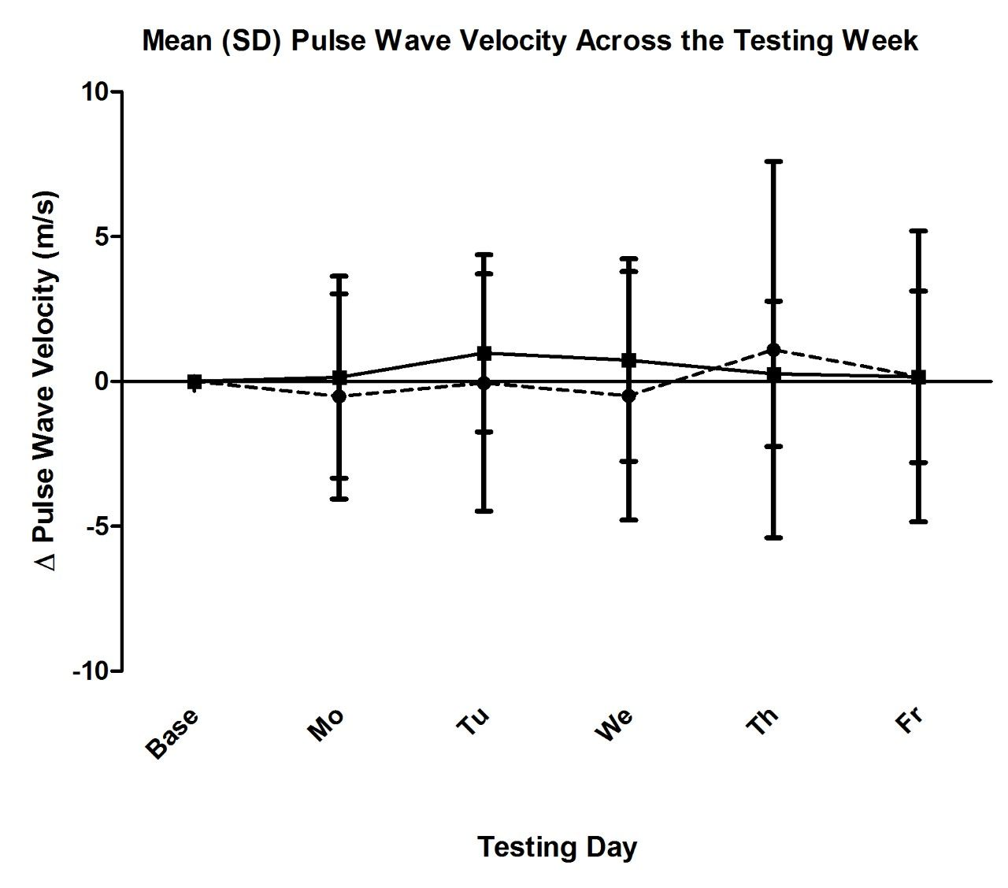

These graphs show that there is no significant difference in pulse wave velocity from the foam rolling (FR) group to the control (CON) group (p > 0.05). These results are based on pulse wave velocity measures being taken after 24 hours of a foam rolling bout.

DISCUSSION
There were forty participants in the study, 19 in the FR group and 21 in the CON group. From this data, there was no significant difference found between the pulse wave velocity of the foam rolling group and the control group (p > 0.05).
Foam rolling has recently become much more popular. Many people use foam rollers as a form self-massage to relieve the affects of delayed-onset muscle soreness after intense bouts of exercise. Many places, including fitness centers and physical therapy clinics, now provide foam rollers for as a form of massage. Greater popularity of foam rollers opens up the opportunity for relevant research. There could be additional applications for the use of foam rolling. Not only can it provide relief from muscle soreness¹⁴, but it could potentially have an effect on pulse wave velocity.¹ According to Okamoto et al, foam rolling releases tension in muscles, which can create better circulation and blood flow in the area. This increased circulation of the cardiovascular system could lower arterial stiffness. Pulse wave velocity is a measure of arterial stiffness and can predict the potential of a cardiovascular event. If foam rolling could influence pulse wave velocity, there is possibility that foam rolling could decrease the probability of a cardiovascular event to occur.¹
Pulse wave velocity is a marker of arterial stiffness that can help to predict the likelihood of a cardiovascular event. There has been research into treatments can help to decrease arterial stiffness to lessen this likelihood. Janić et al (2014) researched the pharmacological treatments available to improve arterial compliance, thus decreasing pulse wave velocity. Antihypertensive drugs were suggested to decrease arterial stiffness by inhibiting the renin-angiotensin system, which, when stimulated, was shown to increase arterial stiffness. ACE inhibitors were also suggested to improve arterial compliance, as the renin-angiotensin system is affect by the loss of the enzyme. Arterial compliance was also suggested to be affected by angiotensin receptor blockers, which inhibit the angiotensin system. Janić et al suggested that beta blockers also decrease arterial stiffness by reducing HR. AGE cross-link breakers were shown to decrease arterial stiffness by breaking up the crossing of collagen fibers, which are responsible for creating the stiffness in arteries.¹⁹
In addition to pharmacological interventions, some studies suggest that simply exercise can reduce arterial stiffness. Ferreira et al (2006) suggested that aerobic exercise can improve arterial compliance. Aerobic exercise may reduce arterial stiffness because it reduces risk factors that are associated with less arterial compliance, such as blood pressure. Arterial stiffness is also affected by SNS, inflammation, and endothelial function, all of which are affected by aerobic activity. According to the study, further research is necessary to form concrete reasons for aerobic exercise to have a direct effect on arterial compliance, but there is a possible association between aerobic exercise and arterial stiffness.²⁰
Pharmacological treatments and aerobic exercise have the potential to increase arterial compliance. Foam rolling could be another possible intervention used to decrease arterial stiffness, in addition to the previous with further research. Foam rolling affects the fascia of the targeted muscle, which stimulates the mechanoreceptors located in the fascia. This stimulates the parasympathetic nervous system, as a relaxing effect occurs in targeted area.¹⁰ The stimulation of the parasympathetic nervous system relaxes the blood vessels and the heart, which increases arterial compliance.¹³ There is a possible chain reaction from the foam roller to the fascia to the mechanoreceptors to the parasympathetic nervous system to the cardiovascular system, which could decrease arterial stiffness. If future research suggests foam rolling as a plausible treatment, this could give individuals with high pulse wave velocity measures multiple ways to decrease the possibility of a cardiovascular event occurring. Something as simple as a foam cylinder could have a beneficial effect on one’s life.
From the results, it is suggested that there is no significant difference between pulse wave velocity measures of those who foam roll 24 hours before, which suggests that foam rolling had no effect on arterial stiffness after 24 hours. However, Okamoto et al suggests that there may be a short-term influence of foam rolling on pulse wave velocity, since that study saw a significant difference in pulse wave velocity measures after 30 minutes.¹ Because of this, foam rolling may have an effect on the vasculature in the body, but only a temporary effect.
CONCLUSION
The data suggests that there is no significant difference on pulse wave velocity from the FR group to the CON group, which means that foam rolling had no effect on pulse wave velocity. This could be attributed to taking pulse wave velocity measures 24 hours later, which may be too long to wait. Further research should be pursued to see at what various time intervals show significant pulse wave velocity changes due to foam rolling. For example, time intervals after a foam rolling bout could be 30 minutes, 1 hour, 2 hours, 6 hours, and 12 hours to see how long foam rolling is able to influence pulse wave velocity.
From the data, it is interesting to note that high variability between the participants in the FR group. The CON group remained clustered especially when compared to the FR group, as seen in the data tables measuring the area under the curve. The FR group had both positive and negative extremes. This could possibly suggest that individual responses to foam rolling may vary from an autonomic perspective. Some individuals may beneficially respond to foam rolling, while others may not be affected at all. This high variability in the FR group compared to the CON group may indicate that foam rolling is individualized, and each person may respond differently. If further research suggests this to be the case, then individuals with cardiovascular problems may or may not be positively affected by foam rolling, as it is an individualized method.
REFERENCES
¹ Okamoto, T., Mitsuhiko, M., Komei, I. (2014). Acute Effects of Self-Myofascial
Release Using a Foam Roller on Arterial Function. The Journal of Strength and Conditioning Research, 28, 69-73.
² Pereira, T., Correia, C., Cardoso, J. (2015). Novel Methods for Pulse Wave Velocity
Measurement. The Journal of Medical and Biological Engineering:35, 555-565.
³ Lurbe, E., Torro, I., Garcia-Vicent, C., Alvarez, J., Fernandez-Fornoso, J., Redon, J. (2012). Blood Pressure and Obesity Exert Independent Influences on Pulse Wave Velocity in Youth. Hypertension:60, 550-555.
⁴ Diaz, A., Tringler, M., Wray, S., Ramirez, A., Cabrera, E. (2017). The effects of age on pulse wave velocity in untreated hypertension. The Journal of Clinical Hypertension:20, 258-265.
⁵ Steppan, J., Barodka, V., Berkowitz, D., Nyhan, D. (2011). Vascular Stiffness and
Increased Pulse Pressure in the Aging of the Cardiovascular System. Cardiology
Research and Practice:2011.
⁶ Koivistoinen, T., Kööbi, T., Jula, A., Hutri-Kähönen, N., Raitakari, O., Majahalme, S.
… Kähönen, M. (2007). Pulse wave velocity references in healthy adults aged 26-
75 years. Clinical Physiology and Functional Imaging: 27, 191-196.
⁷ Boutouyrie, P., Vermeersch, S. (2010). Determinants of pulse wave velocity in healthy
people and in the presence of cardiovascular risk factors: ‘establishing normal
and reference values.’ European Heart Journal:19, 2338-2350.
⁸ Kenney, W., Wilmore J., Costill, D. (2015). Physiology of Sport and Exercise. Illinois:
Human Kinetics.
⁹ Mäki-Petäjä, K., Barrett, S., Evans, S., Cheriyan, J., McEniery, C., Wilkinson, I. (2016). The Role of the Autonomic Nervous System in the Regulation of Aortic Stiffness. Hypertension:68, 1290-1297.
¹⁰ Logan, J., Kim, S. (2016). Resting Heart Rate and Aortic Stiffness in Normotensive
Adults. Korean Circulation Journal:46, 834-840.
¹¹ Quinn, U., Tomlinson, L., Cockcroft, J. (2012). Arterial stiffness. JRSM
Cardiovascular Disease. Doi: 10.1258%2Fcvd.2012.012024
¹² Kang, S., Kim, I., Choi, E., So, W. (2018). Effects of the Tui-na and Thai Massage
Techniques on Vascular Arterial Compliance in Middle-aged Korean Men. Iranian Journal of Public Health:47, 292-294.
¹³ Cheatham, S., Kolber, M., Cain, M., Lee, M. (2015). The effects of self-myofascial
release using a foam roller or roller massager on joint range of motion, muscle recovery, and performance: a systematic review. International Journal of Sports Physical Therapy: 6, 827-838.
¹⁴ Simmonds, N., Miller, P., & Gemmell, H. (2012). A theoretical framework for the role of fascia in manual therapy. Journal of Bodywork and Movement Therapies:16, 83-93.
¹⁵ Schleip, R. (2002). Fascial plasticity-a new neurobiological explanation: Part 1. Journal of Bodywork and Movement Therapies. 7(1), 11-19.
¹⁶ Aboodarda, S., Spence, A., Button, D. (2015). Pain pressure threshold of a muscle
tender spot increases following local and non-local rolling massage. BMC
Musculoskeletal Disorders: 16, 625.
¹⁷ Woolley B. P., Jakeman J. R., Faulkner J. A. (2014) Multiple Sprint Exercise with a Short Deceleration Induces Muscle Damage and Performance Impairment in Young, Physically Active Males. J Athl Enhancement 3(2).
¹⁸ Macdonald GZ, Button DC, Drinkwater EJ, Behm DG. (2014). Foam Rolling as a recovery tool after an intense bout of Physical Activity. Medicine and Science of Sports and Exercise:46, 131-42.
¹⁹ Janić, M., Lunder, M., Šabovič, M. (2014). Arterial Stiffness and Cardiovascular
Therapy. BioMed Research International. doi:10.1155/2014/621437
²⁰ Ferreria, I., Boreham, C., Stehouwer, C. (2006). The Benefits of Exercise for Arterial
Stiffness. Americna Journal of Hypertension: 19, 1037-1038.

