Bacterial Attachment to Microspheres

By: Kathleen Marie Troisi
Advisor: Professor Peter Alachi
Biology Department, Salem State University

Acknowledgments
I’d like to thank Dr. Sheila Schreiner for her initial suggestion and development of the project. I also want to thank Professor Peter Alachi for his guidance as my advisor throughout the project. I’d like to also thank Dr. Paul Kelly for his help obtaining scanning electron micrograph pictures of the microspheres. Many thanks to Lianna Murphy for her help with general lab maintenance. This work could not have been done without the generous funding from the Honors program and the Biology Department at Salem State University. (KT)

Table of Contents

Acknowledgments page 2
Abstract page 4
Introduction page 4
Materials page 5
Methods page 5
Results page 7
Discussion page 10
Conclusion page 12
References page 14

Abstract
Microspheres are small beads that average around 875 μm in diameter and are found in popular facial soaps and toothpastes. They are popular with consumers which raises the concern over how they impact the environment after they have been used. Our data suggests that bacteria were able to attach to the microspheres and crevices within. But can be detached when subjected to different rates of saline solution washes. Since these microspheres can stay intact in water, there are many concerns over their impacts on marine and freshwater life and environments.

Introduction
Some companies have introduced products that include small plastic 'beads', scientifically named microspheres. The manufacturers claim that the microspheres can facilitate the removal of bacteria from the skin by attracting them to their surfaces and that they’re environmentally biodegradable⁴. The microspheres are made of plastic polymer shells and coated with petroleum-based chemicals that attract bacteria.
In facial soaps, these microspheres are washed down the drains after their use along with the bacteria they harbor. Once in the aquatic ecosystems, the microspheres can persist for an unknown amount of time, and in the interim, may attract evolving communities of microorganisms that grow on their surfaces and in various grooves and nicks. Hence, there may be potential risks to humans, animals, and the environment from ingesting these microspheres and their residues.
This initial study looked at the ability of some bacteria to attach to these microspheres.

Materials
- Clean and Clear Morning Burst facial soap
- Forceps
- Toothpicks
- Coffee filters
- Bunsen Burner
- Petri dishes
- Vacuum filtration system
- 9 mL Saline solution in sterilized screw-capped test tubes
- Nutrient agar broths and plates
- Ethanol
- Gram stain kit
- UV light
- Autoclave
- Scanning Electron Microscope (SEM)

Methods
Microspheres were collected from the facial soap product using membrane filtration. The microspheres were sterilized using short wave UV light to avoid damage to them. These microspheres were measured using calibrated micrometer. They averaged at 875 μm and the scanning electron microscope (SEM) measurements showed their size to be the same. The microspheres samples were then tested for sterilization following exposure to UV light and there was no growth found on the agar plates after a 48 hour incubation period. Four bacteria were selected, gram positive bacteria Staphylococcus epidermidis and Bacillus subtilis and gram negative bacteria Escherichia coli, and Salmonella enteritidis. S. epidermidis and B. subtilis are bacteria that are found on skin. S. epidermidis is a resident bacteria on skin whereas B. subtilis are transient bacteria. E. coli and S. enteritidis are found on contaminated food surfaces. A hand culture sample was also done to see what kinds of bacteria are found on skin. Gram staining techniques were used to help identify the morphology of bacteria. Microspheres were seeded overnight with the bacteria cultures on nutrient broths and agar plates. They were then placed into a sterile nutrient agar and broth to see if they were able to transfer bacteria. The microspheres loaded with bacteria were subjected to a number of washes in saline solution. This involved shaking the samples for 10 seconds. This was followed by culturing the microspheres in nutrient broth for 24 hours.
The first wash test was done using E. coli loaded microspheres. E. coli microspheres were subjected to 10 washes. E. coli was recovered after four washes but failed to grow beyond that. This process was repeated again for Salmonella enteritidis, Staphylococcus epidermidis, and B. subtilis. Determining the amount of bacterial growth through the wash cycle required removing two microspheres after each wash onto nutrient agar.
Being able to understand the structure of the microbeads was an important aspect to this study. Microscopy was used to see the structure of the microsphere with and without bacteria. The scanning electron microscope was then used in order to see the structure of the microspheres in a higher resolution. The specimen for this study were microspheres with no bacteria loaded on them, microbeads with B. subtilis, and microbeads with bacteria from a mixed hand culture. The pictures of the electron microscope were done by dehydrating and fixing the microbeads to the carbon paper. Microbeads with bacteria on them were dehydrated and fixed on filter paper. A small amount of gold was then added to the specimens. After the dehydration and adding the gold filaments to the samples, the specimens were ready to be examined under the electron microscope.

Results
Microspheres were able to be filtered using a vacuum filtration system with sterile coffee filters. Sterile microspheres which were sterilized with UV light yielded no growth following a 48 hour incubation period. UV light sterilization was used in order to minimize the risk of structure damage to the microspheres. Since there was no bacteria growth found on the nutrient broths, this meant that the microspheres were sterilized. The microspheres were then subjected to saline solution tests with bacteria loaded onto them. B. subtilis was recovered at 3 and 4 washes. There was no bacteria growth after 20 washes. Since this was a large gap, the test was then scaled down to 10 washes for each bacteria and two microspheres were taken out after each step to track the progress. E. coli wash test was done but after the 10 washes, contamination was found but not E. coli. The experiment was then repeated with more aseptic techniques to limit the amount of contamination. This was repeated again and E. coli growth was not recovered after 4 washes. S. epidermidis and S. enteritidis were recovered after 10 washes. B. subtilis growth was not found after 9 washes.
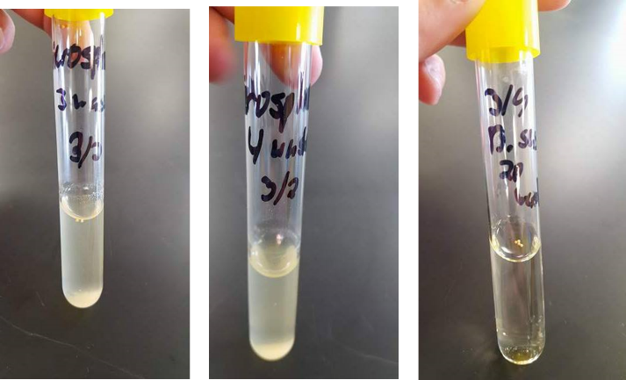

Figure 1: B. subtilis culture in nutrient broth after 3, 4, and 20 washes.

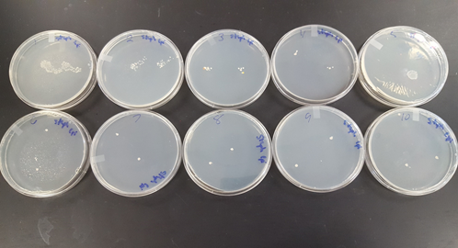

Figure 2: S. epidermidis culture on nutrient agar plates after 10 washes. S. epidermidis was recovered after each wash.
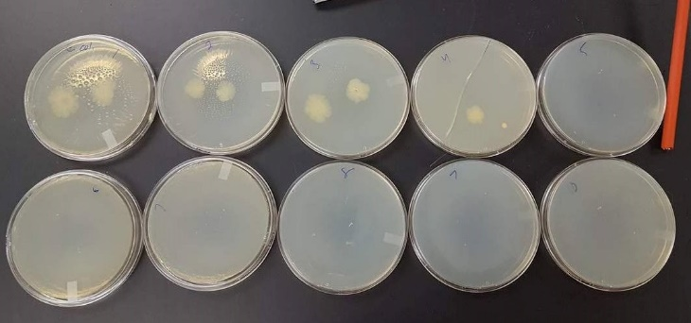

Figure 3: E. coli culture on nutrient agar plates after 10 washes. E. coli failed to be recovered after 4 washes.
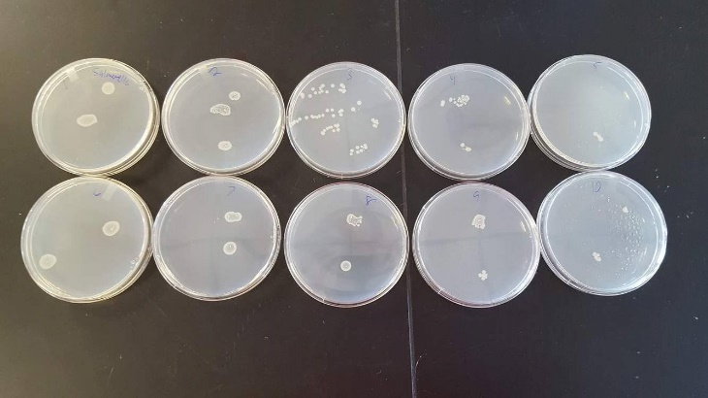

Figure 4: S. enteritidis culture on nutrient agar plates after 10 washes. S. enteritidis was recovered after each wash.

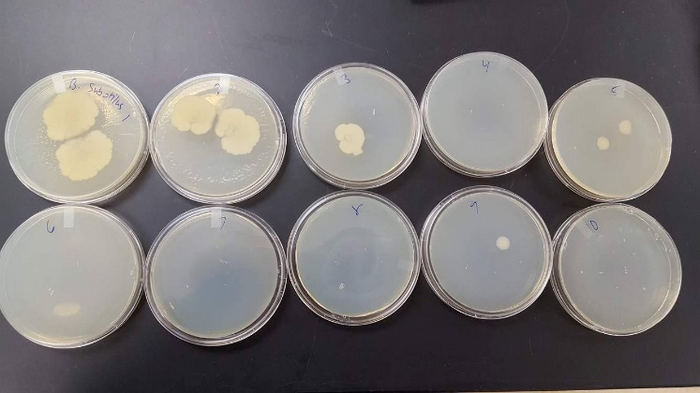

Figure 5: B. subtilis culture on nutrient agar plate after 10 washes. B. subtilis was recovered after 9 washes.

The SEM pictures show a more detailed view of the microspheres and collaborated with the results from the compound microscope. The SEM showed the various nicks and grooves that the microspheres had where, hypothetically, bacteria can hide. Microspheres that were loaded with B. subtilis were examined under the SEM and were shown to have structural damage and bacteria was not found on the microspheres. There is a possibility that the structural damage came from the ethanol dehydration process and that there was not enough bacteria added to the sample before placing under the SEM.
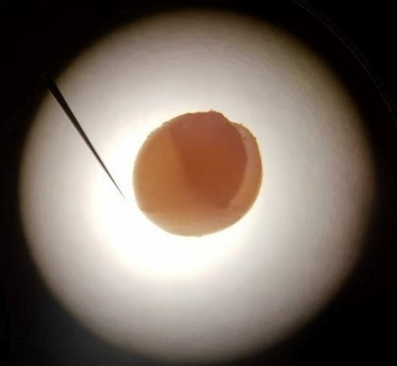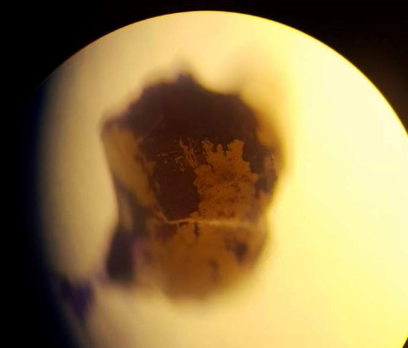
Figure 6: Microspheres under a compound microscope. Left picture show a fragmented microsphere at magnification of 10x. Right picture shows a fragmented microsphere with B. subtilis loaded onto the surface at magnification of 40x.
Figure 7: Snapshots of microspheres under the SEM. Magnifications from left to right are 200x, 55x, and 33x.

Figure 8: Microspheres that had structural damage. Possibility from the dehydration process with ethanol. Magnification from left to right are 1500x, 3500x, and 3700x.

Discussion
In order to get a better idea of the structure of the microsphere, light microscopy and the scanning electron microscope was used. It was hypothesized that there were nicks and grooves on the surface of the microspheres. There was no ability to see the details of the structure using the light microscope. Microspheres with loaded B. subtilis were treated with crystal violet in order to view the bacteria. Microspheres loaded with bacteria were examined under the microscope and bacteria cells were visible under the 1000x. The bacteria cells were visible as shown in Figure 6 and it was difficult to see the how exactly the bacteria were able to attach to the surface. The SEM which has a higher resolution than the compound microscope showed the various nicks and grooves on them, but didn’t show bacteria attachment.. The microcrystalline wax on the microspheres acts as an adhesion with explains how bacteria are able to attach to the surface and how they can attach to each other.
The bacteria that was used in this study have been found to survive in water environments but the survival times vary. E. coli was found to survival in water and depending on the strain, it can survive more than 100 days. E. coli relies on its fimbriae to attach to surfaces and other cells.⁸ S. epidermidis can survive for long periods of time on dry surfaces but it wasn’t stated how long it can survive in water. This kind of bacteria produces a biofilm to attach to other cells and surfaces. Similar to S. epidermidis, S. enteritidis also produces a biofilm to attach to surfaces. It was also observed to be able to survive for long periods of time in water but there was no definite time frame.¹¹ B. subtilis can survive in water environments by transforming into an endospore but like the other types of bacteria, there was no set time of survival.¹² Past research suggested that these kinds of bacteria can survive in water but for most, there wasn’t a defined time frame for survival. Further research could be done to look at how long bacteria can survive in water after being dislodge from objects.
Many different research articles discussed the environmental impact that these microspheres have. One research article estimated that Americans were flushing down close to 8 trillion microspheres daily into the water ecosystems.³ Furthermore, these microspheres have the ability to be fragmented into smaller pieces since their structure consists of plastic and microcrystalline wax. Since they have the ability to fragment into smaller pieces, there is the possibility that they are able to avoid entrapment through filtration. The attachment of bacteria and the saline solution water tests gives the possibility that the microspheres facilitate bacteria movement in aquatic environments. This could probably lead to bacteria detachment and increasing the levels in water. Also, bacteria that are found in local environments can also attach these microspheres. Microspheres levels have also been increasing and many other studies have noticed more of them in the environment. One article discussed how the Connecticut River has higher levels of these microspheres in the last 3 years.⁷ The microspheres are able to float in liquids and many researchers noticed that fish and birds are chocking and dying off because of the microspheres getting lodged in throats or stuck in stomachs. These microspheres possibility have a larger environmental impact than what was originally thought. Since so many researchers and environmentalists have noticed the increase in microspheres in aquatic environments, they started to rally behind the idea of banning these microspheres. President Obama had enacted a law in 2015 that banned the microspheres and their production. The law stated that on July 1st, 2017, the microsphere production would cease and they should be phased out from products by 2019.¹³ There are steps already in place to prevent more of these microspheres from entering aquatic environment but in the meantime, there are still microspheres entering the water systems.These microspheres are a possible environmental hazard and the ability for bacteria to attach and detach so easily could possibly have another harmful impact.

Conclusion
This study discussed the possibility of bacteria being able to attach to microspheres and if they are able to detach as well. The saline solution wash tests showed that bacteria is able to attach to the microspheres as well as detach when shaken. These microspheres have already been known to be causing harm to the environment and the bacteria that can attach adds another possible risk. How bacteria were able to stay on the microspheres was inconclusive but this opens the opportunity for more research to be done. Further research could be also done to see bacteria survival rates in water and see if any environment bacteria competes with the bacteria done in this study.

References
- Boerger CM, Lattin GL, Moore SL, Moore CJ. 2010. Plastic ingestion by planktivorous fishes in the North Pacific Central Gyre. Mar Pollut Bull. 60(12):2275-8. Accessed January 9, 2017. doi: 10.1016/j.marpolbul.2010.08.007.
- Fendall LS, Sewell MA. 2009. Contributing to marine pollution by washing your face: microplastics in facial cleansers. Mar Pollut Bull. 58(8):1225-8. Accessed January 7, 2017. doi: 10.1016/j.marpolbul.2009.04.025.
- Rochman CM, Kross SM, Armstrong JB, Bogan MT, Darling ES, Smyth Ar, Verissmo D. 2015. Scientific evidence supports a ban on microbeads. Environ Sci Technol. 49(18):10759-61. Accessed April 3, 2017. doi: 10.1021/acs.est.5b03909.
- Roy PK, Hakkarainen M, Varma IK, Albertsson AC. 2011. Degradable polyethylene: fantasy or reality. Environ Sci Technol. 45(10):4217-27. Accessed November 5, 2016. doi: 10.1021/es104042f.
- Tanaka K, Takada H, Yamashita R, Mizukawa K, Fukuwaka MA, Watanuki Y. 2013. Accumulation of plastic-derived chemicals in tissues of seabirds ingesting marine plastics. Mar Pollut Bull. 69(1-2):219-22. Accessed December 1, 2016. doi: 10.1016/j.marpolbul.2012.12.010.
- Tuson HH, Weibel DB. 2013. Bacteria-surface interactions. Soft Matter. 9(18): 4368–4380. Accessed March 5, 2017. doi: 10.1039/C3SM27705D.
- Standard Ed. 2015. Southern Connecticut University prof says microbeads impacting the Sound. New Haven Register. Accessed April 1, 2017. http://www.nhregister.com/article/NH/20150927/NEWS/150929554.
- Flink KP. 1987. The long-term survival of Escherichia coli in river water. J Appl Bacteriol. 63: 261-270. Accessed March 20th, 2017. http://www.pcwp.tamu.edu/docs/lshs/end-notes/the%20long-term%20survival%20of%20e.%20coli%20in%20river%20water-0071796226/the%20long-term%20survival%20of%20e.%20coli%20in%20river%20water.pdf
- Cornell Chronicle. 1997. Salmonellosis (Public Health Concerns for the Farm Family and Staff). http://www.news.cornell.edu/stories/1997/12/salmonella-fact-sheet
- Himathongkham S, Nuanualsuwan S, Riemann H. 1999. Survival of Salmonella enteritidis and Salmonella typhimurium in chicken manure at different levels of water activity. FEMS 172: 159-163. Accessed April 5th, 2017. doi: 10.1111/j.1574-6968.1999.tb13464.x.
- Yanga Y, Kumara A, Zhenga Q, Yuka HG. 2015. Preacclimation alters Salmonella Enteritidis surface properties and its initial attachment to food contact surfaces. 128: 577-585. Accessed April 6th, 2017. http://www.sciencedirect.com/science/article/pii/S0927776515001459.
- Kaieda, S., Setlow, B., Setlow, P., & Halle, B. (2013). Mobility of Core Water in Bacillus subtilis Spores by 2H NMR. Biophysical Journal, 105(9), 2016–2023. Accessed April 10th. http://doi.org/10.1016/j.bpj.2013.09.022
- https://www.congress.gov/bill/114th-congress/house-bill/1321/text

