ATTITUDES SURROUNDING LONG-ACTING REVERSIBLE CONTRACEPTIVE METHODS AMONG FEMALE UNDERGRADUATE NURSING STUDENTS OVER 18 YEARS OF AGE AT A LARGE NEW ENGLAND UNIVERSITY

Honors Thesis

Presented in Partial Fulfillment of the Requirements
For the Degree of Bachelor of Science in Nursing

In the Maguire Meservey
College of Health and Human Services
at Salem State University

By
Nicole Nearen

Charlene Moske-Weber, PhD, MSN, RN
Faculty Advisor
Department of Nursing

***
The Commonwealth Honors Program
Salem State University
2017-2018

TABLE OF CONTENTS
INTRODUCTION 1
PURPOSE 1
LITERATURE REVIEW 2
METHODS 4
DISCUSSION 13
CONCLUSION 15
Appendix A: 15
Appendix B: 17
Appendix C: 18
REFERENCES 21

LIST OF FIGURES
Figure 1. Participant Ages in Years 5
Figure 2. Current Contraceptive Methods 6
Figure 3. Reasons to Select a LARC Method 7
Figure 4. Benefits of a LARC Method 8
Figure 5. Reasons not to use LARC 9
Figure 6. LARC Side Effects 10
Figure 7. Sources of LARC Education 11
Figure 8. Did you Receive LARC Education? 11
Figure 9. Was the LARC education effective? 12
Figure 10. Are LARC methods highly effective? 12

ABSTRACT
BACKGROUND/PURPOSE: Long-Acting Reversible Contraceptive (LARC) methods are highly effective methods of birth control including intrauterine devices (IUD) and the implant. There is often a lower rate of usage with these methods due to factors such as high upfront cost, invasive insertion methods, and possible side effects. This research is aimed to understand some of the perceived and actual barriers for usage, as well as to identify any gaps in education regarding this method.
DESIGN AND METHODS: This project was conducted as a qualitative study with 114 total participants. Consent for the study will be implied by completing the survey. The survey will be distributed via the School of Nursing from Survey Monkey. The data was collected via a 10 question survey, which was distributed through the Salem State University School of nursing email server.
RESULTS: Respondents had a generalized understanding of long-acting reversible methods, while also having low levels of usage. The data supported that this population, which was predominantly 18-22 years old, had an adequate LARC understanding. However, 55% of women claimed current oral contraceptive use, and only 17% cited current LARC use, despite the high 88% education rate
IMPLICATIONS: The study enables healthcare providers and health educators to assess the education needs and barriers that exist with LARC usage. An understanding of LARC methods will help to expand access and understanding of this method.
Key Words: long-acting reversible contraception, education, contraception, barriers, understanding

INTRODUCTION

Contraceptive methods are a highly contentious topic. There is no consensus as to which methods are best, and every method carries risks and benefits. Oral contraceptives are very commonly used. However, “unlike the oral contraceptive pill or injection, long-acting reversible contraceptive (LARC) methods, such as the intrauterine device (IUD) and subdermal implant, are designed so that once inserted, a woman does not have to think about using birth control on a daily, weekly, monthly or quarterly basis” (Birgisson, Zhao, Secura, Madden, Peipert, 2015, p. 349). LARC has the ability to be used long term with no upkeep, women who utilize a LARC method “experience effectiveness rates of greater than 99%; perfect and typical use effective rates are equivalent” (Birgisson et al., 2015, p. 349). This method is available to any women, but “despite the availability of LARC, less than 8% of women in the United States use an IUD and even fewer report use of the subdermal implant” (Birgisson et al., 2015, p. 349). But availability does not always equate to assess and proper education, as many “women and teens experience multiple barriers when accessing and using birth control including prohibitive method costs, limited or nonexistent information about all methods available, and provider bias or outdated clinical practice regarding appropriate candidates for particular contraceptive methods” (Birgisson et al., 2015, p. 349).

PURPOSE
This research is aimed to understand some of the perceived and actual barriers for usage, as well as to identify any gaps in education regarding this method. The overarching goal of this project is to understand any and all barriers as well as the educational gaps associated with this method in order to increase access and understanding.

LITERATURE REVIEW
There are 3 types of intrauterine devices that are currently in use. The first and most common method is the Mirena which is “a small, T-shaped contraceptive device with a banding of progestogen that sits in the uterine cavity. The woman will continue to ovulate, but her periods may become shorter and lighter, and may result in amenorrhea” (Kipps, 2014, p. 338). This method can stay in place for “5 years and is useful for women with heavy menstrual bleeding. Women can have some nuisance bleeding for 3–6 months post-fitting, and should be advised on the risks of fitting” (Kipps, 2014, p.338-339). There is also a smaller version of the Mirena IUD (the names vary with brand) with a “lower dose of levonorgesterel into the uterine cavity (13.5 mg as opposed to 52 mg in Mirena), and is licensed for 3 years” (Kipps, 2014, p.339). The third method is the Paragard which is “a small [hormone free], T-shaped plastic device with a copper banding that sits in the uterine cavity. Threads are situated 2 cm from the cervix to assist with the removal of the device. Copper causes sperm dysfunction and therefore prevents fertilization” (Kipps, 2014, p. 338). Due to the use of copper “periods may become longer and heavier, and sometimes more painful. This method is useful for women who do not want to use a hormonal method” (Kipps, 2014, p.338). Another option for LARC is the “Nexplanon which is a subdermal progestogen-only rod consisting of 68 mg of etonogesterel” (Kipps, 2014, p. 338). The insertion of the method requires “a minor clinical procedure for fitting and removal by a specially trained professional. This method lasts for 3 years but can cause nuisance bleeding in some women” (Kipps, 2014, p.339). LARC options also “offer increased method satisfaction and higher continuation rates, with over 25 % more LARC users persisting after 12 months compared to other methods. These methods are also more cost-effective over time for individuals and health care systems because they are highly effective for long periods of time and offer low maintenance after insertion” (Sundstrom, Baker-Whitcomb, & DeMaria, 2015, p. 1507).
Multiple factors regarding the selection of LARC methods are examined. Prominent themes include financial affordability, fertility, side effects, and general perception. Women often “underestimated the risks of oral contraceptives and overestimated the risks of LARC” (Sundstrom et al., 2015, p. 1510). Women favor other methods, particularly oral contraception, because they are unable to recognize the actual risk benefit ratio of each method. Many women associate “LARC methods with negative side effects and potential health complications” (Sundstrom et al., 2015, p. 1511). Also, women may not have the funds to spend on this method up front, even if insertion is provided at a free or reduced rate, the “removal of an IUD or implant occurs at a different time from placement and is thus billed separately, [thus] women who lack or have inconsistent health insurance coverage may still face financial barriers” (Manchikanti Gomez, Fuentes, & Allina, 2014, p. 172). In terms of education regarding this method many women receive misinformation. Many women perceive LARC as ‘‘invasive,’’ ‘‘uncomfortable,’’ and requiring ‘‘surgery’’ or ‘‘almost a surgery” and many view LARC as outside the norm and inconsistent with their understanding of contraception” (Sundstrom et al., 2015, p. 1510).
The current literature is very critical of LARC methods. The understanding is that LARC methods may be used to perpetrate reproductive inequality. “Evidence suggests that providers recommend IUDs and implants more to poor women of color than to poor White women and more to poor White women than middle-class women” (Higgins, Kramer, & Ryder, 2016, p. 1932). The consensus among the literature is that “the family planning community must make particular efforts to ensure that women are able to freely choose LARC methods: It must take steps to make certain that use of these methods is driven by women’s own expressed desires for them, and not by a programmatic attempt to reduce population-level unintended pregnancy rates by encouraging “risky” women to use them” (Manchikanti Gomez et al., 2014, p. 172). Overall the goal of increased access and education in regards to LARC products should seek to “expand—not restrict—contraceptive options for all women, particularly for women whose racial, ethnic or class identities have made them targets of forced sterilization” (Manchikanti Gomez et al., 2014, p. 173).

METHODS
The aim of this qualitative study was to assess the baseline LARC knowledge of female undergraduate nursing students at Salem State University. The survey questions were adapted from a previous student survey (Quirk, 2015, p. 27-28). The survey was distributed via Survey Monkey and the School of Nursing email server. Data was directly exported and proceed in Microsoft Excel 2010.
The participants of the study had to be current female Salem State University undergraduate nursing students. In total we received 114 responses. The survey was created and distributed via the online generator, Survey Monkey. The survey generator provides a secure link so that participants can complete the survey. The survey was distributed via the School of Nursing email server. Participants were given a month, between October 2017 to the end of November 2017 to respond to the survey. The survey was composed of ten questions. The questions were select all that apply, fill in the blank, and true/false. The questions were directed towards assessing the level of knowledge that nursing students possess regarding LARC methods, which could be used to direct future education regarding these methods.
Out of 114 survey results, 113 were utilized. The survey was uploaded onto the online survey generator and distributor, Survey Monkey, and was distributed to the entire undergraduate nursing class at Salem State University via the School of Nursing’s listserv. Only female nursing students were directed to participate. All of the completed survey results were utilized. The survey data was directly imported into Microsoft Excel from Survey Monkey for interpretation, organization, and for graph production. There were no open ended questions that would require specific descriptive statistics software. Both the numerical and percentage form of the data are used, and rounded to the nearest whole number.
RESULTS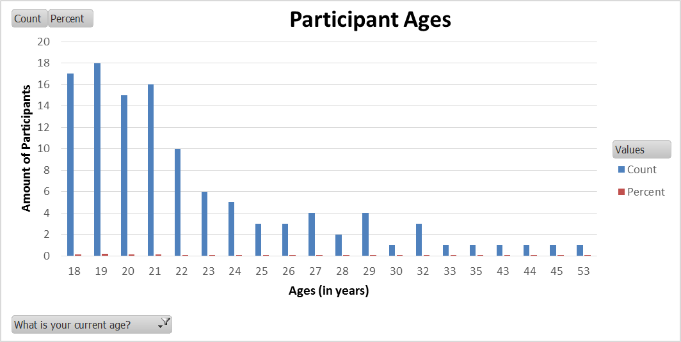
Figure 1. Participant Ages in Years

In question one answers ranged between the ages of 18 to 53. The majority of respondents fell into the 18-22 years age group.
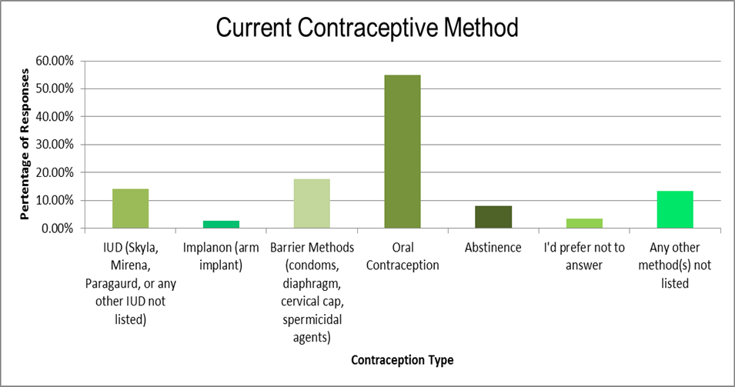
Figure 2. Current Contraceptive Methods
In question two oral contraceptives were the most commonly used method with 62 respondents (55%) of women stating current use. The next method was the barrier methods, such as condoms, diaphragms, spermicidal agents, etc., as 20 respondents (18%) chose barrier methods as their primary birth control. The next method was IUD’s with 16 women or (14%). A total of 15 participants (13%) chose the other option. The responses included the Depo Provera injection, no use of birth control, current pregnancy, the patch, and the NuvaRing. Nine participants or eight percent of the total participant pool chose abstinence as their primary method, followed by four participants or four percent of the total participant pool who declined to answer, with the remaining three participants utilizing the arm implant.
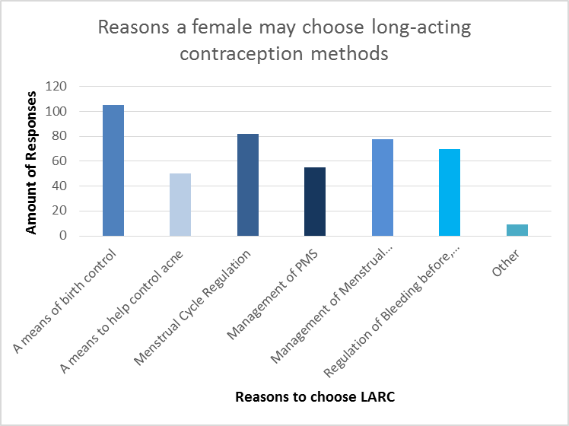
Figure 3. Reasons to Select a LARC Method
In question three women identified birth control as the main purpose for LARC 105 times or 93% of the responses. The second most selected response was regulation of the menstrual cycle, which was selected by 82 participants (73%). The next was the management of menstrual symptoms with 78 total selections (69%). The management of bleeding throughout a monthly cycle was also a common response with 70 total responses (62%). Symptoms associated with menstruation and birth control use were chosen less often—acne control was only chosen by 50 participants (44%) and PMS management was only selected by 55 participants (49%). The other selection was utilized by nine participants or eight percent of the time, and the responses included piece of mind, endometriosis, cysts, cramping, and convenience.
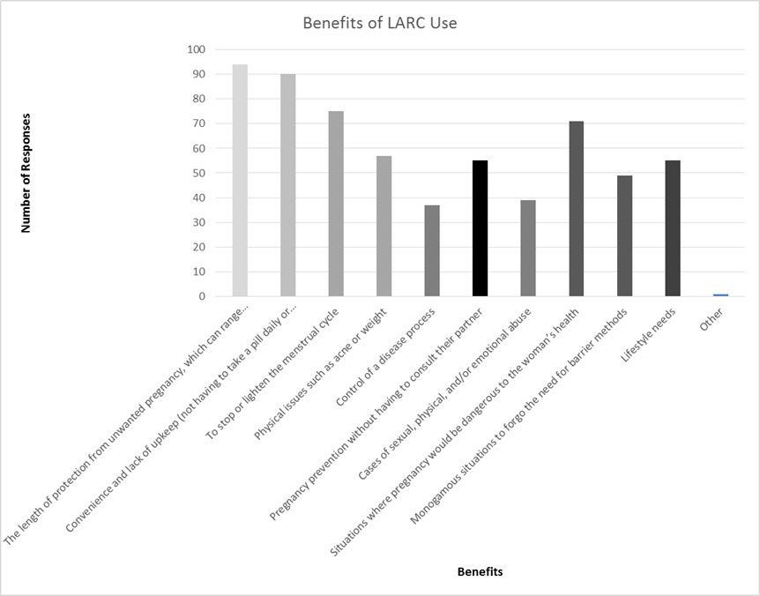
Figure 4. Benefits of a LARC Method
In question four women chose the length of protection as their primary reason for method selection with 93 total selections (83%). Another popular reason was lack of upkeep, as this option was selected by 90 total participants (80%). The issue of altering menstrual cycles was also an option that woman chose often with 75 total selections (66%). Participants selected LARC when pregnancy would endanger the mother’s life with 71 total responses (63%). The issue of physical side effects such as weight and acne control was also cited with 57 total responses (50%), and lifestyle needs and protection without having to consult a partner both received 55 selections (49%). The issue of current monogamy received 49 selections (43%). Cases of abuse were selected less often with 39 total responses (35%), and the control of a disease process received 37 selections (33%). And there was one other selection, while stated “Women have the right to decide what they want to do with their bodies”.

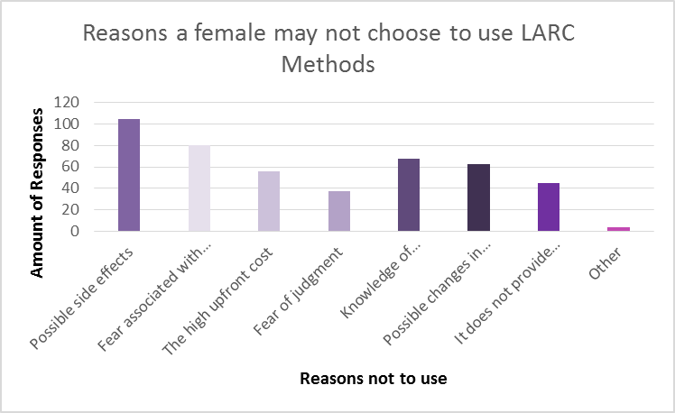
Figure 5. Reasons not to use LARC
In question five the fear of possible side effects received 105 participants (93%). Fear of the insertion of LARC methods was also a highly selected answer choice with 80 participants (71%). Women also chose the negative experience option 68 times (60%). Menstrual flow changes were a concern with 63 participants (56%). The high upfront cost of LARC methods was selected by 56 women (50%). The issue of lack of STI protection was also sited with 45 participants (40%). There was also the issue of fear of judgment, as 37 women (33%), sited this as a reason not to select LARC methods. The other selection was utilized by four participants. They cited issues such as insurance coverage, religion, and distrust of the effectiveness of the method in preventing pregnancy due to possible adverse effects.

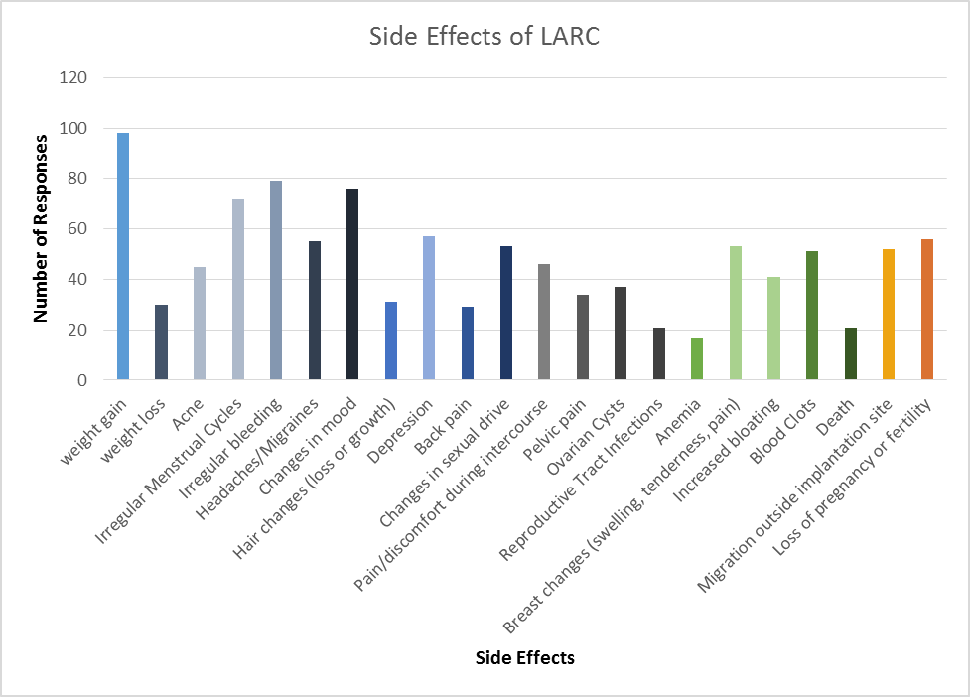
Figure 6. LARC Side Effects
In question six 98 (87%) participants selected weight gain, while 30 participants (27%) selected weight loss. Acne received 45 selections (40%). 72 participants (64%) chose irregularities in the menstrual cycle, and 79 (70%) chose irregular bleeding. Headaches/migraines were selected by 55 participants (49%). Changes in mood received 76 selections (67%), while hair changes received 31 selections (27%). 57 (50%) of participants selected depression as a possible side effect, and back pain was selected by 29 women (26%). Changes in sexual drive received 53 (47%) selections, while pain during intercourse received 46 (41%) selections and general pelvic pain received 34 (30%) selections. Ovarian cysts were cited as a side effect 37 times (33%), while RTI’s were selected 21 times (19%). Anemia was selected 17 times (15%), while breast changes received 53 selections (47%), and increased bloating was chosen 41 times (36%). Blood clots were selected by 51 participants (45%), and migration was chosen by 52 participants (46%). Loss of pregnancy or fertility was chosen 56 times (50%), while death received 21 selections (19%).
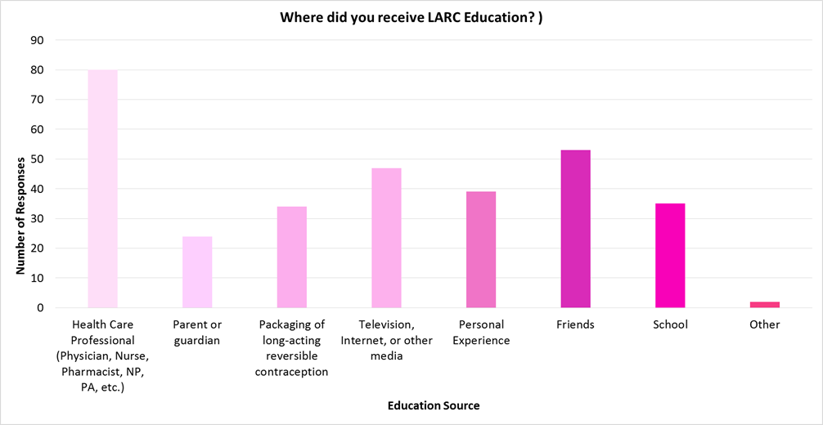
Figure 7. Sources of LARC Education
In question seven 80 participants (71%) of woman claimed that they received their education from a health care professional. Friends were the second most popular selection with 53 participants (47%). Media was the next most popular source with 47 participants (42%). Personal experience was also selected with 39 participants (35%). Participants also cited school was a source of education with 35 participants (31%). And the least selected options were packaging with 34 participants (30%) and parents with 24 participants (21%). There were also two other selections that cited that they either researched or just ‘guessed” about the information.
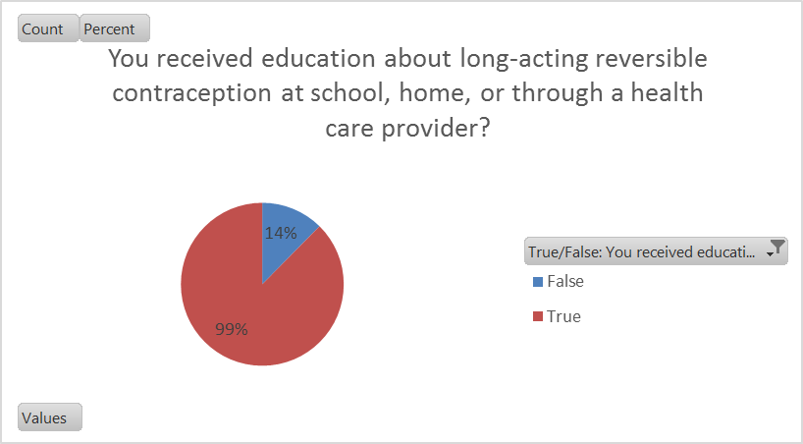
Figure 8. Did you Receive LARC Education?
In question eight 99 respondents (88%) said that they had prior education, while only 14 respondents (12%) claimed no prior education regarding LARC.
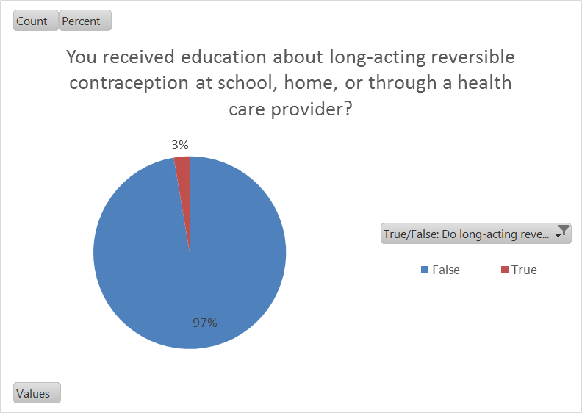
Figure 9. Was the LARC education effective?
In question nine 110 respondents (97%) said no, while only three (three percent) of respondents said the education was effective.
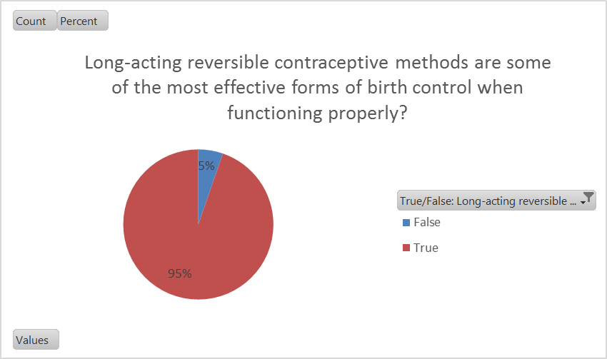
Figure 10. Are LARC methods highly effective?
In the final question 107 participants (95%) chose true, while false was only selected by six participants (five percent).

DISCUSSION
The purpose of LARC is to expand contraceptive options. Individual needs are a consideration when selecting contraceptive methods. Also, while these methods would provide benefits, women must consent for use. When it comes to the concern of reproductive freedom, LARC puts a responsibility on health care providers. We have to ensure that women obtain these methods free from coercion—from a significant other, family, a government or state entity, etc. Education and assessment techniques must be utilized in order to promote individualized contraceptive access.
The way we approach sex and contraceptive education plays a role in method selection and success rates. Thus we should focus on providing universal access and education. We are currently in an unpredictable climate in terms of reproductive access. Keeping education in mind it is important to remember that these methods are invasive, and that can be intimidating for a young adult that is just trying her first birth control method. The majority of the participants were between the ages of 18-22 years of age, which is not surprising given that these were undergraduate students. Their experiences with LARC methods may be limited, as oral contraception is usually the first line as found through data. The issue of participant education was relevant throughout this study. The question of the quality and variation would be an interesting point to elaborate upon given their limited experiences with LARC in comparison to oral contraception.
Contraceptive education should be neutral, so that women can make informed and personalized choices regarding their contraceptive needs. LARC methods are invasive, and the insertion process and healing process thereafter is a point of anxiety for many young women. Thus giving women a clear understanding of what to expect and what they will feel can help to decrease associated anxiety that has the possibility of detracting from method selection.
The frequency in which women chose situations of abuse as a reason for LARC method selection were significant, as 71 (63%) women selected this option. The high response rate could suggest issues of intimate partner violence, knowledge of abuse situations, or fear of abuse among this group as reasons for the high selection rate. The issue of side effect selection was also an interesting point to note. All of the options were possible side effects, thus there were no right or wrong answer choices. However, women chose weight gain as their top side effect associated with the method. Thus weight and appearances are key motivators for this group. The question from this would be: would you still choose the method even if weight gain was a likely side effect?
LIMITATIONS
The main limitation of this study is that it only included female nursing students at one university. A cohort of diverse participants would have provided the study with more data on LARC. Survey studies also run the risk of obtaining inaccurate responses or participant bias.
RECCOMENDATION
The next step in the research process for this data would be to include non-nursing women, and compare the responses with the differences in education in mind. This data could provide additional insight on how to better educate women as a population.

CONCLUSION
The purpose of the study was to understand some of the perceived and actual barriers for usage, as well as to identify any gaps in education regarding this method. The results of this study were that women had a general understanding of LARC, with low levels of usage. Emphasizing the need for proper and thorough education for all methods is critical for the promotion of reproductive health. The individual selection of contraception is achieved when health care professionals and educators provide complete and accurate education. Proper education enables women to make quality choices regarding their contraceptive needs. Prominent themes were misinformation and fear, as many cited prior knowledge of bad experiences and fear of both side effects and insertion are reasons not to choose a LARC method. This fundamental gap in communication and understanding among women and their providers further supports the need for further inquiry into the baseline knowledge of the general female population, while also incorporating multiple tiers of education to ensure understanding. Without a proper understanding, women cannot make informed choices regarding their health and sexuality.
APPENDICES

Appendix A:
IRB Approval Letter
Notice of Exemption {Exempt 45 CFR 46.101(b)}
The Office of Sponsored Programs and Research Administration has evaluated the project named above. According to the information provided, you intend to study Attitudes surrounding long-acting contraceptives among 18-22 year old SSU students. This is a minimal risk study. This study has been granted an exemption from Salem State IRB review in accordance with 45 CFR 46.101 (b) under one of the following categories: 1. Research conducted in established or commonly accepted educational settings, involving normal educational practice, such as (a) research on regular and special education instructional strategies or (b) research on the effectiveness of or the comparison among instructional techniques, curricula or classroom management methods. 2. 3. Research involving the use of educational tests (cognitive, diagnostic, aptitude, achievement), survey procedures, interview procedures or observation of public behavior that is not exempt under #2 above if (a) the human subjects are elected or appointed officials or candidates for public office, or (b) federal statute(s) require(s) without exception that the confidentiality of the personally identifiable information will be maintained throughout the research and thereafter. 4. Research involving the collection or study of existing data, documents, records, pathological specimens or diagnostic specimens, if these sources are publicly available or the information is recorded by the investigator in such a manner that the subjects cannot be identified directly or through identifiers linked to the subjects. 5. Research or demonstration projects which are conducted by or subject to the approval of the federal or state department or agency heads and which are designed to study, evaluate or otherwise examine (a) public benefit or service programs, (b) procedures for obtaining benefits or services under those programs (c) possible changes in or alternatives to those programs or procedures or (d) possible changes in methods or levels of payment for benefits or services under those programs.6.Taste and food quality evaluation and consumer acceptance studies, if (a) wholesome foods without additives are consumed or (b) if a food is consumed that contains a food ingredient at or below the level and for a use found to be safe, or agricultural chemical or environmental contaminant at or below the level found to be safe, by the Food and Drug Administration or approved by the Environmental Protection Agency or the Food Safety and Inspection Service of the Department of Agriculture. This designation is based on the assumption that the materials that you submitted to SPRA contain a complete and accurate description of all the ways in which human subjects are involved in your research. This exemption is given with the following conditions: 1. You will conduct the project according to the plans and protocol you submitted; 2. No further contact with SPRA is necessary unless you make changes to your project or adverse events or injuries to subjects occur; 3. If you propose to make any changes in the project, you must submit the changes to the SPRA for IRB review. You will not initiate any changes until they have been reviewed and approved by the IRB; 4. If any adverse events or injuries to subjects occur, you will report these immediately to SPRA. The University appreciates your efforts to conduct research in compliance with the federal regulations that have been established to ensure the protection of human subjects in research.
Date of Exemption:
May 18, 2017
Date of Salem State University IRB Approval:
May 18, 2017
If you are conducting research using an online survey such as Survey Monkey, the IRB requires that the approval dates appear on the online consent page of your survey.
This research project has been reviewed by the Institutional Review Board at Salem State
University in accordance with US Department of Health and Human Services Office of Human
Research Protections 45 CFR part 46 and does not constitute approval by the host institution.

Appendix B:
Survey Disclosure Statement
Salem State University
Institutional Review Board (IRB)
Disclosure Statement
My name is Nicole Nearen. This survey is for an honors thesis, which serves as a requirement to graduate with honors from Salem State University. You will be asked to complete an online survey that should take about 15-20 minutes from start to finish. Within the survey multiple choice, select all that apply, and true/false questions regarding your experiences and perceptions about long-acting reversible birth control are posed.
Participation in this survey is voluntary and your identity will be kept anonymous. This survey has no right or wrong answers. You may stop at any time during the survey. You do not have to answer any questions that make you uncomfortable or cause emotional distress. Any incomplete surveys will not be used, as that will be taken as revoked consent. Entering and completing the survey implies consent to use any and all information given for the purposes of this study only. Consent cannot be withdrawn after submission.
You have the right to learn about any potential risks or benefits of this study before you decide whether you would like to participate. This is called informed consent. In general, the project is very low-risk which means that participation poses minimal risks or discomforts to participants. The benefits of participating in this study include that you will be helping me to understand perceptions and knowledge about long-acting reversible birth control among female undergraduate nursing students. You may benefit from this study by gaining knowledge related to long-acting reversible birth control. The nature of the survey questions may make you feel uncomfortable and twenty minutes of research participation could potentially be inconvenient for participants related to time constraints. There is also a slight risk of fatigue while viewing the computer screen. Although a minor risk, the possibility that a survey of birth control methods may cause negative or distressful feelings among participants. You may speak with Nicole Nearen or Charlene Moske-Weber, to discuss any distress or other issues related to participation
By entering and completing the survey you understand that your name or identity will not be used in reports or presentations of the findings of this study. The information provided to the researchers will be kept confidential with the exception of information which must be reported under Massachusetts’s law including cases of child or elder abuse. For questions or concerns about the research, please contact Nicole Nearen at n_nearen@salemstate.edu or Charlene Moske-Weber at cmoskeweber@salemstate.edu. This research project has been approved by the Institutional Review Board at Salem State University. Thank you for your participation!
For concerns about your treatment as a research participant, please contact:
Institutional Review Board (IRB)
Sponsored Programs and Research Administration
Salem State University
352 Lafayette Street,
Salem, MA 01970
(978) 542-7556 or (978) 542-7177 or irb@salemstate.edu
This research project has been reviewed by the Institutional Review Board at Salem State University in accordance with the US Department of Health and Human Services Office of Human Research Protection 45 CFR part 46 and does not constitute approval by the host institution.

Appendix C:
Participant Survey
- What is your current age? (open response)

- Please select the birth control method that you currently use (if you use more than one method, please select all that apply).
- IUD (Skyla, Mirena, Paragaurd, or any other IUD not listed)
- Implanon (arm implant)
- Barrier Methods (condoms, diaphragm, cervical cap, spermicidal agents)
- Oral Contraception
- Abstinence
- Other (open response)
- Please select the reasons for which you believe a female may choose long-acting contraception (Please select all that apply to you).
- A means of Birth Control
- A means to help control acne
- Menstrual Cycle Regulation
- PMS management
- Menstrual Cycle Management
- Regulation of bleeding
- Other (open response)
- Please select the reasons why you believe that a women would choose to use a long-acting method of birth control (select all that apply)
- The length of protection from unwanted pregnancy, which can range from 3-10 years
- Convenience and lack of upkeep (not having to take a pill daily or change a vaginal ring every 3 weeks)
- To stop or lighten the menstrual cycle
- Physical issues such as acne or weight
- Control of a disease process
- Pregnancy prevention without having to consult their partner
- Cases of sexual, physical, and/or emotional abuse
- Situations where pregnancy would be dangerous to the woman’s health
- Monogamous situations to forgo the need for barrier methods
- Lifestyle needs
- Other (open response)
- Please select the reasons why you believe that a woman NOT choose to use long-acting methods of birth control (select all that apply)
- Side Effects
- Fear of insertion
- High upfront cost
- Fear of judgment
- Knowledge of negative experiences from self or others
- Possible changes in menstruation
- No protection from STI’s
- Other (open response)
- Please select any side effects that you are aware long-acting contraceptives can have upon consumers (select all that apply)
- Weight gain
- Weight loss
- Acne
- Irregular menstruation
- Irregular bleeding
- Headaches/migraines
- Changes in mood
- Changes in hair distribution
- Depression
- Back pain
- Changes in sexual drive
- Pain or discomfort during intercourse
- Pelvic pain
- Ovarian cysts
- Reproductive tract infection
- Anemia
- Breast changes
- Increased bloating
- Blood clots death
- Migration from implantation site
- Death
- Loss of a pregnancy or fertility
- Other (open response)
- How did you learn of these side effects? (select all that apply)
- Health care provider
- Parents or guardians
- Friends
- Television, internet, or other media
- Packaging from contraceptive products
- Personal experiences
- School
- Other (open response)
- True/False: You received education about long-acting reversible contraception at school, home, or through a health care provider?
- True
- False
- True/False: You received accurate education about long-acting reversible contraception at school, home, or through a health care provider?
- True
- False
- True/False: Long-acting reversible contraceptive methods are some of the most effective forms of birth control when functioning properly?
- True
- False

REFERENCES

Birgisson, N., Zhao, Q., Secura, G., Madden, T., Peipert, J. (2015). Preventing Unintended Pregnancy: The Contraceptive CHOICE Project in Review. Journal of Women’s Health, 24 (5), 349-353. doi: 10.1089/jwh.2015.5191

Higgins, J., Kramer, R., Ryder, K. (2016). Provider Bias in Long- Acting Reversible Contraception (LARC) Promotion and Removal: Perceptions of Young Adult Women. Perspectives from the Social Sciences, 106 (11), 1932-1937.

Kipps, S. (2014). Counselling women on LARC: a practical guide. Practice Nursing 2014,
25 (7), 338-343.

Manchikanti Gomez, A., Allina, A., Fuentes, L.(2014). Women or LARC First?
Reproductive Autonomy and the Promotion of Long-Acting Reversible Contraceptive Methods. Perspectives on Sexual and Reproductive Health, 46 (3), 171-175.
Quirk, V. (2016). "Nursing Students’ versus Non-nursing Students’ Understanding of Oral
Contraceptives”. Honors Theses. 117.

Sundstrom, B., Baker-Whitcomb, A., DeMaria, A. (2015). A Qualitative
Analysis of Long-Acting Reversible Contraception. Maternal Child Health, 19, 1507–
1514. doi: 10.1007/s10995-014-1655-0

