A STUDY OF SOCIAL MEDIA’S EFFECTIVENESS AS A VEHICLE FOR SOCIAL CHANGE

Honors Thesis

Presented in Partial Fulfillment of the Requirements

For the Degree of Bachelor of Communications
In the College of Arts and Sciences
at Salem State University

By
Judith Culp

Professor Cindy Vincent
Faculty Advisor
Department of Communications

***

Commonwealth Honors Program
Salem State University
2015

Abstract
Human trafficking is one of the greatest sources of crime in the world, second only to the drug trade. Modern day slavery isn’t just an issue abroad, though, it happens in the United States every day. Public relations experts are calling social media the next big industry secret, but can it tackle social issues this big? Social media is a cheap alternative to traditional public relations tactics that are too costly for nonprofit organizations, but it might not be the best way to create the lasting change they are looking for. In this study, I tested how I could use social media to show college students that human trafficking is happening in their backyards and they have the tools to end it at their fingertips. I posted photos, videos, infographics, quotes, articles, and information about anti-trafficking organizations daily for two months on Facebook and Twitter and monitored likes, shares, favorites, and retweets. At the end of the study, I encouraged followers to take a survey that asked about their engagement with the posts on social media and their actions offline regarding the information. I hope that other researchers will continue this work so we can understand the effectiveness of this industry trend.

Table of Contents
Acknowledgements 4
Introduction 5
Literature Review 6
Method 15
Results 19
Discussion 27
Conclusion 29
Bibliography 31

Acknowledgements
I would like to thank my advisor, Cindy Vincent, for her support, encouragement, and critical eye. Without her guidance, I would not have been able to develop strong research tactics that were social media savvy. Her careful corrections helped me to say what I meant to say and ask the questions I meant to ask. With her help, I dug deeply into the question of what social change is and how it is measured. Thank you, Professor Vincent, for your willingness to work with me on this important question.
I would also like to thank my communications professors who have taught me about the triumphs and pitfalls of social media, the tactics of public relations, and the importance of ethics. Without their help, I would not have been able to construct this question and come to these results. I appreciate their tireless efforts to engage and educate their students.
Finally, I would like to thank Kimberly Poitevin, Joanna Gonsalves, and the rest of the honors faculty for their work to develop me and so many other students into serious, global thinkers. They have encouraged me to think deeply and critically about every subject. I would not have been able to delve so deeply into the issues of social media and social change without this program.

Introduction
Human trafficking is an issue that goes largely unnoticed in society even though it is still a serious problem in many areas around the world, even the United States. Despite the fact that slavery is outlawed in the United States, the US State Department estimates that about 14,500 to 17,500 victims are trafficked every year in the United States alone (Godziak and Collett 108). This number is merely those that the US government are aware of, which means that thousands more could be the victims of human trafficking. We can’t remain ignorant to an issue that is hurting so many innocent lives, and yet many are unaware that human trafficking is an issue at all in the United States today.
When social media began gaining popularity in recent years, it became evident that it had the ability to captivate audiences. Social media sites like Facebook and Twitter have gained a worldwide following in recent years. In the beginning of 2015, Facebook had an estimated 1.44 billion users each month (Facebook, 2015). Twitter has also gained quite a following with 302 million active users (Twitter, 2015). Yes, social media use is on the rise and so is its influence. In fact, there are 30 million small businesses on Facebook as of 2014 (Ha, 2014). The Public Relations industry is taking notice of this. Public relations programs at schools around the U.S. and the world have begun training their students in social media as a public relations tool. Students are taught to use social media as a vehicle for their message. The question becomes, then, what do we hope readers will do with the information that we give them? There are captive audiences around the world who are ready to hear what companies and nonprofit organizations alike have to say. With all of this information being disseminated on a daily basis, though, how much of it are users interacting with? It has become increasingly common for public relations professionals to use social media as a supplementary source, or the only source, of information for their publics. When companies are using social media, is it their hope to make people aware or to transform people? The question is, is anyone listening? Moreover, are people taking action?
This question inspired my thesis as I began to question how social media could be effective in bringing about social change. There have been some viral social issue campaigns since the dawn of social media such as the Kony 2012 campaign as well as the ALS Ice Bucket Challenge in the summer of 2014. Each campaign seemed to have the potential to change the way we spread social issue awareness. And it did. Social media has become a place for individuals to share their personal triumphs, failures, and musings, but it has also become a place for nonprofit companies to share their stories and encourage users to take action. In light of this, one question arises: Is social media an effective vehicle for social change?

Literature Review
Human Trafficking in the United States
Human trafficking has become a topic of interest in the past 20 years, with many researchers beginning to dig deeper into who is trafficked, who the traffickers are, how they are trafficked, and how we are able to prevent human trafficking. Because it is an illegal industry, the statistics are largely estimated. In Gozdziak and Collett’s article on the subject, they argue that the ambiguity regarding the actual number of trafficked victims is one of the largest issues because it represents a significant gap in research (Gozdziak and Collett, 2005, 109). This issue is one that I will need to address in the statistics that I share in my campaign in order to create a reputable campaign that audiences will trust.
The size of the human trafficking industry has been one of the most researched aspects of human trafficking for academic circles and nonprofit companies alike. Patrick Belser, who works for the International Labor Office, conducted a study in which he estimated the annual profits of human trafficking (Belser, 2005). In his study, Belser estimated that industrialized countries make about $15 billion per year in the sex trafficking industry and $18 billion per year in the forced labor industry (Belser, 2005, 15-16). As Belser suggested in his study, his estimates are higher than other human trafficking statistics, but he points out how many of these studies don’t include their calculations (Belser, 2005, 18). He said that based on his calculations, he would consider his estimates to be conservative because of the many people who profit from trafficking beyond the traffickers (Belser, 2005, 18). This study shows just how profitable the industry is. In fact, Jeremy Haken conducted a study entitled Transnational Crime in the Developing World where he discussed 12 of the most profitable forms of illegal trade in the developing world (Haken, 2011). In this study, he discussed human trafficking and the profitability of it as well as the harm that it causes. Haken said, “Similar to drug trafficking, human trafficking erodes the capacity of the state” (Haken, 2011, 10). He said that these profitable illegal industries ultimately hurt citizens’ trust in their government amid the pain that it causes (Haken, 2011, 10). Once again, Haken shows the mark that human trafficking has left financially and eventually, emotionally on a country. The area of profitability of human trafficking seems to have the most prior literature, likely because of its ability to shock readers when they see the scope of this international crime. Statistics like the ones that these researchers have found will provide powerful information for my campaign.
One of the topics that does not seem to have very much literature currently is awareness of human trafficking among a given population. Hounmenou conducted a study entitled, “Human Services Professionals’ Awareness of Human Trafficking” in which he studied how much human services professionals in Illinois knew about human trafficking (Hounmenou, 2012). This study focused on a particular population in an area with a high rate of human trafficking; however, this type of focus is not very common in the current literature. There was one article that discussed legislation to prevent human trafficking, but there was not literature following this that showed how aware people were of this legislation (Prelogar, Ardito, and Navarre, 2013). In their article New Human Trafficking Laws and US Government Initiatives Make Anti-Trafficking a Compliance for Businesses in 2013, Brittany Prelogar, Laura Ardito, and Michael Navarre discuss the Trafficking Victims Protection Reauthorization Act of 2013. The TVPRA of 2013 seeks to serve victims of human trafficking and make government organizations more responsible for taking part in anti-trafficking organizations (Prelogar, Ardito, and Navarre, 2013). The law also encourages more collaboration between US government organizations and nonprofit organizations who work to prevent trafficking so that the United States isn’t using materials made by trafficked victims (Prelogar, Ardito, and Navarre, 2013). One of the biggest efforts to increase awareness of laws like this currently is done through Polaris Project, an international nonprofit organization that aims to end trafficking worldwide. Because of their work in this area, I will be using some of their resources in my campaign in order to increase public awareness of these laws on my campus. In my efforts, I hope to increase student awareness of these laws so they feel equipped to take action to stop human trafficking in the United States.
College Students’ Attitudes toward Social Change
Because college is a time of exploration for many students, civic engagement is often a part of this journey whether it is required or done at students’ leisure. In a study that categorized civically engaged students, Weerts, Cabrera, and Mejías posit that college students who are involved in bettering their community do so at different levels. The first level is the charity paradigm, which is concerned with temporary activities that focus on giving some of their amassed resources to those who have very little (Weerts, Cabrera, and Mejías, 2014, 143). The second level is the project paradigm, which is when students focus on a specific project that works on a local issue (Weerts, Cabrera, and Mejías, 2014, 143). The third level is the social change paradigm, which is made up of students who seek to partner with the less fortunate to find tangible solutions that will deal with the root of the issue rather than the extraneous effects (Weerts, Cabrera, and Mejías, 2014, 144). According to the authors, many students want to work on charity work because it solves short-term problems while fewer students want to take part in social change issues because these issues often take more time and effort as they seek to change societal norms (Weerts, Cabrera, and Mejías, 2014, 158). This social change paradigm will be at the center of this study because it is the kind of civic engagement that will be required to stop human trafficking.
While the idea of social change might still be relatively unappealing to students, civic engagement is becoming the norm on college campuses. In his article on civic engagement in college, O’Connor writes, that civic engagement is a “movement that has spread across American college campuses” (O’Connor, 2006, 52). O’Connor uses Ehrlich’s definition from Civic Responsibility and Higher Education in his article, which says, “Civic engagement means working to make a difference in the civic life of our communities and developing the combination of knowledge, skills, values and motivation to make that difference. It means promoting the quality of life in a community, through both political and non-political processes” (Ehrlich qtd. in O’Connor, 2006, 52). This concern for civic engagement in higher education will likely be a tipping point in my research because it will determine students’ interest in getting involved as they begin to find out that human trafficking might very well be happening in their community.
Social Media Use among College Students
The use of social media among college students has drastically increased since its beginnings. In 2010 alone, approximately 57% of individuals who used social networks were between the ages of 18 and 29 (Sponcil and Gitimu, 2013, 4). About half of college students go on their social networking accounts more than a few times a day (Sponcil and Gitimu, 4). In this way, college students have a strong presence on social media, making my research method a technique that could effectively reach them. As Jenkins, Ford, and Green say in their book Spreadable Media, “’post and pray’ is not an option” (Jenkins, Ford, and Green, 2013, 195). Instead, my content will need to be that which engages my audience. The authors suggest that a given media’s “spreadability,” as they put it, depends more on how well they understand their audience and less on how clever their posts are (Jenkins, Ford, and Green, 2013, 196). To better understand my given audience, I studied Not For Sale’s Twitter page. Not For Sale is an anti-trafficking organization that has 54.2 thousand followers. Nearly all of their postings have engagement of some sort be in retweets, favorites, or comments (https://twitter.com/NFS). The thing that seemed to make this organization so successful on Twitter was not only its engaging posts, but also its engagement with its audience. If they were tagged in a post, they read it and often retweeted it. They also shared content that readers cared about. For example, they frequently posted photos and quotes (https://twitter.com/NFS). Finally, they posted often. They maintained a consistent presence on Twitter so that their followers saw them frequently. Like Jenkins, Ford, and Green said, it’s important to know your audience in order for you to reach them (Jenkins, Ford, and Green, 2013, 196). I will examine both current Facebook and Twitter use among college students as a comparative study for this research so that I can see what differentiates the content of each site.
According to McDermott’s article, “Facebook Losing Its Edge Among College-Aged Adults,” Facebook use decreased to 88.6 percent from 91.6 percent between February 2013 and November 2013 (McDermott, 2014). “Facebook certainly isn’t cool anymore, but it has transformed into a useful internet service like Google” (McDermott, 2014). Many social media professionals have seen this shift and are beginning to work on how they can use Facebook effectively as its purpose transitions. McDermott said that some of Facebook’s features like photos and a feature called Facebook Connect is mostly what has kept college-aged adults around in recent years as he says that engagement “will continue to soften” (McDermott, 2014). This lack of engagement will be something I will test in this study as I seek to figure out if Facebook is a more effective medium for social change than Twitter.
While Facebook might be on the decline among this age group, Twitter has been on the rise. According to Duggan and Brenner’s article, The Demographics of Social Media Users – 2012, Twitter use doubled from 2010 to 2012 (Duggan and Brenner, 2013, 4). As of 2012, 27% of internet users who use Twitter were between 18 and 29 (Duggan and Brenner, 2013, 4). This is significant growth compared to that of Facebook. In this study, I will be comparing Twitter’s effectiveness at sharing messages rather than its popularity. If Twitter is not sharing messages effectively, it might not be having the right kind of influence on college students.
Social Media Campaigns and Effectiveness
Social media is a recent buzzword in the field of public relations, and rightly so, because it has brought about mass awareness for many once unknown organizations and causes. However, as social media becomes more prominent, critics have begun to question whether or not this tool can bring about the kind of awareness that promotes action. In one such study, Adamoli studied whether or not people believe that they can use Facebook as a means for food activism. The author examined the perception that people have of their influence in sharing their opinions on important issues (Adamoli, 2012, 103). This study showed that 93% of the respondents felt that Facebook allowed them to share their opinions freely and honestly (Adamoli, 2012, 104). As Adamoli pointed out, Jürgen Habermas believed that a perfect public sphere, “revolves around free access to a space in which individuals can engage in conversations driven by well-reasoned debates not confined by external authority” (Adamoli, 2012, 104). If this is the case, it is also important to consider whether people believe their social media conversation is a regulated or unregulated one. Their view on this will ultimately affect how they share their opinions.
In a study conducted by Dey on social media’s effect on active change in individuals’ lives, he studied whether or not social media was a useful medium for social change. In the study, he found that about 96.6% of organizations surveyed used Twitter and about 93.1% used Facebook (Dey, 2013, 50). When asked which media were most effective at engaging customers personally, 63.3% said that Facebook was effective while only 8.2% thought Twitter was effective likely because of its smaller content allowance (Dey, 2013, 55). This finding carries a lot of weight for those organizations trying to use social media as a medium for engagement because, although Twitter has been the most used site among organizations, many workplaces that Dey studied didn’t find it to be as engaging as Facebook and blogs. In fact, Twitter ranked second to last for engagement value in Dey’s study with 47.9% of users finding it to be less engaging (Dey, 2013, 56). Ultimately in the study, 53.1% of users believed that social media could create change (Dey, 2013, 60). One person questioned said that their organization went from “being a supplier of information into a business that listens to the needs of our members” (Dey, 2013, 59). Dey’s findings in this study make the question of social media as a tool for social change all the more important since the full scope of its effectiveness is still relatively unknown.
Peisker explored this question of whether social media can be a vehicle for creating effective social change in her 2011 literature review entitled The Communication of Participation: An Exploratory Study of the Effects of Social Media on Social Change. In this article, she writes, “Dialogue is at the heart of communication for social change” (Peisker, 2011, 13). In other words, two-way communication is needed in order to effectively inspire people to action. Social media, in this way, offers an interactive way for people to seek out change because the theme of social media is engagement. Peisker discusses Gladwell’s skepticism of social media’s ability to promote social change in her article. She writes, “Social change demands strong ties between participants as challenging the status quo is a high-risk activity” (Peisker, 2011, 21). Gladwell says, “Clicking a ‘like’-button on Facebook forwarding an email or even visiting the ‘We are all Khaled Said’ web page gives people a sense of being active, whilst there is very little risk – or consequence – of their action” (Gladwell qtd. in Peisker, 2011, 21). This is a theory that I will explore in practice to see if many who share Gladwell’s opinions are indeed cynical or if they are correct in their assumptions. Though Gladwell seems skeptical of social media and its power, McChesney suggests in his book The Digital Disconnect, that the Internet – and social media – have become such fixtures in our society that they have become a new way of living. He writes, “We are in a position, in some respects for the first time, to make sense of the Internet experience and highlight the cutting-edge issues it poses for society” (McChesney, 2013, 3). McChesney goes on to say that our society has the power right now to define the Internet and choose how we want it to be and how we want to coexist with it (McChesney, 2013, 3). With that logic in mind, McChesney suggests that Gladwell’s views of the power social media can have might be too limited. These ideas that McChesney suggests are just that – ideas. So how does this play out practically? He later shares Eli Pariser’s thoughts from his 2011 book The Filter Bubble that says that people merely flock to ideas that, “reinforces their known preferences” (McChesney, 2013, 9). These thoughts certainly show one of the obstacles I will encounter in this study: how to inform those who do not want to be informed. I will be interested to see if Gladwell or McChesney’s idea is correct in this study.

Method
This project was framed as a public relations campaign so that the data I gathered at the end would accurately reflect the way in which college students engaged with the information. The study was designed so that people would interact with the Facebook and Twitter as they would with any other organization’s social media sites. For example, would they “like” a post or simply scroll past? Would the post dictate their conversation or donation opportunities in the months following their viewing? In a testing situation, many students might be apt to engage more because that is their focus. The test here was how they would respond to injustice on their newsfeed on a daily basis. Because of this, students were asked to follow the account and I tracked their engagement on an ongoing basis and in the exit survey. This allowed them to respond organically.
Each day, I posted one to two articles, videos, statistics, infographics, or quotes designed to inform students or inspire a response. I posted every day in November and December so that students would regularly interact with the information. Since I was monitoring students’ natural engagement with social issue postings, I did not use post boosting or any sort of advertisement on social media. I did, however, use the most popular posting times so that students were more likely to see the information.
For this study I created a Facebook and Twitter account dedicated to sharing this information. Because there are dozens of social media accounts, each with different services, I aimed for the two most popular. This allowed me to study the effectiveness of the systems that are used by the masses. In the case of many social media sites on the rise in popularity, the sites themselves are the trend, which does not allow for stability to study people’s usage patterns. With Facebook and Twitter, I was able to see how people interact with social justice news and information within the scope of their routine, allowing for a more authentic understanding of how people interact with social injustice.
Finally, I shared the link to an exit survey that participants took in order to describe how following the account changed their perception of human trafficking as an American problem and how that changed their actions – if it had any effect at all. In the survey, I asked ten questions to determine their demographics, psychographics, and engagement with the site. First, I asked for their age to determine my audience. Though I was specifically interested in the responses of college students, the nature of social media makes it difficult to limit followers. If I had tried to limit followers, I likely would have lost some of the authenticity of my following or my results. So, in order to filter my results after the fact, I asked for respondents’ ages. The other demographic question I asked determined whether or not respondents were Salem State University students in order to help me further filter my results to my campus if necessary.
I then asked questions that asked respondents to share how they interacted with the Facebook and Twitter accounts. I gave them options to say they had followed the account, followed one of the human trafficking organizations suggested, retweeted or shared a post, or favorited or liked one of the posts. Each option was designed to indicate whether respondents’ engagement was passive, active, or nonexistent. For example, if a respondent favorited a post on Twitter or liked a post on Facebook, that was an indication of passive action. A respondent might have shown online approval for anti-human trafficking efforts, but that wasn’t necessarily an indication of further action. In contrast, if someone had followed one of the accounts suggested or shared one of the pieces of information that they were interacting with, it showed further online engagement.
The next question measured respondents’ engagement offline. Respondents had the option to say that they donated to an anti-human trafficking organization, watched a video outside of what was shared, talked to a friend about human trafficking, read an article outside of those that were shared, or to say they had not taken any of the actions. While this was a limited list, it was designed to see whether people were engaging in ways that could be helpful to organizations who are working to stop human trafficking. Mostly, this question was designed to determine whether respondents’ ideas of meaningful action in response to injustice were passive or active, online or offline.
I then asked how following the account had impacted respondents’ views on human trafficking as a current issue. This was designed to measure how much civic engagement came into play regarding respondents’ interest in the issue. They had the option to say that they didn’t view human trafficking as an issue, it didn’t impact their views, it showed them that human trafficking is a current United States issue, or that they wanted to personally work to stop human trafficking. The results of this question helped to measure how people had engaged with the information and how they had interpreted what was shared.
Following that, respondents were asked to share the most shocking information that they learned while following the Facebook or Twitter account. This would help them to interact with what they found to be surprising, interesting, or troubling, but it would also help me to understand what kinds of information get people to engage more. The results of this question could potentially help with further research. In addition, it could be helpful for nonprofit public relations professionals who were seeking to share the most relevant information with their audiences.
Respondents were then asked if they believed human trafficking was a current issue in the United States. This was designed to determine how people were interpreting the information that was shared with them. If they had answered “Yes,” it indicated that they had been paying attention to and were understanding the purpose of the accounts as well as the message. If they had answered, “No,” then it would indicate that they either had not been paying attention or did not think it was an issue, which would rationalize their lack of commitment. Finally, if they answered “I don’t know,” this would show any communication errors that might be present with the information shared or the platform through which it was being shared.
Next, I asked if respondents typically followed nonprofit Facebook or Twitter accounts. This was a yes or no question designed to provide me with information on the values of the respondents. If many typically followed nonprofit companies on social media, it would show that they already had a level of interest in civic engagement and social issues. If not, it could indicate either a lack of interest in or engagement with social issues.
Finally, I asked the respondents if they believed that social media was an effective way to fix current social issues. This was about the respondents’ perception of the information they were engaging with. For example, if they believed that social media was an effective way to make change happen, then they might believe that they were making a difference by engaging with these issues online. If they didn’t think social media was effective for creating change, then it might show a cynicism in social media’s power, much like Gladwell.

Results

Because the nature of this study was to determine how people responded to injustice that they saw on social media on a daily basis, I administered the survey after the postings to see how people had reacted to the information that they had read over the course of the two months. My goal was to see if people would take tangible, abstract, or nonexistent action in response to the injustice that they saw. This was the reason that I designed this survey with specific, logical actions that students could take. The survey yielded several noteworthy results.
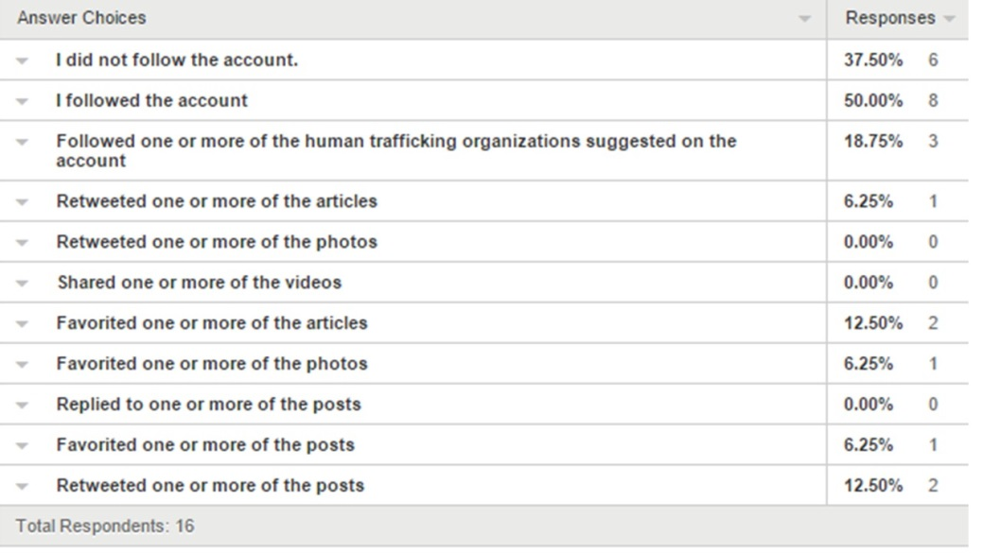
Twitter following results

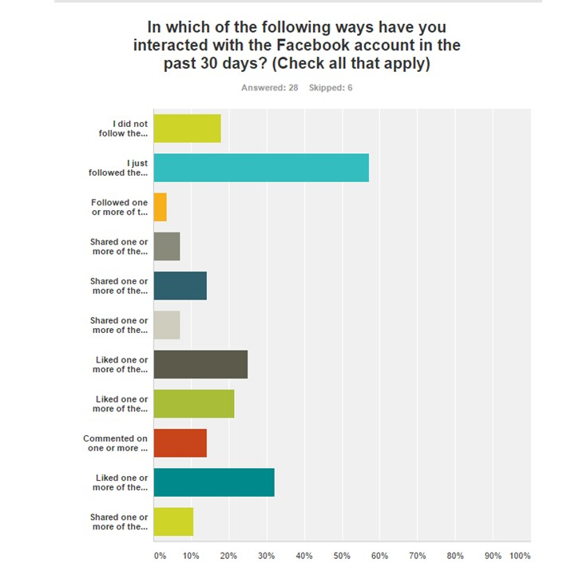
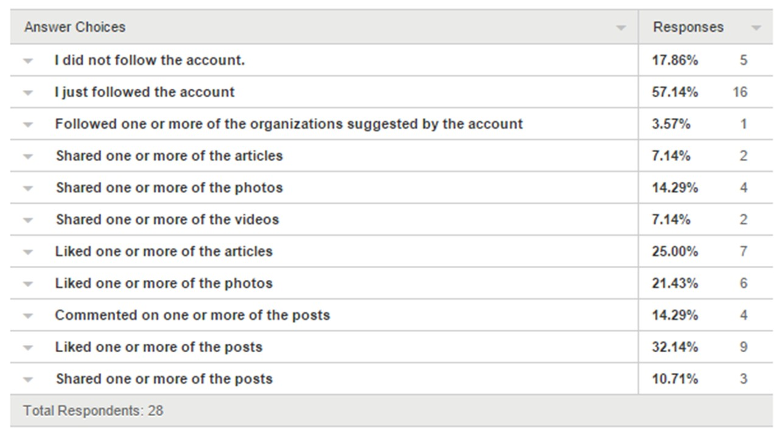
Facebook following results

First, people’s interactions varied based on the type of social media that they were using. When it came to the Twitter account, 50% of respondents only interacted with the account by following it. In comparison, 57.14% of respondents on Facebook just followed the account. The difference between the engagement with the sites is minimal, but it gets more significant when it comes to the way that people engaged. On Facebook, the most engagement came from those who liked postings, articles, and photos. People who took these actions made up over half of the respondents who had engaged in some way. On Twitter, on the other hand, the most engagement came from those who followed suggested human trafficking organizations, favorited articles, and retweeted posts. The people who took these actions made up a smaller percentage of respondents, though, with about 43% engaging in these ways. In addition, the scope of engagement on Facebook was much wider, since people engaged in a wide variety of ways when they did. Some chose to have a higher level of involvement by sharing the information they learned with their friends while others simply followed a suggested account or liked a posting. Still, people ultimately engaged in more unique ways on Facebook than on Twitter. For example, no one who followed the Twitter account retweeted or shared the photos or videos, but some respondents did retweet or favorite the posts. About 18.75% of respondents engaged by retweeting a posting while about 25% of respondents interacted with the posts by favoriting them. This shows the unique ways in which people engage with the information that they receive on different social media accounts. In addition, it showed a greater preference toward passive online action as opposed to more active action.

Engagement question results

While the engagement that they had while following the accounts showed some interesting information about how people engage with the information that they are receiving on a daily basis, the way in which people interacted with the news outside of their social media activity was a greater indicator of social media’s effectiveness. This will determine whether or not society will see a change in the long run. About 45% of respondents did not take any actions that were listed after they had followed the account. Still, others responded by taking actions behind the screens with 48% of respondents reading an outside article about human trafficking after following the account and 18% of respondents watching additional videos on human trafficking after following the account for a total of 66% of respondents engaging further through online resources. Those who took it one step further when it came to engagement represented a smaller population, though. About 27% of respondents talked to a friend about human trafficking in the United States after following the account and 3% of respondents donated to an anti-human trafficking organization after following the account, making up a total of about 30% offline engagement. While over half of the respondents did engage outside of social media in some way, there didn’t seem to be a widely-favored response that participants took after what they were reading and seeing.
Trafficking currency response

After following the account, about 77% of respondents said that human trafficking is currently an issue in the United States, 0% said that it is not a current issue, and 23% didn’t know. We see here that respondents could largely agree that human trafficking is a current issue in the United States. The fact that the majority of respondents believed that human trafficking was an issue showed that social media can be positive in creating awareness. However, it was troubling that such a large number of respondents didn’t have a definitive answer. With about a quarter of respondents not knowing whether or not human trafficking was an issue after engaging with the account, there is a clear issue in clarity when it comes to online communication. While it is clear that those who interacted with the account believe that human trafficking is a current issue, it is unclear what they perceive their roles are in stopping it.
Nonprofit social media following

Because of this discrepancy in the results, I included another question about whether or not respondents typically follow nonprofit account on Facebook and Twitter to figure out whether or not they tend to be aware of social issues. About 54% of the respondents do typically follow social media accounts for nonprofit organizations. This means that a majority of those who followed are likely to follow social media accounts like this on a daily basis. Because of this, many of them are interacting with injustices and social issues on a regular basis on their newsfeeds.

Discussion
There are a couple of significant findings from this study that have the potential to impact the role of social media in public relations in the future. First, social media content is capable of spreading awareness within the confines of social media. For example, 48% of respondents read an article about human trafficking after following my account and 16% watched an outside video on human trafficking. This shows a willingness on respondents’ part to educate themselves through low involvement activities that might represent a small inconvenience. In this way, social media does have some potential to open people’s eyes to social issues, but at a slow pace. Also, based on these results, it would appear that those individuals who do take action as a result of something that they’ve seen on social media tend to take the kinds of action that won’t quickly spread an idea. Because of this, it is likely that content shared on social media regarding social issues is more likely to add followers rather than multiply. This has crucial implications for those who are hoping for a multiplying effect when using social media.
It is also important to consider that those who took offline action were most willing to have a conversation with a friend about what they just read or saw. About 27% of respondents talked with someone they knew about human trafficking after viewing the content on the site. That means that a little over a quarter of people were affected enough to want to share what they learned with a friend. If this is true of a larger audience, then social media has the potential to get people talking when it comes to social issues like human trafficking. These results are even more promising than those who were willing to take online action because the people who talked to a friend had the opportunity to share their ideas about a social issue. This is not to say that respondents who shared the information online didn’t get other conversations started. There is certainly potential for a shared article to create other conversations. When people talk about social issues that they read about, it obviously has greater potential to spread awareness of an issue than if they keep it to themselves. That being said, this result will certainly spread awareness if it can be applied to a larger audience, but it has a low potential to create change. Still, this does have the potential to start the conversation about current social issues.
The most action-oriented result that people could choose on the survey was for those who chose to donate to an anti-human trafficking organization after following the account. This was also the piece that required what many might consider to be the most sacrifice. Because of this, it stands to reason that this might be the least popular result – and it was with about 3% of respondents taking this action. I expected this option to have the lowest response rate because of its high risk quality. Still, this is the most indicative of whether or not social media can create social change because it required respondents to take the most ownership over the issue.
Because the question revolved around social media as it relates to social change, I was paying the most attention to the number of people willing to take offline actions and actions that might be costly. In the case of the responses on the survey, I was the most skeptical of respondents’ willingness to talk to a friend or to donate money. While a decent-sized population was willing to have a conversation, the vast majority wasn’t willing to take a financial risk as a result of anything that they saw or read. That means that though social media has the potential to spread awareness, it doesn’t have nearly as much potential to spread change because the change that it spreads is often contained in the online world. In order to spread change, social media would have to get people to be willing to spend time, money, or other resources in order to see a change happen. They would need to be inspired to take action. In the case of these respondents, they were willing to make passive moves to become more aware. If this were a question of respondents’ awareness, then social media would certainly have the potential to change that. The question is, is that enough? Based on these results, I would argue that social media can certainly make people more aware of injustice, but based on the way we’re currently using social media, it cannot be a vehicle for social change yet.

Conclusion
Based on the results of this study, public relations professionals can certainly use social media as a means to raise awareness of their organization or their issues. If they are seeking to inspire people to take action, they will likely need to find a different medium or use different tactics in order to get the results that they are looking for. As I hypothesized at the beginning of this study, though, social media is not able to promote social change at this point in time in the ways that many organizations might hope for.
There are still plenty of opportunities for continued study on this topic. For example, I provided some opportunities for people to take the desired actions, but many of them had to be intuitive based on the way that the accounts were set up. That being said, there could potentially be future research on how high risk responses change when there are more specific directions about how people can take these high risk actions. It is possible that this could yield higher results, making social media a viable option for creating change.
In addition, there could be further research using a larger college or university in the future in order to measure a wider population. For example, Salem State advertises civic engagement as one of its values which might have had a different influence on the results than it would have at another university. A larger university might also promote a wider response rate as well.
A final area that could help to forward the research in this area would be to use this same model at a university in a state that has the most human trafficking. Because Salem State University is in Massachusetts, which has strong anti-trafficking laws, there might be potential for a greater student interest when the issue is more prevalent in the participants’ geographic area. Due to the somewhat segmented nature of the United States, it might be useful to bring the issue even closer to home for future research in order to see how this changes the results.

Works Cited
Adamoli, G. (2012). Social media and social movements: A critical analysis of audience's use of Facebook to advocate food activism offline. (Graduate, The Florida State University). Electronic Theses, Treatises and Dissertations, 1-251.
Belser, P. (2005). Forced labor and human trafficking: Estimating the profits. Forced Labor. 17.
Dey, K. (2013). The effectiveness of social media in advancing transformational change. (Master of Arts in Communication and Leadership Studies, Gonzaga University). , 2-78.
Duggan, M., & Brenner, J. (2013). The demographics of social media users - 2012. Pew Research Center.
Facebook. (2015). Number of monthly active Facebook users worldwide as of 1st quarter 2015 (in millions). Retrieved from http://www.statista.com/statistics/264810/number-of-monthly-active-facebook-users-worldwide/
Gladwell, M. (2011, February 2, 2011). Does Egypt need Twitter? The New Yorker.
Gozdziak, E. M., & Collett, E. A. (2005). Research on human trafficking in North America: A review of literature. International Migration, 43(1), 99-128. doi:10.1111/j.0020-7985.2005.00314.x
Ha, A. (2014). Facebook says there are now 30M small businesses with active pages, including 19M on mobile. Retrieved from http://techcrunch.com/2014/06/03/facebook-30m-small-businesses/
Haken, J. (2011). Transnational crime in the developing world. Washington, D.C.: Center for International Policy.
Hounmenou, C. (2012). Human services professionals' awareness of human trafficking. Journal of Policy Practice, 11(3), 192-206.
Jenkins, H., Ford, S., & and Green, J. (2013). Designing for spreadability. Spreadable media: Creating value and meaning in a networked culture (pp. 195-228). New York and London: New York University Press.
McChesney, R. W. (2013). What is the elephant in the digital room? Digital disconnect: How capitalism is turning the internet against democracy (pp. 1-22). New York and London: The New Press.
McDermott, J. (2014, January 21, 2014). Facebook losing its edge among college-aged adults. Retrieved from http://digiday.com/platforms/social-platforms-college-kids-now-prefer/
O'Connor, J. S. (2006). Civic engagement in higher education. Change, 38(5), 52-58.
Peisker, M. (2011). The communication of participation: An exploratory study of the effects of social media on social change, 1-50.
Prelogar, Brittany, Ardito, Laura, and Navarre, Michael. (2013). New human trafficking laws and US government initiatives make anti-trafficking a compliance priority for businesses in 2013. Steptoe,
Sponcil, M., & Gitimu, P. (2013). Use of social media by college students: Relationship to communication and self-concept. Journal of Technology Research, 4, 1-13.
Twitter. (2015). About. Retrieved from https://about.twitter.com/company
Weerts, D. J., Cabrera, A. F., & and Mejías, P., Pérez. (2014). Uncovering categories of civically engaged college students: A latent class analysis. The Review of Higher Education, 37(2), 141-165.

